
Arizona Academy of Health Certification LLC
37509 N 16th Street
Phoenix, AZ 85086
Ph # 623 734 5011
Fax # 480 565 7860
email: info@aahealthcert.com
Website: aahealthcert.com

Owner: Daniela Cosma
Author: Linn A. Cunningham LPN, BSBA

“GUIDING PRINCIPLES OF MANAGEMENT”
for
ARIZONA ASSISTED LIVING MANAGERS

November 10, 2025
Table of Contents
Chapter 1 Introduction 6
Using the Regulations 6
Using the AA Health Cert Program Manuals: 6
Chapter 2 About the Examinations 7
D & S Diversified Technologies Exam 7
Chapter 3 Resident Services Management 8
ARS36-401 State regulation definitions: “Levels of Care” 9
Developing Policies and Procedures 10
Resident rights and confidentiality: 11
The Service Plans and Residency: The Service Plan: Key Terms 13
Service Plan Requirements: 14
Resident move-in: Impact of relocation 16
Providing social and recreational services: 17
Key Terms…………… 17
Quality Management 22
Managing Dining Services 24
Meal Services Challenges /Requirements 26
Preventing abuse, neglect, and exploitation: 27
SAMPLE POLICY: Abuse, Neglect, Exploitation- Prevention and Reporting 28
Accepting or retaining residents: 28
Residency: Accepting and or Retaining a Resident 29
Cognitive Impairment: 30
Personal Care services:. 33
Acute and Chronic Illness Terms 35
Directed Care Services: 36
Behavior Definitions: 37
Behavior Interventions 38
Non-medication intervention for managing difficult behaviors: 38
Alzheimer's and Music Therapy 38
Chapter 4 Human Resources Management 40
Key Terms: Personnel Management 41
Before you hire or pay employees 42
Arizona State New Hiring Reporting Law Requirements: 43
Staffing Process - 8 Steps involved in Staffing 43
Arizona Assisted Living Regulations: Personnel 44
Maintaining Employee Records: 45
Staff Recurring Requirements 46
Evaluating personnel: 46
Job Descriptions: 47
Evaluations- Key Concepts 47
Discipline and Termination Actions 48
Termination of the Employee: 48
Staff Turnover 48
When they leave - Exit interviews can give insight 48
Retention, Recognition & Benefits: 49
Chapter 5 Leadership & Governance (Legal Management) 50
Leadership and Governance: 50
Corporate Structures: Governance of Assisted Living 50
Five Attributes of Leadership that drive performance 51
Leadership Styles, Three common styles: 51
Sample Organizational Charts 51
Functions of Management: 52
Quality Improvement: 52
Ethics: 52
Standards of conduct under R4-33-407 53
Board-prescribed requirements for certification and re-certification; 54
R4-33-405 Renewal Application 56
Delegation 58
Appointment as Manager of Multiple Assisted Living Facilities (R4-33-411)Effective June 6, 2015 58
Other Legal Terms to Consider: 59
Advanced directives and do-not-resuscitate orders 59
Frequently Asked Questions: Arizona Life Care Planning &, Advance Directives instructions and the current DNR form. 60
Department of Health Services compliance and complaint inspections: 63
SAMPLE: Statement of deficiencies (SOD) 64
Plan of Correction (POC) and Informal Dispute Resolution Process (IDR) 65
Enforcement Actions 74
Risk Management and Quality Improvement: 77
Negotiated risk agreements: 77
Quality management programs: 79
Chapter 6 Physical Environment Management: 80
Key Terms………. 80
Introductio to OSHA…… 81
Implementation of Evacuation requirements 88
Implementation of Evacuation & Relocation Plan 92
HVAC 105
Plumbing 105
Electrical 105
Exterior 106
Roof 106
Use of Medical Equipment 107
Why Preventative Maintenance? 107
Cleanliness and Maintenance 107
Chapter 7 Financial Management 110
Key Terms: 110
Regulatory Compliance: Starts with the NCIA Board: R4-33-603(C)(5) 112
Regulatory Compliance Federal, State and Local: 113
Medicare: 113
Medicaid: 114
Americans with Disabilities Act (ADA) 114
Health Insurance Portability and Accountability Act (HIPAA) 114
PHI (Protected Health Information) 115
Sarbanes-Oxley Act of 2002 116
Generally Accepted Accounting Principles (GAAP) 117
Reporting Financial Data is done through annual reports that include: 117
Accrual Accounting vs. Cash Accounting 117
Not-for Profit vs. For-Profit: Accounting differences: 117
Types of contribution restrictions (not-for-profit) are: 117
Financial Statement Analysis: 117
Income Statement or Statement of Operations differences: 118
Variance Reports: 118
Net Operating Income Margin: (NOIM) 118
Basic Accounting Lesson 119
Cash Flow or Statement of Change in Financial Position: 129
Internal Control ………………………………………………………………………………………………………………………………….129
Budgeting……… 129
Short- term Strategic Planning- (Budgeting) 130
Long-term Projections or Strategic Planning 130
Three (3) primary methods for managing service revenue: 132
Expenses 132
Maintain appropriate insurance coverage 133
Maintaining appropriate insurance coverage: AZ Assisted Living 134
Resident issues that impact financial management: 136
Resident Fund 136
Handling Fees, Deposits and Charges: 137
Residency and Residency Agreements (as related to financial management) 137
Terminating Residency the Agreement by the Manager: 138
Terminating Residency the Agreement by the Resident: 139
Resident terminating policies to consider: 139
Employee issues that impact financial management 140
Before you hire or pay employees: The eight steps financial issues. 140
Other employee (labor) laws 141
What is FUTA? 142
Arizona State New Hiring Reporting Law Requirements 142
PAYROLL 143
Delegating Payroll Task: 144
Workplace and Mandated Posting Requirements: 145
Person-Center Care (PPC) in AL 146
Medication Management: 147
POLICY: Disposing of Medications 152
POLICY: Controlled Substance Narcotic Drug Count 153
POLICY: Inventorying and Tracking Medications 153
POLICY: track and inventory medications . 153
POLICY: Self-Administration of Medications: 154
Medications Management: 155
Glossary of Terms……………………………,,,,,,,,,,,,,,,,,,,,,,,,,,,,,,,,,,,,,,,,,,,,,,,,,,,,,,,,,,,,,,,,,,,,,,,,,,,,,,,,,,,,,,,,,,,,,,,,,,,,,,,,,,,,,,,174

Chapter 1 Introduction
CHAPTER 1

Your Success:

Your success is important to us, we are proud to be part of the process. This chapter will outline things that you must challenge yourself to do in order to be successful. All the materials were selected or developed to enhance the classroom experience. Please take time to review, if you have questions your classroom instructor will be glad to guide you.

Using the Regulations
- Read introduction pages Access web-links in Chapter 2 be familiar with all regulations. This will enhance your learning experience and better prepare you for your D & S testing
- Focus on key terms (definitions)
- Do Practice questions at end of each chapter

Using the AA Health Cert Program Manuals:
This textbook was developed to compliment the required regulations and to provide you materials that will not only prepare you for the D&S (third party provider) exam but also give you useful study guides that can be utilized in preparing you for the NCIA board (manager certification) test. Your true success will come for YOU, take time to become familiar with all the materials, and again your classroom instructor is here to help.

Tips:
- Read and utilize syllabus to better understand expectations for each class
- Read chapters prior to classroom lectures
- Study Abbreviations and read and have an understanding of terminology (glossary of terms section)
- Utilize all of the resources after your classroom experience to study and prepare for all testing



Chapter 2 About the Examinations
CHAPTER 2:

D & S Diversified Technologies Exam
The examination consists of 50 multiple –choice questions. Questions are selected from subject areas based on the approved Arizona Assisted Living Facility Manager test plan and include questions from all the required categories as defined in the Arizona NCIA/ALFM Board of Examiners regulations. The subject areas are as follows:
Chapter # | Title | Number of Questions
Chapter 1 | Resident services management | 14
Chapter 2 | Personnel management | 8
Chapter 3 | Medication management | 7
Chapter 4 | Legal management | 7
Chapter 5 | Financial management | 8
Chapter 6 | Physical environment management | 6
 |  | 50
D&S Diversified Technologies LLP
Arizona Manager's Exam
The examination consists of 100 multiple-choice questions. To prepare yourself for the examination, you will need to study the Board's statutes and rules pertaining to managers, as well as the Arizona Department of Health Services (DHS) statutes and rules pertaining to managers and assisted living facilities. The statutes and rules are included in this supplemental manual
Statutes and Rules | Governing Body | What they are??
Study Article 6 of the NCIA Board Statutes | NCIA Board Statutes | Definition related to the board, disciplinary action from the Board & How board will handle violations ,civil penalty etc.
Study Articles 1, 4 & 5 of the NCIA Board Rules | NCIA Board Statutes | Definitions: These about the Board and Your license, referrals, and CEU’s
Study Article 1 of the DHS Statutes | DHS Statutes ARS 36-401 | Definitions (not all pertain to AL) lic. fee for building etc., Flu, fingerprint, references
DHS Rules Article 1 | DHS Statutes  R9-10-101-118 | Definitions pertaining to AL& TB testing  Building Application, fee, enforcement
DHS Rules Article 8 | DHS Statutes  R9-10-801-821 | AL Facility Operations Regulations Laws that govern the facility
ARIZONA BOARD OF EXAMINERS OF NURSING CARE IINSTITUTION ADMINISTRATORS AND ASSISTED LIVING FACILITY MANAGERS (NCIA//ALFM) 8:00 am to 5:00 pm M-F …… (602) 364-2273
1400 West Washington, Suite B-8 Phoenix, AZ 85007 Fax…….. (602) 542-8316
information@aznciaboard.us

Chapter 3 Resident Services Management
CHAPTER 3:

AL Manager skill, knowledge and Responsibilities:
- Maintain health, safety and welfare of residents
- Overall functions of the facility
- Developing, implementing and maintaining (evaluating) facility policies and procedures
- Knowledgeable of applicable State regulations
- Code of Ethics ( pg. 2 and pages 21-22 NAB text)
- Understanding needs of residents (what does the consumer want?)
- Managing Resident Services
- Managing Human Resources (employee issues)
- Legal and Leadership Management
- Financial Management
- Maintaining physical environment

Key Terms:
- Person-Centered Care-person centered care optimizes the quality of life and quality of care with the goal of enhancing the resident’s function and well-being (honor’s life experiences, interests, routines. Example???

- Hospitality Model- “customer service”, kind, friendly and caring Is KEY to the longevity of the AL facility.

- ADL’s- (activities of daily living) bathing, dressing, mobility/ transferring, eating, toileting

Define and Discuss the following terms:
- Advance directive-
- Conservator-
- DNR ( Do Not Resuscitate)
- Durable Power of attorney
- Guardian
- Living Will
- Power of attorney

R9-10-101. Definitions
- "Activities of daily living" means ambulating, bathing, toileting, grooming, eating, and getting in or out of a bed or a chair.

- "Daily living skills" means activities necessary for an individual to live independently and include meal preparation, laundry, housecleaning, home maintenance, money management, and appropriate social interactions.

R9-10-803. A. 10 Administration
A governing authority shall: Ensure the health, safety, or welfare of a resident is not placed at risk of harm

ARS36-401 State regulation definitions: “Levels of Care”

- Supervisory Care Services: Means general supervision, including daily awareness of resident functioning, and continuing needs, the ability to intervene in a crisis and assistance in the self-administration of prescribed medications.

- Personal Care Services: Means assistance with Activities of Daily living that can be performed by persons without professional skills or professional training and includes the coordination or provision of intermittent nursing services and the administration of medications and treatments by a nurse or as otherwise provided by law.

- Directed Care Services: Means programs and services including personal care services provided to persons who are incapable of recognizing danger, summoning assistance, expressing need of making basic care decisions.

- Memory Care Services: "Memory care services" means the same as defined in A.R.S. § 36-405.03(D).
- "memory care services" means services that support individuals with dementia and other progressive and neurodegenerative brain disorders, including specialized environmental features, care planning, directed care services, medication administration services, specialized accommodations, activity programming or other services required by the department in rule.

- All levels we must: promote and support dignity, individuality, independence, self- determination, privacy and choice
PROFILE of the AL resident:
- Average age 85 years old
- Only about 24 % are male
- Will need assistance with 2 or more ADL’s
- More than 68% need assistance w/ bathing
- Approximately 86% need assistance w/ meds
- Dementia specific facilities – residents will require more assistance
- Usually have one or more “chronic illness”
- Have reduced capacity to function without assistance
Aging Process
- In general as we age all body organs tend to decrease in size and decrease in function.
- There are changes that occur that are normal and others that are a results of common diseases seen in the elderly. Functional loss can be accelerated by disease or ailments. So what are the systems of the body and what is considered normal aging process of each system?
Body Systems: There are many systems in the human body, which include all of the following:
- Integumentary System (skin/hair) Largest system of the body
- Circulatory System (heart, blood, vessels)
- Respiratory System (nose, trachea, lungs)
- Musculoskeletal System (muscles & bones) (206 bones)
- Digestive System (mouth, esophagus, stomach, intestines)
- Endocrine System (glands)-produce hormones (for homeostasis) Such as thyroid and insulin
- Urinary System (bladder, kidneys)
- Reproductive System (male and female reproductive organs)
- Nervous (Neurological) System (brain, spinal cord, nerves) (touch, smell, eyes /ears)
- Immune System (collection of many types of protein, cells, organs, tissues)

Developing Policies and Procedures
CHAPTER 3:

Key Terms
“Governing authority" means the individual, agency, group or corporation, appointed, elected or otherwise designated, in which the ultimate responsibility and authority for the conduct of the health care institution are vested.

However: “The Manager shall ensure!” The one common thread of all P & P and is the responsibility of a Manager. What Policies do you need? What are the required guidelines, laws or desired outcome of the company or required policy?

Start your plan -List those guidelines, Compare list with required law and all required specifics -write policy statement to reflect the plan or course of action. Required policies are dictated by law, company policies are related to the facility / company’s core values. Further, policies are influenced and based also on the level of care and scope of services the facility is authorized or able to provide.

Develop the procedure: Determine goals, how goals will be accomplished/ or implemented- Write the steps required to meet goal and implementation. Remember to evaluate for effectiveness, mandated by Regulations P&P must be reviewed and updated every 3years. Exception P &P re: Quality Management and Disaster plans must be reviewed every 12 months.

Other considerations: Policies and Procedures that require proof, documentation or require posting will require forms, so in addition to writing the P &P you will need to develop appropriate documentation or paperwork for that required or desired policy. Remember: P&P must be available to employees and volunteers of the assisted living facility.

R-9-10-803 (C) (1) A manager shall ensure that policies and procedures are: Established, documented, and implemented to protect the health and safety of a resident that:
- Job descriptions, duties, and qualifications, including required skills and knowledge, education, and experience;  - Orientation and in-service education;  - Include how an employee may submit a complaint related to resident care;  - Fingerprint clearance requirements  - CPR & First Aid training and requirements  - How a caregiver will respond to a resident’s sudden, intense, or out-of-control behavior to prevent harm to the resident or another individual;  - Staffing and recordkeeping;  - Resident acceptance, resident rights, and termination of residency;  - The provision of assisted living services, including: coordinating the provision of assisted living services,  - R9-10-816 Memory Care Services provided to residents who are directed care level with a neurodegenerative brain disorder effective 7-1-25  - Reporting harmful events to the Department effective 7-1-25 | - Making vaccination for influenza available to residents  - Obtaining resident preferences for food and the provision of assisted living services;  - The provision of respite services or adult day health services, if applicable;  - Resident medical records, including electronic medical records;  - Personal funds accounts, if applicable;  - Specific steps for: A resident to file a complaint, and. The assisted living facility to respond to a resident’s complaint;  - Health care directives;  - Assistance in the self-administration of medication, and medication administration;  - Food services;  - Contracted services;  - Equipment inspection and maintenance, if applicable;  - Infection control; and  - A quality management program, including incident report and supporting documentation
R-9-10-803 (C) (2) Available to employees and volunteers of the assisted living facility; and
R-9-10-803 (C) (3) Reviewed at least once every three years and updated as needed.
R9-10-803. H. A manager shall permit the Department to interview an employee, a volunteer, or a resident, or a resident’s representative as part of a compliance survey or a complaint investigation.

Is this it??
No, this is not a conclusive list, by reading all of the regulations governing assisted living, such as Medication Services R9-10-817, the words “ per facility policy and procedures” may be written into some laws, that is your cue that a policy and procedure will need to be established, documented and implemented.

It is the Manager’s responsibility to ensure all policies and procedures are just that, “established, documented and implemented.”

- Remember, company core value policies may be established: Core issues or values- Core values are the fundamental beliefs of a person or organization. The core values are the guiding principles that dictate behavior and action. Core values can help people to know what is right from wrong and are

- Influenced and based also on the level of care and scope of services the facility is authorized or able to provide.

Resident rights and confidentiality:
CHAPTER 3:

R9-10-810 Resident Rights
          - A manager shall ensure that, at the time of admission, a resident or the resident’s representative receives a written copy of the requirements in subsection (B) and the resident rights in subsection (C).

Understanding this section is important subsection B refers to the duty of the manager to protect the resident and that they are not subject to certain things (as noted by the law) such as, abuse, neglect and exploitation. Subsection C lists the actual rights of the resident. Upon move-in (time of admission) resident or representative must receive a copy of both requirements. (Here’s a clear example of needing a “form”).

This regulation also covers the need for the resident or representative to be informed of the policy on
- health care directives,
- resident complaint process
- consents to photograph for identification and administrative purposes
- Written consent before releasing medical or financial records
- Request or consent to relocation within the facility and exception based on change of condition
- Access to their records during normal business hours at an agreed time
- Rate changes and charges at least 30 days before services are initiated unless change is results of service plan changes then is effective day notified of the service needs and plan updated
Again these trigger policy and procedures and forms! (See handout- Resident Rights to post)

Confidentiality: Review HIPAA

Be sure as a manager you are comfortable and knowledgeable of confidentiality issues and duty to protect, ensure, and educate staff that all resident personal and health information is safe and protected at all times. Remember: HIPAA is the acronym coined from the Health Insurance Portability and Accountability Act of 1996 By the US Department of Health and Human Services.
The HIPAA Privacy Rule provides federal protections for individual identifiable health information held by covered entities and their business associates and gives residents an array of rights with respect to that information
PHI (Protected Health Information) Defined : Any information that can be used to identify a resident – whether living or deceased and which relates to the resident’s past, present, or future physical or mental health or condition, including healthcare services provided and the payment for those services. PHI: Employees may access PHI only when necessary to perform their job-related duties
Examples of Sensitive Information
- Social Security numbers
- credit card numbers
- driver’s license numbers
- personnel information
- research data
- computer passwords
- Individually identifiable health information

The improper disclosure of sensitive information presents the risk of identity theft, invasion of privacy, and can cause harm and embarrassment to, staff, residents, and the facility. Breaches of information privacy can also result in criminal and civil penalties for the company and for those individuals who improperly access or disclose sensitive information, as well as disciplinary action for responsible employees. Every employee must protect the privacy and security of sensitive information.

Other Considerations: Is there an appropriate use of social media in healthcare? Any information shared by your facility or staff posted on social media without consent very well may be violating resident confidentiality, privacy intentional or unintentional may constitute a breach. Be Cautious; educate staff of “selfies” with residents and what they may be posting about their job and especially about the residents.

Policy: Department Access A manager shall permit the Department to interview an employee, a volunteer, or a resident, or a resident’s representative as part of a compliance survey or a complaint investigation.
Procedure:
- The Assisted Living manager will assist the department (compliance officer) with obtaining information such as:
  - name, phone and address and permit the department to interview any employee, volunteer, resident or resident representative during a survey or complaint investigation

CHAPTER 3:

The Service Plans and Residency: The Service Plan: Key Terms

Service plan means a written description of a resident's need for supervisory care services, personal care services, directed care services, ancillary services, or behavioral health services and the specific assisted living services to be provided to the resident. (a plan that outlines the resident’s needs, assessed and how those needs will be meet by the facility)

Resident Care- programs and services that meet the physical, cognitive, medical and psychosocial needs of and individual.

Resident Needs- refers to basic human needs, food, fluids, shelter, feeling secure, loved, and feeling of self-worth. In assisting living this could also include physical need for assistance with ADL’s (activities of daily living). It is necessary that the assisted living promotes and supports individuality, privacy, choice, dignity, respect and self-determination in order to meet the resident’s needs

Significant change means an observable deterioration or improvement in a resident’s physical, cognitive, behavioral, or functional condition that may require an alteration to the physical health services or behavioral health services provided to the resident.

Service Plan Requirements:
Summary of Service Plan Requirements
Developing Service Plan | Behavioral care: | Updating Service Plans | Maintaining
Description of the resident’s medical or health problems, physical, behavioral, cognitive, or functional conditions or impairments;  Level of service  Amount, type, and frequency of services, including medications  Reviewed by a nurse or medical practitioner; if intermittent nursing service, med adm. or directed care  Initiated day of move-in and completed within 14 days | psychosocial interactions/ behaviors  Psychotropic medications ordered  Planned strategies and actions for behaviors  Goals for changes  Reviewed by a medical practitioner or BHP | No later than 14 days after a significant change in physical, cognitive, or functional condition and updated as follows:  Supervisory: q 12months  Personal care: q 6months  Directed care: q 3months  Memory Care Services provided  7-1-25: must be noted and updated on the plan any ancillary services being provided to the resident  R9-10-808.A.3.c | Staff has duty to protect private information  Confidentiality /HIPAA  Can review any or all records if desires @ agreed time with Manager
Personal Care Requirements | Directed Care Requirements: | Respite Care Service Plan | Signing the Service Plans
Skin Maint. preventing & treatment ,  Incontinence Care  Mobility if transfer assist- “Request for Continued Residency” statement from medical practitioner  If storing medication themselves-how will be stored & controlled | If applies determination (behavioral)  Cognitive stimulation & activities Strategies to ensure a resident’s personal safety;  Enc. to eat meals and snacks; Weight, or  Dr. stating that weighing is contraindicated; and  communications with resident & family, POA etc | Within 3 working days of move-in.  If change of condition during the stay updated with 3 working days of change of condition | Signed and dated by: The resident or resident’s representative; The manager;  If applicable the nurse or medical practitioner who reviewed the service plan;  If applicable the medical practitioner or behavioral health professional who reviewed the service plan

Assessment This examination by a qualified healthcare professional helps to determine if the facility is authorized and able to provide care in the following categories:

- Physical Needs
- Psychosocial Needs
- Medications ( assessing if able to self-administration or will staff be administering medication)
- Ability to function ( level of assistance- to promote independence)
- Cultural and religious preferences (know preferences)
Residency: If a future resident requires care services, they shall not be accepted unless the care services are within the facility’s scope of services, or the facility has the ability to provide these services. If the potential resident requires restraints, including the use of bedrails, the resident cannot be accepted or retained.

R9-10-807 (B) Resident will submit to the ALF documentation within 90 days as to wheteher the resident requires continuous medical services, continuous or intermittent nursing services or restraints. The documentation must be dated and signed by a Medical Practitioner, Registered Nurse Practitioner, Registered Nurse or a Medical Practitioner Assistant.

If the individual is requesting or is expected to receive behavioral health services, documentation of such signed by a behavioral health professional.

Key Terms:

“Admission” means, after completion of an individual’s screening or registration by a health care institution, the individual begins receiving physical health services or behavioral health services and is accepted as a resident of the health care institution. Often in assisted living the term “move-in” is utilized rather than admission.

“Discharge" means a documented termination of services to a resident by a health care institution. Often in assisted living the term “move-out” is utilized rather than discharge.

Termination of residency" or "terminate residency" means a resident is no longer living in and receiving assisted living services from an assisted living facility. Proper notice must follow the established regulation for AZ assisted living and those terms are found in the residency (lease) agreement.
“Scope of services” means a list of the behavioral health services or physical health services the governing authority of a health care institution has designated as being available to a resident at the health care institution.
Student challenge: What is or will be the scope of services for your facility? Write policy and procedures for Scope of Services;
Residency Agreement Requirements: R9-10-807

Summary of Residency Agreement Requirements
CHAPTER 3:

Agreement Includes | Terminating Residency by Facility | Terminating Residency by Resident
Name  Terms of occupancy, including:  Date or expected date of occupancy,  Resident & ALF responsibilities  Services to be provided by the ALF  Services available from the ALF at an additional fee or charge;  For an assisted living home, whether there is awake nighttime hours;  The policy for refunding fees, charges, or deposits;  The policy and procedure for resident and the ALF terminate residency;  The complaint process; | Without notice- behavior that is an immediate threat to self or others  With a 14 day written notice for nonpayment of fees, charges, or deposit or The resident requires:  - Continuous medical services;  - Continuous nursing services, or  - Continuous behavioral health services  - Not within ALF’s scope of service  - ALF does not have the ability to provide services needed or  - resident requires restraints, including the use of bedrails  With 30 day written notice for all other reasons | The policy and procedure for a resident to terminate residency, including terminating residency because services were not provided to the resident according to the resident’s service plan;
Term Notices Include: | Maintaining other Records Required | Signing the Agreement
Date of notice & Reason for termination  Policy for refunding, fees etc.  The deposition of fees etc.  The State LTC Ombudsman information  Description of services the ALF is not authorized or unable to provide  Must provide to resident a copy of the resident’s current service plan; and TB test results | Provides a copy of: The residency agreement  Resident’s rights, and  The policy and procedure on health care directives; and  Maintains the original residency agreement in the resident’s record | The manager’s signature and date signed  Before or within 5 days of an individual’s acceptance  the individual or individual’s representative signs and dates

Resident move-in: Impact of relocation
- Stress / Anxiety- will need orientation to space, common areas, facility rules, exits
- Unpacking (who will be helping?)
- Meeting admission criteria- manager must ensure appropriate for facility and needs can be met
- Need empathy and closely monitor ( most falls occur within 48 of new move-in)
- Sense of loss ( remember approx. 60% are coming from their home to AL)
- Behaviors may be worst at first (adjusting period)
- Frequent communication with resident, family, care team to determine needs

Providing social and recreational services:
CHAPTER 3:

Key Terms

Social History- an interview with the resident or family to gather personal history which can include but not limited to: birthplace, parents, siblings, childhood, marriage, career/where they worked, veteran status, hobbies, languages spoken, read and write, recreational likes or dislikes, play a musical instrument in general things they may have enjoyed in the past or still may enjoy now.
Psychosocial adjustment- relating social conditions to mental health. Social influences such as peer pressure, parental support, cultural and religious background, socioeconomic status, and interpersonal relationships all help to shape personality and influence psychological makeup. Individuals with psychosocial disorders frequently have difficulty functioning in social situations and may have problems effectively communicating with others

Rehabilitative, rehabilitating: to restore to a condition of good health, ability to work. This could include Occupational or Physical therapies.

R9-10-808 (E.) Manager shall ensure that:
1. Daily social, recreational, or rehabilitative activities are planned according to residents' preferences, needs, and abilities;
- A calendar of planned activities is:
  - Prepared at least one week in advance of the date the activity is provided,
  - Posted in a location that is easily seen by residents,
  - Updated as necessary to reflect substitutions in the activities provided, and
  - Maintained for at least 12 months after the last scheduled activity;
- Equipment and supplies are available and accessible to accommodate a resident who chooses to participate in a planned activity; and
- Multiple media sources, such as daily newspapers, current magazines, internet sources, and a variety of reading materials, are available and accessible to a resident to maintain the resident’s continued awareness of current news, social events, and other noteworthy information.
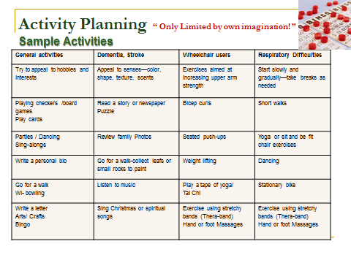
Maintaining resident records and documentation:
Key Terms:
CHAPTER 3:

Observation skills: what you see, what you hear, what you smell, and what you touch, used to assess person’s condition and are categorized by: Subjective- what they say to you and Objective- what you observe.

Documentation: documents, records, etc., that are used to prove something or make something official

Records- "Medical records" means all communications related to a patient's physical or mental health or condition that are recorded in any form or medium and that are maintained for purposes of patient diagnosis or treatment, including medical records that are prepared by a health care provider or by other providers

Those keys terms are the basics of resident records it starts by what we observe, then what is documented and that equals all the parts of the medical record which is maintained and utilized in the care of the residents. Remember: Anything we need to document means we will need form(s) or means to record this information, rather its paper or electronic ensuring privacy and confidentiality are essential. Following the policy and procedures of the facility and the outlined regulations ensure the proof that services are provided based on resident needs and as outlined on the individual service plan.

Key Points of the Regulations

R9-10-803.C “Manager shall ensure” that there are policies and procedures for recordkeeping. These records include: Resident records (which is divided into Medical records and Financial records), Staff records, and Facility records.
R9-10-811 A medical record is established and maintained for each resident according to A.R.S. Title 12, Chapter 13, Article 7.1 this is a very extensive law regarding medical records for health care services organizations which as an ALF manager you will want to be familiar with.
R9-10-806 (C) A manager shall ensure that there are personnel records for each employee or volunteer.
Throughout R9-10-801 to R9-10-821 there are numerous requirements to document items such as i.e. Evacuations, Menus, Activity Calendars, etc. these all fall into the Facility records requirements.

Maintaining (Maintenance) Medical Records
A. Unless otherwise required by rule or by federal law, a health care provider shall retain the original or copies of a patient's medical records as follows:
1. If the patient is an adult, for at least six years after the last date the adult patient received medical or health care services from that provider.
All other records retention requirement are stated in the particular rule here are few examples:
Menus – 60 days
Activity Calendar – 12 months
Evacuation Records – 12 months
Employee Records– 24 months
Remember: Documentation is used to prove something or make something official. One of the primary reasons for deficiencies during DHS inspections and losing in litigation issues is the lack or poor documentation that the requirement or care need was met. Ensure and educate that your staff understands: Document! Document! Document!

Key Elements of a Resident File (chart)
Medical file will include but not be limited to the following:

- Resident’s Name (see face sheet) Date of move in or acceptance to facility
- Residency Agreement
- Admission record or room number ( as applicable)
- Previous address
- Social Security Number
- Move-in ( admission) date
- Referral source ( if applicable)
- Name, address and telephone number of:
  - Representative/responsible party
  - Primary Care Provider
  - Case Executive Director
  - Emergency Contacts
  - Funeral community preference
  - Hospital preference
- Health care Advanced Directives
- Orange form ( pre-hospital directives) if DNR
- POA, living wills (copy)
- Copy of insurance cards
- Recent photo of resident
- Records authorization release forms (2)
- Care notes
- Physician plan of care (move-in orders), Determination Statements( bedbound, behavior care, memory care)
- Diet order
- TB screening / any Lab results
- Medications Administration records
- ADL’s documentation sheet
- Personal Service plan, functional evaluations
- Food preferences form (questionnaire)
- Mailing list request form
- Activities / Social History
- Photo release form
- Community health or hospice documentation
- Amenities (outside sources) /services release form
- Resident orientation checklist ( includes residents rights, phone numbers, evacuation exits with 24 hours)
- Flu Vaccinations Consents
- Grievance Procedure
- Behavior , significant changes documentation, ADL’s Vital sign flow sheets
- Written notice of termination if applicable
- Date termed residency

Managing ancillary services:

In Article 1 R9-10-101. (19) Definitions "Ancillary services" means services other than medical services, nursing services, or health-related services provided to a patient. Remember: The residency agreement must include Services available from the ALF at an additional fee or charge. So a policy and procedure is written to address what we call these “ancillary services”. A form may be needed also to include any information about the fee or charges associated with those services. But at a minimum must be addressed in the residency agreement.

These are “in-house” services provide by the facility, but many times the facility may list or address with the resident or representative outside sources that are made available by the ALF that the resident may access. By addressing them as “ancillary” service this ensures the resident or representative are aware of any additional charges or fees associated with the services.

Some facilities do an “all-inclusive monthly fee” others do what we call “ala cart” by where the resident only pays for services they use. Below are examples of services that may be addressed in residency agreement that the facility may consider ancillary. This again, will vary from facility to facility.

Examples of Ancillary Services Charges:
The need for additional services may be mandated or needed during the residency, however charges for ancillary services are not included in the monthly fee and will be billed by / or for the ALF or service provider. Examples of such services are

- Beauty/ Barber Shop
- Escort to and from meal and activities
- Meal room trays
- Special diets
- Nutritional supplements
- Incontinency products
- Personal Care products ( shampoo, deodorant, toothpaste)
- Wound Care supplies
- Additional laundry services
- Additional housekeeping services
- Activities outings or events
- Medications pick –up service
- Transportation for appointments
- Service plans reviews and updates
- Pharmacy / Medication Services
- X-rays
- Podiatrist/Foot Specialist
- TB testing
- Vaccines (flu /pneumonia)
- Newspaper
- Home Health Agency
- Emergency medical transport
- Lab
- Mobile dentist services
Responding to and reporting specific incidents, accidents, and emergencies involving resident:
CHAPTER 1: REVIEW AND OTHER CONSIDERATIONS

CHAPTER 3:

Key Terms:
Accident” means an unexpected occurrence that causes harm to a resident. (Note: This definition became obsolete as of October 2013.) However, it is noteworthy look at the meaning of

Advocate: To speak, plead, or argue in favor of. Patient Advocate provides patients with arbitration, mediation and negotiation to settle issues with access to care, medical debt, and job retention related to their illness.

“Incident” which has been changed to “an unexpected occurrence that may or may not cause harm a resident” from “an occurrence or event that has the potential to cause harm to a resident.” So at this time there no clear understanding of what DHS means by “Accident”.

“Emergency” means an immediate threat to the life or health of a patient.

“Medical services" means the services that pertain to medical care and that are performed at the direction of a physician on behalf of patients by physicians, dentists, nurses and other professional and technical personnel

“Injury" Harm or damage: an act or event that causes someone or something to no longer be fully healthy or in good condition.”

Definition: R9-10-101.112 “Immediate jeopardy” means a situation in which a patient or resident has suffered or is likely to suffer serious injury, serious harm, serious impairment, or death as a result of a licensee's noncompliance with one or more health and safety requirements

"Health care provider" means:
  - A physician licensed pursuant to title 32, chapter 13 or 17.
  - A doctor of naturopathic medicine licensed pursuant to title 32, chapter 14.
  - A midwife licensed pursuant to chapter 6, article 7 of this title.
  - A nurse midwife certified pursuant to title 32, chapter 15.
  - A nurse practitioner licensed and certified pursuant to title 32, chapter 15.
  - A physician assistant licensed pursuant to title 32, chapter 25.
  - A health care provider who is licensed or certified by another state or jurisdiction of the United States and who works in a federal health care facility

R9-10-819(D) When a resident has an accident, emergency, or injury that results in the resident needing medical services, a manager shall ensure that a caregiver or an assistant caregiver:
Immediately notifies the resident’s emergency contact and primary care provider; and Documents the following:
        - The date and time of the accident, emergency, or injury;
        - A description of the accident, emergency, or injury;
        - The names of individuals who observed the accident, emergency, or injury;
        - The actions taken by the caregiver or assistant caregiver;
        - The individuals notified by the caregiver or assistant caregiver; and
        - Any action taken to prevent the accident, emergency, or injury from occurring in the future.
Student Activity: Prepare Incident report for resident who has fallen see handout
Reporting Deaths
R9-10-803 (K)
A manager shall provide written notification to the Department of a resident’s:
      - Death, if the resident's death is required to be reported according to A.R.S. § 11-593, within one working day after the resident’s death; and

      - Self-injury, within two working days after the resident inflicts a self-injury that requires immediate intervention by an emergency services provider.

      - Elopement, within 24 hours of the elopement being discovered (Effective 7-1-25)

A.R.S. 11-593 Reporting of certain deaths; failure to report; classification
Any person having knowledge of the death of a human being including a fetal death shall promptly notify the nearest peace officer of all information in the person's possession regarding the death and the circumstances surrounding it under any of the following circumstances: (note most circumstances do not apply or would rather occur in ALF. But, managers must know what those circumstances are and when to report.

Key Points to Know and Study:
- Key terms
- What would a policy and procedure look like?
- Know when and how to report deaths or self-inflicted episodes that resulting in needing medical attention
- Requirements of documenting the incident reports
- Educating staff on reporting incidents to emergency contacts, medical providers, and other per policy & procedure of the facility
- Requirements for following up and Quality Management Reviews of all incident reports

Quality Management
As per requirements R9-10-804 the manager shall ensure that a plan is established, documented, and implemented for an ongoing Quality Management Program to include at a minimum the following:

- Method to identify, document and evaluate resident incidents

- Method to collect data to evaluate services provided to residents, including contracted services
- Method to evaluate the data collected to identify a concern about the delivery of services related to resident care

- Method to make changes or take action as a result of the identification of a concern about the delivery of services related to resident care

- Establish frequency of submitting a documented report to the governing authority

Student assignment: Develop QM policy and procedure –discuss how it will be implemented?
SAMPLE : Quality Management Monthly Indicators Report
Year:____________
- January-March Manager’s Signature of Review:____________________________ Date___________
- April-June Manager’s Signature of Review:____________________________ Date___________
- July-September Manager’s Signature of Review:____________________________ Date___________
- October-December Manager’s Signature of Review:____________________________ Date___________
Quality Indicators Reviewed
FALLS
# Residents found on floor
# Found down other location
# Slipped on floor
#Fell or slipped from bed
# Fell or slipped from W/C
# Occurring while transferring themselves
# Occurring while being transferred by staff
# Resident reported incident to staff
#Incidents witnessed by staff
# Incidents Staff Discovered the Resident
# Residents with more than 1 fall each month
Types of Injuries from Falls
# Falls with no injury
#Falls with minor injuries
#Falls requiring 911 and ER visits
#Falls resulting in hospitalization
#Falls with reported fracture
#Falls with head trauma
#Falls with multiple injuries
Skin Issues Reported
# of Skin Tears
# Residents with bruising
#Residents with wounds
#Stage 1 pressure sores
#Stage 2 pressure sores
#Stage 3 pressure sores w/ nurse oversight
#Stage 4 pressure sores w/ nurse oversight
Nutrition Monitoring
# of Residents with unwanted wt. loss
# of Residents with wt. gain
# Residents w/ dehydration = hospital visit
# Residents w/ diabetic crisis = hospital visit
Behavior Monitoring
# Residents with wandering behavior
# Residents of Elopement Incidents
# Residents with Altercations with other residents
# Residents with Other behaviors requiring staff interventions
# Alleged Abuse/Neglect or Exploitation Reported
Medication Variances Reported
# of Medication Errors / Adverse Reactions
# of Medication Refusals
Outside Agencies or Equipment Support
# Residents on Hospice
# Residents on Home Health Services
# of Hoyer lifts , slide boards, or other devices used to transfer
Incident Reports Follow up/Notifications
#Action Plans requiring Staff Training
# Failure or unable to notify emergency contact or POA
# Failure or unable to notify resident’s medical practitioner
#Medical (non-fall) reports requiring 911 to be activated
# of Reported Elopements and outcome
Manager Signed all incidents ( Yes or No)
Total # of Incident reports each month

Managing Dining Services

Key Terms:

Food supply- a recommended 3 day non-perishable food supply is always available in the event of disaster. Visit FEMA website on building kits; provides helpful tips (http://www.ready.gov/food)

Meals: Meals and snacks provided by the assisted living facility are served according to posted menus;

A meal is an eating occasion that takes place at a certain time and includes specific, prepared food, or the food eaten on that occasion.
- Breakfast is eaten within an hour or two after a person wakes in the morning
- Lunch or dinner is eaten around mid-day, usually between 11 am and 2 pm. In some areas, the name for this meal depends on its content. [
- Supper or dinner or tea is eaten in the evening. In some areas, the name for this meal depends on its content, but many English-speakers use "dinner" for this meal regardless of size.

“Residential unit" means a private apartment, unless otherwise requested by a resident, that includes a living and sleeping space, kitchen area, private bathroom and storage area

Key Points: Review and Study the Following Requirements mandated for “Food Services”

- Requirements technical termed as “Food Service Worker Cards”-applies to anyone who handles, sells, prepares, serves or gives away food for human consumption. (frequently called “food handlers card”)

- Menu preparation, posting, food substitution Meals and snacks serve per the menu
- Proper storage, preparing, refrigerating, freezing, cooking, and reheating food , proper temperatures
- Water available and accessible at all times, ensuring proper hydration of residents
- Diets / therapeutic manual and adaptive devices requirements
- Thermometer in both refrigerators and freezers
- ALC- license or permit as a food establishment has and maintains
- Soiled and clean linen requirement
- Poisonous or toxic materials storage
- Maintaining equipment in working order
- Tableware, utensils, equipment, and food-contact surfaces are clean and in good repair
- Requirements if kitchen in a residential unit (resident’s apartment) working, and capable of disconnecting or removing
Student Challenge: Pick one requirement above and write the policy and procedures for that requirement
Meal Planning: Meals and snacks for each day are planned using the applicable guidelines in http://www.health.gov/dietaryguidelines/2010.asp
Dietary Guidelines:
Estimated Calorie Needs per Day by Age, Gender, and Physical Activity Level.
Estimated amounts of calories needed to maintain calorie balance for various gender and age groups at three different levels of physical activity. The estimates are rounded to the nearest 200 calories for assignment to a USDA Food Pattern. An individual’s calorie needs may be higher or lower than these average estimates
46–50 | 2,200 | 2,400 | 2,800 | 1,800 | 2,000 | 2,200
51–55 | 2,200 | 2,400 | 2,800 | 1,600 | 1,800 | 2,200
56–60 | 2,200 | 2,400 | 2,600 | 1,600 | 1,800 | 2,200
61–65 | 2,000 | 2,400 | 2,600 | 1,600 | 1,800 | 2,000
66–70 | 2,000 | 2,200 | 2,600 | 1,600 | 1,800 | 2,000
71–75 | 2,000 | 2,200 | 2,600 | 1,600 | 1,800 | 2,000
76+ | 2,000 | 2,200 | 2,400 | 1,600 | 1,800 | 2,000

Meal Planning: Appendix 10. THE DASH EATING PLAN AT VARIOUS CALORIE LEVELS
CHAPTER 3:

The number of daily servings in a food group vary depending on caloric needs | 1,200 calories | 1,400 calories | 1,600 calories | 1,800 calories | 2,000 calories | 2,600 calories | 3,100 calories | Serving sizes
FOOD GROUPS | Servings | Servings | Servings | Servings | Servings | Servings | Servings | Serving Size Guide:
Grains | 4–5 | 5–6 | 6 | 6 | 6–8 | 10–11 | 12–13 | 1 slice bread 1 oz. dry cereal ½ cup cooked rice, pasta, or cereal
Vegetables | 3–4 | 3–4 | 3–4 | 4–5 | 4–5 | 5–6 | 6 | 1 cup raw leafy vegetable ½ cup cut-up raw or cooked vegetable ½ cup vegetable juice
Fruits | 3–4 | 4 | 4 | 4–5 | 4–5 | 5–6 | 6 | 1 medium fruit ¼ cup dried fruit ½ cup fresh, frozen, or canned fruit ½ cup fruit juice
Fat-free or low-fat Milk and Milk products | 2–3 | 2–3 | 2–3 | 2–3 | 2–3 | 3 | 3–4 | 1 cup milk or yogurt 1½ oz. cheese
Lean Meats, Poultry, and Fish | 3 or less | 3–4 or less | 3–4 or less | 6 or less | 6 or less | 6 or less | 6–9 | 1 oz. cooked meats, poultry, or fish 1 egg
Nuts,  Seeds, and Legumes | 3 per week | 3 per week | 3–4 per week | 4 per week | 4–5 per week | 1 | 1 | ¹⁄3 cup or 1½ oz. nuts 2 Tbsp. peanut butter 2 Tbsp. or ½ oz. seeds ½ cup cooked legumes (dried beans, peas)
Fats and Oils | 1 | 1 | 2 | 2–3 | 2–3 | 3 | 4 | 1 tsp soft margarine 1 tsp vegetable oil 1 Tbsp. mayonnaise 1 Tbsp. salad dressing
Sweets and added Sugars | 3 or less per week | 3 or less per week | 3 or less per week | 5 or less per week | 5 or less per week | < 2 | < 2 | 1 Tbsp. sugar 1 Tbsp. jelly or jam ½ cup sorbet, gelatin dessert 1 cup lemonade
Maximum Sodium limit | 2,300 mg/day | 2,300 mg/day | 2,300 mg/day | 2,300 mg/day | 2,300 mg/day | 2,300 mg/day | 2,300 mg/day

Food temperatures at a glance:
Foods requiring cooking are “cooked to heat all parts of the food” at least 145° F for 15 seconds, except the following:
Food | Temp | Additional Instructions
Ground beef and ground meats | 155° F | “cooked to heat all parts of the food”
Poultry, poultry stuffing, stuffed meats, stuffing with meat | 165° F | “cooked to heat all parts of the food”
Pork and any food containing pork | 155° F | “cooked to heat all parts of the food”
Raw shell eggs for immediate consumption | 145° F | For at least 15seconds
Any food containing raw shell eggs | 155° F | “cooked to heat all parts of the food”
Roast beef and beef steak | 155° F | an internal temperature
Leftovers are reheated | 165° F
A refrigerator used for food or medications | 41° F < | thermometer, accurate + or - minus 3° F, placed at the warmest part of refrigerator
Frozen food | 0° F <

Student Challenge:
- Develop a one week menu for a 75 year old Sedentary male using the above
- health.gov/dietaryguidelines/2010.asp as outlined in this chapter

Meal Services Challenges /Requirements
 “Food is the heart of the home”
- Planning and implementation- meet all nutritional needs, special or therapeutic diets, likes/dislikes, allergies, religious, cultural differences (food preferences forms)
- Availability of Snacks
- Qualified staff (may use a dietician) to ensure quality
- Food handler card requirements
- Tasty food, correct temps,
- Monitoring weights
- Facility functions
- Handling, storing, dishwashing, disposing of garbage
- Cleanliness of kitchen and appliances,
- Leftovers Remember—”when it doubt throw it out”
- Locking chemicals
- 5 Star dining experience

Preventing abuse, neglect, and exploitation:
CHAPTER 3:

Key Terms:

“Abuse" means:
(a) Intentional infliction of physical harm.
(b) Injury caused by negligent acts or omissions.
(c) Unreasonable confinement.
(d) Sexual abuse or sexual assault

“Neglect" - means a pattern of conduct without the person's informed consent resulting in deprivation of food, water, medication, medical services, shelter, and cooling, heating or other services necessary to maintain minimum physical or mental health.
Negligence - A failure to behave with the level of care that someone of ordinary prudence would have exercised under the same circumstances. The behavior usually consists of actions, but can also consist of omissions when there is some duty to act (e.g., a duty to help victims of one's previous conduct).

Exploitation - Illegal or improper use of a vulnerable adult or that adult's resources for another person’s profit or advantage. Exploitation may involve obtaining access to and misusing an older person's income, financial resources or real property, obtaining money fraudulently, charging for services riot provided, misuse of a Power of Attorney, and emotional pressure to change a will sign over property

Note: Caregivers or managers should not witness wills or other legal documents without checking first with the administrator or legal counsel. The only exception would be if the caregiver or manager is a relative of the resident. Caregivers should always be instructed to make sure that the manager is aware of any relationship between caregivers and residents in the facility.

“Ombudsman” means a resident advocate who performs the duties described in A.R.S. § 46-452.02

Reportable events- as health care workers there is a duty to report abuse, neglect and exploitation of vulnerable adults; duty to make medical records available; and violations to appropriate authority which could include, police, APS, and DHS as appropriate.

Related Regulations
- R9-10-803 (I) (J) Administration
- ARS 46-454 Duty to Report

New Employee Hiring Practices- APS Registry Search
Updated November 1, 2024
The purpose: of the APS Registry is to prevent vulnerable adults and children from being victimized by
individuals who have been found, through an APS investigation and due process, to have abused, neglected
or exploited a vulnerable adult.
Employers are encouraged to review the registry when deciding whether to employ a person to provide care
for vulnerable populations. The decision to hire a person listed on the APS Registry is solely up to the
employer.
You may search this link APS Registry(link is external) or through the Arizona Department of Health Services “AZ Care Check”. You can search by first name, last name, date of birth or by case information. The registry is updated twice a week on Tuesdays and Fridays.

SAMPLE POLICY: Abuse, Neglect, Exploitation- Prevention and Reporting
POLICY: Every Resident should be free from neglect, abuse and exploitation of any type. Any allegations of neglect or verbal, physical, mental or sexual abuse will be investigated and reported to the appropriate state agencies.
PROCEDURE:
- This Facility should not knowingly employ anyone who has been convicted of neglecting or mistreating individuals.
- All employees and volunteers should immediately report all incidents of alleged neglect or abuse to their Manager. .
- The Manager will notify APS or local law authorities of the alleged abuse, neglect or exploitation immediately.
- Any person who has a reasonable basis to believe that abuse or neglect of a vulnerable adult has occurred may report the information to a peace officer or to a protective services worker.
- If the alleged perpetrators are employed by the Facility, they will be suspended pending the completion of the investigation. The Employee will be reinstated if the allegation(s) are not substantiated. Appropriate disciplinary steps should be followed.
- The Manager will notify DHS within one business day of receiving any allegations.
- The Manager will direct the investigation, documentation and reports, with all law enforcement and agencies, if applicable.
- Manager may take or cause to be taken photographs of the abused resident and the vicinity involved.
- A written report will submitted to if applicable to DHS, APS, law enforcement agencies previously notified and a copy will be maintain on the premises for 12 months from date of the.
The report will include the following:
- Date, time & description of suspected or alleged abuse, etc.
- The names and addresses of the adult and any persons having control or custody of the resident, if known.
- The resident’s age and the nature and extent of the resident's vulnerability.
- The nature and extent of the injuries or physical neglect or of the exploitation of the resident's property.
- Any other information that the person reporting believes might be helpful in establishing the cause of the resident's injuries or physical neglect or of the exploitation of the resident's property.

- Any change in the resident’s physical, cognitive, functional, emotional condition
- Actions taken by the Facility
- Individuals and agencies notified by the Facility
- Names of witnesses of the event
- Actions taken by the Manager to prevent the suspected or alleged event from reoccurring.
Student Challenge: Review Above Policy- Does is met all the requirements for Abuse, Neglect, Exploitation- Prevention and Reporting? Study ways to prevent from chapter.

Accepting or retaining residents:
CHAPTER 3:

Key Terms:
"Accept" or "acceptance" means:
- An individual begins living in and receiving assisted living services from an assisted living facility; or
- An individual begins receiving adult day health care services or respite care services from an assisted living facility.

“Continuous" means available at all times without cessation, break or interruption

"Medical services" means the services that pertain to medical care and that are performed at the direction of a physician on behalf of patients by physicians, dentists, nurses and other professional and technical personnel.
"Nursing services" means those services that pertain to the curative, restorative and preventive aspects of nursing care and that are performed at the direction of a physician by or under the supervision of a registered nurse licensed in this state.

Restraint: means any physical or chemical method of restricting a patient’s freedom of movement, physical activity, or access to the patient’s own body.

“Scope of services” means a list of the behavioral health services or physical health services the governing authority of a health care institution has designated as being available to a resident at the health care institution.

Tuberculosis (TB) is a potentially serious infectious disease that mainly affects your lungs. The bacteria that cause tuberculosis are spread from one person to another through tiny droplets released into the air via coughs and sneezes

Residency: Accepting and or Retaining a Resident

R9-10-807 (A)(C)
A manager shall ensure that a resident provides evidence of freedom from infectious tuberculosis:
      - Before or within seven calendar days after the resident’s date of occupancy, and
      - As specified in R9-10-113.

Will Submit documentation within 90 days as to wheteher the resident requires
- continuous medical services, continuous or intermittent nursing services or restraints.
- The documentation must be dated and signed by a Medical Practitioner, Registered Nurse Practitioner, Registered Nurse or a Medical Practitioner Assistant.
- If the individual is requesting or is expected to receive behavioral health services, documentation of such signed by a behavioral health professional

C. A manager shall not accept or retain an individual if: The individual requires continuous:
- Medical services;
- Nursing services, unless the assisted living facility complies with statue( definition-nursing services as stated above); or
- Behavioral health services;
- The assisted living services needed by the individual are not within the assisted living facility’s scope of services;
- The assisted living facility does not have the ability to provide the assisted living services needed by the individual; or
- The individual requires restraints, including the use of bedrails
Terms:
“Resident” means a patient admitted to a nursing care institution with the expectation that the patient will be present in the nursing care institution for more than 24 hours.

“Resident's representative” means a resident's legal guardian, an individual acting on behalf of a resident with the written consent of the resident, or a surrogate under A.R.S. § 36-3201

Cognitive Impairment:
Developing systems for managing residents with dementia, Alzheimer’s Disease, or difficult behaviors
CHAPTER 3:

Key Terms:

Alzheimer’s is the most common cause of all dementias Specific changes in the brain have been found, no cure or prevention at this time, causes loss of memory, thinking/ reasoning problems and inability to care for one’s self

Behavior- manner of behaving or acting. When a resident acts in a manner deemed unsafe, with risk
immediate harm to self or others the facility must have policies and procedures in place that direct the staff in
managing the unsafe/harmful behavior

“Behavioral care": Means limited behavioral health services, provided to a patient whose primary admitting diagnosis is related to the patient's need for physical health services, that include:
Assistance with the patient’s psychosocial interactions to manage the patient’s behavior that can be performed by an individual without a professional license or certificate including:
- Direction provided by a behavioral health professional, and
- Medication ordered by a medical practitioner or behavioral health professional; or
- Behavioral health services provided by a behavioral health professional on an intermittent basis to address the patient’s significant psychological or behavioral response to an identifiable stressor or stressors; and
- Does not include court-ordered behavioral health services.

"Behavioral health services" means medical services, nursing services, health-related services, or ancillary services provided to an individual to address the individual's behavioral health issue.

Dementia-is a medical term used to describe a group symptoms or syndrome that is caused by certain diseases, temporary illnesses, or conditions. Described as the permanent and progressive loss of the ability to think and remember

Psychosocial adjustment- relating social conditions to mental health. Social influences such as peer pressure, parental support, cultural and religious background, socioeconomic status, and interpersonal relationships all help to shape personality and influence psychological makeup. Individuals with psychosocial disorders frequently have difficulty functioning in social situations and may have problems effectively communicating with others

Psychotropic medication means a chemical substance that: Crosses the blood-brain barrier and acts primarily on the central nervous system where it affects brain function, resulting in alterations in perception, mood, consciousness, cognition, and behavior; and is provided to a patient to address the patient’s behavioral health issue.

“Secured” means the use of a method, device, or structure that:
a. Prevents a resident from leaving an area of the nursing care institution's premises, or
b. Alerts a personnel member of a resident's departure from the nursing care institution
Traumatic brain injury (TBI), also known as intracranial injury, occurs when an external force traumatically injures the brain

“General Consent” means a situation in which no one present objects to a proposal.

“Informed Consent” means consent given by the patient based on knowledge of the procedure to be performed, including its risks and benefits, as well as alternatives to the proposed treatment.

Behavior Health Services: if the ALF plans on providing behavioral health services (BHS) then the manager will need to ensure proper licensure requirements ( R9-10-802)are met and policies and procedures are established, documented, and implemented that cover general and informed consent;
Further that those who request or receive Behavior Care (R-10-812) that a Behavior Health Professional (BHP) or Medical Practitioner:
- Evaluates 30 calendar days before beginning to receive behavior care and every 6 months during need of behavior care
- Reviews the ALF’s scope of services and signs and date determination statement for retention and that needs are being met by the ALF (often called “Request for Continued Residency”)

And that Behavior Health Services (R9-10-812) other than “behavior care”
- Are provider under direction of a BH professional
- Comply with requirements of BHP and BHT
- Assessment requirement
- The BHP evaluates 30 calendar days before acceptance and every 6 months during need of BHS
- That the BHP review the ALF’s scope of services and signs and date determination statement for
retention and that needs are being met by the ALF (often called “Request for Continued Residency”)
CHAPTER 3:

REMEMBER: Understanding Behavior Care and Dementia as Related to Service Plan R9-10-808(F)

If a resident is not receiving assistance with the resident's psychosocial interactions under the direction of a behavioral health professional or any other behavioral health services at an assisted living facility,

The resident is not considered to be receiving behavioral care or behavioral health services from the assisted living facility if the resident:
1. Is prescribed a psychotropic medication, or
2. Is receiving directed care services and has a primary diagnosis of:
a. Dementia,
b. Alzheimer's disease-related dementia, or
c. Traumatic brain injury (TBI)

36-405.03. Memory care services standards; rules; staff training requirements; definition
D. For the purposes of this section, "memory care services" means services that support individuals with dementia and other progressive and neurodegenerative brain disorders, including specialized environmental features, care planning, directed care services, medication administration services, specialized accommodations, activity programming or other services required by the department in rule
R9-10-816. Memory Care Services
A. If an assisted living facility is authorized to provide directed care services, a manager shall ensure that:
1. Policies and procedures for memory care services are established, documented, and implemented to cover the following:
a. Skills and knowledge necessary for the personnel member to provide the expected memory care services;
b. Interventions used for behavior management;
c. Systems to accommodate visitors, staff, and residents who do not need controlled egress;
d. The requirements in R9-10-815(C)(8) regarding the prevention of unsafe wandering or exit seeking, which may include the use of tracking systems;
e. Promotion of nutrition and hydration care;
f. Evacuation and emergency procedures specific to residents receiving memory care services, that include the requirements in R9-10-819(A)(5);
g. Prevention techniques of elopement and responding to elopement incidents promptly and effectively;
h. Monitoring residents receiving memory care services in outdoor areas on the premises;
i. Specialized environmental features to support memory care that include:
i. Secure areas to prevent wandering and spaces designed for cognitive stimulation and engagement; and
ii. Strategies for providing person-centered care that aligns with the principles of dementia-friendly environments, including familiar surroundings, optimized sensory stimulation, and meaningful activities; and
j. Specialized accommodations and progressive support for activities of daily living tailored to persons living with dementia following evidence-based best practices;

2. Activities that match the resident's cognitive ability, memory, attention span, language, reasoning ability, and physical function;

3. For a resident who requests or receives memory care services from the assisted living facility, a medical practitioner:
a. Evaluates the resident within 30 calendar days before acceptance of the resident and at least once every six months throughout the duration of the resident’s need for memory care services;
b. Reviews the assisted living facility’s scope of services; and
c. Signs and dates a determination stating that the resident’s needs can be met by the assisted living facility within the assisted living facility’s scope of services and, for retention of a resident, are being met by the assisted living facility;

4. There is staffing to ensure adequate supervision and care for residents receiving memory care services;

5. In an assisted living facility where residents are housed in two or more detached buildings, or if a building has distinct and segregated areas, a designated caregiver must be awake and available in each building and each segregated area at all times; and

6. If applicable, staffing is increased to compensate for the evaluated care and service needs of residents at move-in or for the changing physical or cognitive needs of the residents.

B. A manager shall ensure that staff obtain a certificate of completion, as specified in R9-10-126 (See personnel requirements)
Key Terms:

“Accept" or "acceptance" means: .An individual begins living in and receiving assisted living services from an assisted living facility; or an individual begins receiving adult day health care services or respite care services from an assisted living facility.

Acute: word used to describe a disorder with rapid onset and relatively short recovery time, usually unexpected and last 14-30 days (Examples are a short-term illness or injury)

Chronic: a word used to describe a disorder or illness that in ongoing expanding possible over lifetime

Pressure ulcers, also known as decubitus ulcers or bedsores, are localized injuries to the skin and/or underlying tissue that usually occur over a bony prominence as a result of pressure, or pressure in combination with shear and/or friction. Pressure sores are categorized by severity, from Stage I (first sign) to Stage IV (worst)

“Hospice" means a hospice service agency or the provision of hospice services in an inpatient facility.

“Hospice service" means a program of palliative and supportive care for terminally ill persons and their families or caregivers

Home Health Agency- Care provided by licensed healthcare professionals who provide medical care needs in an individual’s home (such as a resident living in ALF)

Personal Care services: Means assistance with activities of daily living that can be performed by persons without professional skills or professional training and includes the coordination or provision of intermittent nursing services and the administration of medications and treatments by a nurse who is licensed pursuant to title 32, chapter 15 or as otherwise provided by law.

Accepting or Retaining Residents:
CHAPTER 1: REVIEW AND OTHER CONSIDERATIONS

CHAPTER 3:

Review R9-10-807
A manager shall not accept or retain an individual if: The individual requires continuous:
- Medical services;
- Nursing services, unless the assisted living facility complies with statue( definition-nursing services as stated above); or
- Behavioral health services;
- The assisted living services needed by the individual are not within the assisted living facility’s scope of services;
- The assisted living facility does not have the ability to provide the assisted living services needed by the individual;
- The individual requires restraints, including the use of bedrails
Accepting or Retaining Residents Personal Care:
In addition to the stated above issues R9-10-814 (A) states: If ALF is authorized to provide personal care services (only) shall not accept or retain a resident who:
      - Is unable to direct self-care;
      - confined to a bed or chair because of an inability to ambulate even with assistance; or
      - has a stage 3 or stage 4 pressures sore, as determined by a registered nurse or medical practitioner.
Exception - Confined to bed/chair inability to ambulate:
If ALF is authorized to provide personal care services

R9-10-814 (B) ALF may accept or retain a resident who is confined to a bed or chair because of an inability to ambulate even with assistance if:
      - The condition is a result of a short-term illness or injury; or

      - The following requirements are met at the onset of the condition or acceptance the ALF:
        - The resident or resident’s representative requests be accepted by or remain in ALF

        - The resident's primary care provider or other medical practitioner:
          - Examines at the onset of the condition, or within 30 calendar days before acceptance, and at least once every 6 months during the condition;
    - Reviews the assisted living facility’s scope of services; and
    - Signs and dates a determination stating (often called “Request for Continued Residency”) resident’s needs can be met by ALF, within the scope of services and, for retention of a resident, are being met; and
- Service plan includes the need for personal care services.

Exception - Stage 3 or 4 pressure sore: If ALF is authorized to provide personal care services
R9-10-814 (C) may accept or retain a resident who has a stage 3 or stage 4 pressure sore, as determined by a registered nurse or medical practitioner, met same requirements for the above “Request for Continued Residency”

Exception - Nursing Services: If ALF is authorized to provide personal care services
R9-10-814 (D) may accept or retain a resident who:
- Is receiving nursing services from a home health agency or a hospice service agency; or
- Requires intermittent nursing services if:
        - The resident’s condition for which nursing services are required is a result of a short-term illness or injury, and
  - Mets same requirements stated above for “Request for Continued Residency”.

Remember: Additional service plan requirements as covered in Service plan section

Intermittent Nursing Services: Note: intermittent nursing services- means health care professional provides medical services with what may be 1-2 hour visits several times per week. This is not continuous nursing services, which is not allowed in ALF.
CHAPTER 1: REVIEW AND OTHER CONSIDERATIONS

CHAPTER 3:

Intermittent nursing services maybe need for many medical reasons to support the care and needs of the ALF resident. These services may be provided by a Hospice or Home Health Agency. The following are just a few examples of acute or chronic illnesses (along with a brief definition) that might require supportive outside service such as intermittent nursing services:

Memory Care Services: For a resident who requests or receives memory care services- determination
statement as noted in R9-10-816A.3 previously in this chapter

Acute and Chronic Illness Terms
- Arteriosclerosis is the thickening; hardening and loss of elasticity of the walls of arteries, commonly refer to as hardening or the arteries.
- Arthritis: is a form of joint disorder that involves inflammation of one or more joints. There are over 100 different forms of arthritis. The most common form, osteoarthritis (degenerative joint disease), is a result of trauma to the joint, infection of the joint, or age. Other arthritis forms are rheumatoid arthritis, psoriatic arthritis, and related autoimmune diseases.
- Falls: Caused often by slips or trips. Falls are one of the leading causes of unintentional injuries in the United States, accounting for approximately 8.9 million visits to the emergency department annually (NSC Injury Facts 2011). Adults 55 and older are more prone to becoming victims of falls, and the resulting injuries can diminish the ability to lead active, independent lives. The number of fall deaths among those 65 and older is four times the number of fall deaths among all other age groups.
- CHF- Congestive Heart Failure: Heart failure occurs when the heart muscle has been severely damaged and fails to pump effectively. Blood will back up into the heart instead of circulating causing congestive heart failure.
- COPD is a chronic disorder that groups three other chronic disorders under this umbrella which are bronchitis, emphysema, and asthma. This condition affects the airways and the air sacs, less air goes in to the lungs and less air gets out of the lungs. The airways and air sacs become less elastic; they act like old rubber bands. The walls between the air sacs are destroyed. Walls of the airway become thick inflamed and swollen. The airways of the lungs secret more mucous than normal, this extra mucous clogs the airway
- C.V.A. - is a stroke which is caused by blood supply to the brain being cut off suddenly by either a clot or rupture blood vessel. A stroke is also called a C.V.A.-Cerebral Vascular Accident. When that part of the brain doesn’t receive oxygenated blood and nutrients the brain cells die. This causes brain damage. Whatever that part of the brain controlled for function it is now gone. Stroke is the third leading cause of death.
- Depression- condition of persistent sadness, anxiousness, or "empty" mood. Feelings of guilt, hopelessness, worthlessness, pessimism. Loss of interest or pleasure in hobbies and activities that were once enjoyed
- Diabetes*- the pancreas is responsible for producing insulin which is needed to move sugar from our blood stream to each of our cells for energy. Without insulin sugar will collect in the blood stream depriving the cells nutrients to work this cause increase glucose levels commonly known as diabetes.(disorder that results when the pancreas is unable to produce enough insulin)
- Osteoarthritis--Degeneration of the joints; increased pain. Most common form of arthritis
- Osteoporosis is a disease where the bones are brittle and break easily
- Parkinson disease is a slow progressive disorder with no cure. Parkinson’s is characterized by tremors, stiffness, speech difficulties and problems initiating movement
- Pressure ulcers, also known as decubitus ulcers or bedsores, are localized injuries to the skin and/or underlying tissue that usually occur over a bony prominence as a result of pressure, or pressure in combination with shear and/or friction. Pressure sores are categorized by severity, from Stage I (first sign) to Stage IV (worst
- Skin Tears: Traumatic wound occurring on the extremities of older adults as a result of friction alone or shearing and friction forces
- Terminal illness: An illness or condition from which recovery is not expected

Note: A bell, intercom, or other mechanical means to alert employees to a resident's needs or emergencies is available in a bedroom or residential unit being used by a resident receiving personal care services.

*Chapter 8: “Medication Management” will cover understanding and managing Diabetes.

Directed Care Services: Means programs and services, including supervisory and personal care services, that are provided to persons who are incapable of recognizing danger, summoning assistance, expressing need or making basic care decisions
CHAPTER 3:

R9-10-815 Directed Care Services states:
A manager shall ensure that a resident’s representative is designated for a resident who is unable to direct self-care

“Representative” means a patient’s legal guardian, an individual acting on behalf of the patient with the written consent of the patient, or a surrogate as defined in A.R.S. § 36-3201

“Surrogate" means a person authorized to make health care decisions for a patient by a power of attorney, a court order or the provisions of section 36-3231.
Examples of Surrogates are:
1. The patient's spouse, unless the patient and spouse are legally separated.
2. An adult child of the patient. If the patient has more than one adult child, the health care provider shall seek the consent of a majority of the adult children who are reasonably available for consultation.
3. A parent of the patient.
4. If the patient is unmarried, the patient's domestic partner.
5. A brother or sister of the patient.
6. A close friend of the patient

Accepting or Retaining Residents Directed Care: A manager of an assisted living facility authorized to provide directed care services shall not accept or retain a resident who, except as provided in R9-10-814(B)(2): (“Request for Continued Residency”)
  - 1. Is confined to a bed or chair because of an inability to ambulate even with assistance; or
  - 2. Has a stage 3 or stage 4 pressure sore, as determined by a registered nurse or medical practitioner.
  - 3. For a resident who requests or receives memory care services- determination
statement as noted in R9-10-816A.3 previously in this chapter
Remember: Additional service plan requirements as covered in Service plan section

Making needs known: R9-10-815 (E) A manager shall ensure that:
1. A bell, intercom, or other mechanical means to alert employees to a resident's needs or emergencies is available in a bedroom being used by a resident receiving directed care services; or
2. An assisted living facility has implemented another means to alert a caregiver or assistant caregiver to a resident's needs or emergencies.

Wandering: R9-10-815 (F) (1) ( will discuss Elopement drills in safety)
Policies and procedures are established, documented, and implemented that ensure the safety of a resident who may wander;

A caregiver or an assistant caregiver complies with the requirements for incidents in R9-10-804 (as covered in Quality
Management) when a resident who is unable to direct self-care wanders into an area not designated by the governing authority for use by the resident. R9-10-815 (F) (3)
Access to outdoors R9-10-815 (F)(2) There is a means of exiting a resident who does not have a key, special knowledge for egress, or the ability to expend increased physical effort that meets one of the following:
a. Provides access to an outside area that:
i. Allows the resident to be at least 30 feet away from the facility that is secure, and
ii. Monitors or alerts employees of the egress of a resident from the facility;
b. Provides access to an outside area:
i. From which a resident may exit to a location at least 30 feet away from the facility, and
ii. Monitors or alerts employees of the egress of a resident from the facility; or
  - Uses a mechanism that meets the Special Egress-Control Devices provisions in the Uniform Building Code incorporated by reference in A.A.C. R9-1-412;

Difficult Behaviors: In addition to the behavior of wandering there may be other behaviors the resident may exhibit. How will your facility handling behaviors, will there be additional training for the staff and
CHAPTER 3:

Remember: By law R9-10-811 (15) If applicable, documentation of any actions taken to control the resident's sudden, intense, or out-of-control behavior to prevent harm to the resident or another individual. We must consider these things also when we are establishing, documenting and implementing policies and procedures for those receiving directed care services

Behavior Definitions:

Here are just a few examples and definition of behaviors seen and approaches for preventing or handling difficult behaviors:

Hoarding is collecting things and putting them away in a guarded fashion. In the Alzheimer’s disease/dementia patient this should not be considered stealing.

Pacing is when a resident walks back and forth in the same area.

Perseveration is the uncontrolled repetition such as a behavior, word, questions, thought, or activity

Pillaging is taking things that do not belong to a person

Refusal (meals, cares) - person denies assistance with care or refuses to eat may be caused by fear or decrease cognitive abilities, requires staff using gentle reassurance, guidance or cueing to complete tasks. Reporting and documenting any refusal of care or service is essential by the care staff.

Sun downing_ —person becomes more confused, restless and insecure late in the day, especially at sundown and dark. Be Reassuring, help express what or who they are looking for

Violent Behavior- This behavior includes hitting, grabbing, pinching, threatening, biting, and swearing. Their behavior may result from agitation or restlessness. Sometimes these behaviors are personality traits.

Wandering is where a resident walks around aimlessly

Behavior Interventions
When you have to do something!

- Behavior significantly violates rights of others, others w/ dementia, family, & staff? Example- take other’s possessions

Does the behavior pose a significant threat to someone’s health and safety?
- Example- violence of refusing health related medications or treatments

Non-medication intervention for managing difficult behaviors:
CHAPTER 1: REVIEW AND OTHER CONSIDERATIONS

Prevention– get them engaged doing something. Meeting needs-thirsty, hungry, toilet, comfort (hot or cold), ill, Pain – being in control (offer choices)

Redirection– 3 types
a. Topic/Subject
b. Object
c. Activity

Reminiscence Therapy is encouraging residents to remember and talk about the past. Explore their memories and ask about details. Talk about the time of life that was pleasant
CHAPTER 1: REVIEW AND OTHER CONSIDERATIONS

Validation Therapy is letting the resident believe they live in the past or in imaginary circumstances. Make no attempt to reorient the resident to the present time as this creates anger and agitation.

Alzheimer's and Music Therapy
CHAPTER 3:

The following are some tips for using music to help a loved one with Alzheimer's:

- Go for familiar music. Music from a person’s young adult years, ages 18 to 25, will most likely prompt the strongest responses. However, watch closely to make sure the music doesn't provoke agitation due to an unknown, possibly upsetting link to the person’s past.

- Try some new tunes. Unfamiliar music can be helpful because it isn't linked to any memories. That way, you can play a happy or relaxing song without worry that it will trigger an emotional memory.

- Pay attention to tempo. Stimulating music with percussive sounds and quick tempos will promote movement, and can help when trying to get Alzheimer's patients to eat, bathe, or get dressed. Sedating music with unaccented beats and slow tempos is good for calming purposes, and can be used to help your loved one relax before bedtime or calm down after being agitated.

- Skip the commercials. Use only tapes or CDs to play music, as radio shows might include commercials that would confuse the Alzheimer's patient. Also be sure to limit competing stimuli by turning off the television and closing windows and doors.
Alzheimer's and Other Therapies
There are a number of other approaches that can bring enjoyment to someone with Alzheimer’s and help reduce some of their upsetting emotional reactions.

These include:
- Pet therapy has been shown to reduce symptoms of Alzheimer’s-related depression and to boost self-esteem. For the best results, make sure the person likes animals before bringing one around. Also, take care to match the right sort of pet to the person; someone with good coordination might enjoy taking an energetic dog for a short walk, but that wouldn't be good for someone whose mobility is limited. A less mobile person might better mesh with a cat or a smaller, mellower dog.

- Art therapy can stimulate a person's imagination and allow them to express feelings that are difficult to articulate. Just be sure to keep the project on an adult level, be ready to help out if needed, and make sure all materials are safe and nontoxic.

- Religious activities can provide a feeling of peace to an Alzheimer's patient, and can also allow them a chance to remain connected to the world. A Sunday school group is a good way for your residents to stay mentally active and socially involved

- Aromatherapy, or the therapeutic use of oil-based scents, is another means of drawing a person out through their senses. Aromatherapy is important because it can help recall memories, and helps the person feel connected to nature.

- Storytelling or scrapbooking also can be an engaging way to give an Alzheimer's patient a lift. Find a quiet place in your home and try to engage your loved one by asking about the history behind old family photos, or by showing them pictures and asking them to come up with a story based around what's seen in the picture.

The Bottom Line: A variety of non-medical therapies can be useful as part of an Alzheimer's treatment plan



Chapter 4 Human Resources Management
Maintaining Employee Records:
“Employee Records” (or sometimes called “personnel file)
R9-10-806 (C) A manager shall ensure that a personnel record for each employee or volunteer:
Includes:
- name, date of birth, and contact telephone number;
- starting date of employment or volunteer service and, if applicable, the ending date; and
Documentation of:
- Qualifications, including skills and knowledge applicable to the individual’s job duties;
- Completed orientation and in-service education required by policies and procedures;
- License or certification as required to be licensed or certified in this Article or in policies and procedures;
- If is a behavioral health technician, clinical oversight required in R9-10-115;
- Evidence of freedom from infectious tuberculosis, On or before the date the individual begins
- Cardiopulmonary resuscitation training,
- First aid training,
- Documentation of compliance with fingerprint clearance requirements ARS36-411 (A) & (C)
- The certificate of completion , according to R9-10-126 ( Memory Care Services)

References???
Manager shall ensure there is Documentation of:
- The type and duration of experience that may allow the caregiver or assistant caregiver to have acquired the specific skills and knowledge for the caregiver or assistant caregiver to provide the expected assisted living services, behavioral health services or behavioral care listed in the established job description (suggest- job reference checks- per facility policy)
- Policy should address:
- How many references required such as: 2 personal -2 professional to include name, address, phone #’s
- Make “GOOD FAITH” effort to verify!!
- Documentation that you verified
- Keep in file

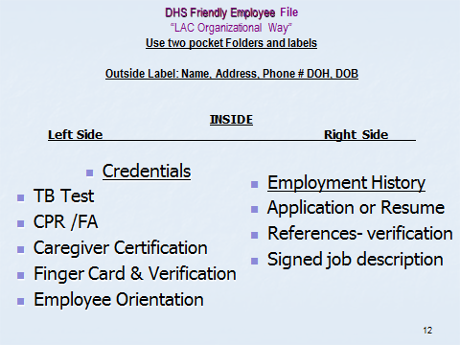
CHAPTER 4:

Let’s also exam
Regulations Guiding HR Practices-

Key Terms: Personnel Management
CHAPTER 4: Human Resources Management

The Fair Labor Standards Act of 1938” (abbreviated as FLSA; also referred to as the Wages and Hours Bill]) is a federal statute of the United States. The FLSA introduced the forty-hour workweek, established a national minimum wage, guaranteed "time-and-a-half" for overtime in certain jobs and prohibited most employment of minors in "oppressive child labor", a term that is defined in the statute.

Hiring: consists of putting right number of people, right kind of people at the right place, right time, doing the right things for which they are suited for the achievement of goals of the organization

Interviewing questions: A job interview is a type of employment test that involves a conversation between a job applicant and representative of the employing organization. Care to avoid questions regarding age, sex, religion, health, medical history, arrest records unless the questions are considered a “Bona fide occupational qualification.” (See NAB text pg. 40-41)

Personnel File- is a collection of either electronic or printed material which provides a documentary history of a person's activities and accomplishments while serving as a member of a given organization. Personnel file offer contains documents pertinent to the employment such as; credentials, education, and skills required.

"Orientation" means the initial instruction and information provided to an individual before starting work or volunteer services in a health care institution. In assisted living employees must receive orientation before providing care or services of the residents that resides in the assisted living.

"Tax ID number" means a numeric identifier that a person uses to report financial information to the United States Internal Revenue Service.

Terminations- EMPLOYMENT TERMINATION: Termination of employment is an inevitable part of personnel activity within any organization, and many of the reasons for termination are routine. Below are a few examples of some of the most common circumstances when employment terminates:
- Resignation – voluntary employment termination initiated by an employee.
- Termination – involuntary employment termination initiated by employer
- Layoff – involuntary employment termination initiated by employer for non-disciplinary reasons. (Ex. decreasing workforce, poor sales, low census related etc.)

Staff Training- is programs or in-service meetings that maintains credentials such CPR/ First Aid or to enhance skills, knowledge, and abilities to perform task(s) required based on the employee’s job description or duties.

Sick Leave- (or paid sick days or sick pay) is time off from work that workers can use to stay home to address their health and safety needs without losing pay. Some workplaces offer paid sick time as a matter of workplace policy, and in few jurisdictions it is codified into law. Currently, the United States are considering legislation that would require access to paid sick days for workers

Wage garnishment, the most common type of garnishment, is the process of deducting money from an employee's monetary compensation (including salary); sometimes as a result of a court order. Wage garnishments continue until the entire debt is paid or arrangements are made to pay off the debt. Garnishments can be taken for any type of debt but common examples of debt that result in garnishments include:
- child support
- defaulted student loans
- taxes
- unpaid court fines
Workers' compensation is a form of insurance providing wage replacement and medical benefits to employees injured in the course of employment in exchange for mandatory relinquishment of the employee's right to sue his or her employer for the tort (legal fault) of negligence. Workers ‘ compensation statutes are designed to ensure that employees who are injured or disabled on the job are not required to cover medical bills related to their on-the-job injury, and are provided with monetary awards to cover loss of wages directly related to the accident, as well as to compensate for permanent physical disability.
CHAPTER 4:

Personal Management: What is PERSONNEL MANAGEMENT? The Law Dictionary Featuring Black's Law Dictionary Free Online Legal Dictionary (2nd Edition) defines it as:

The techniques used to manage (hire/ fire) employees of any organization, so as to increase their value. Personnel management techniques consist of selecting adequate people for the right job, with the right skills, job appraisal, training, ensuring effective communication within the tiers and making sure that employees are working up to their maximum productivity levels.

Before you hire or pay employees
Step 1 - Obtain an Employer Identification Number (EIN)
Step 2 - Set up Records for Withholding Taxes (3 types)
- Federal Income Tax Withholding
- Federal Wage and Tax Statement
- State Taxes
Step 3 - Employee Eligibility Verification
Step 4 - Register with Your State's New Hire Reporting Program
Step 5 - Obtain Workers' Compensation Insurance
Step 6 - Post Required Notices
Step 7 - File Your Taxes
Step 8 - Get Organized and Keep Yourself Informed *Note these will be discussed later in Chapter 7
Set up Recordkeeping- Federal employment laws (websites to consider)
- Tax Recordkeeping Guidance
- Labor Recordkeeping Requirements
- Occupational Safety and Health Act Compliance
- Employment Law Guide (employee benefits chapter)
- Apply Standards that Protect Employee Rights
- Complying with standards for employee rights in regards to equal opportunity and fair labor standards is a requirement. Following rules and regulations for minimum wage, overtime, and child labor will help you avoid error and a lawsuit. See the Department of Labor’s Employment Law Guide for up-to-date information on these rules and regulations.

Arizona State New Hiring Reporting Law Requirements:

Partnering with Employers to Guarantee the Support of our Nation's Children: Arizona Revised Rule 23-722.01 and the Personal Responsibility and Work Opportunity Reconciliation Act (PRWORA) of 1996, 42 U.S.C. 653a require that all employers report newly hired, and re-hired employees to a state directory within 20 days of their hire date.

Becoming mandatory in October, 1998, new hire reporting is now required by law in all 50 states. The State of Arizona works with employers to help ensure that all new hires are reported as required, as the Federal Office of Child Support Enforcement (OCSE) provides states with a quarterly report containing information on employers who may not have properly done so.

Staffing Process - 8 Steps involved in Staffing
- Manpower requirements (have job description developed for position you are hiring for)
- EOE ( equal opportunity employer)
- Recruitment
- Selection
- Orientation and Placement
- Training and Development-
- Remuneration
- Performance Evaluation
- Promotion and transfer
Arizona Assisted Living Regulations:
“Personnel” will outline requirements for recruiting, selecting, orientation, and training which all part of the staffing process.

Arizona Assisted Living Regulations: Personnel

R9-10-806 (A) Staff Qualification:

- A caregiver: Is 18 years of age or older; and Provides documentation of Completion of a caregiver training program
- An assistant caregiver is 16 years of age or older, and interacts with residents under the supervision of a manager or caregiver

R9-10-806(A) (3) (4) (5) Caregiver or Assistant Caregiver
CHAPTER 1: REVIEW AND OTHER CONSIDERATIONS

Have the qualifications, skills, and knowledge required based on the type of assisted living services, behavioral health services, or behavioral care expected to be provided according to the established job description; and
- The acuity of the residents
- Behavioral health services, or
- Behavioral care, and
Includes:
The specific skills and knowledge necessary
The type and duration of education and experience- how they acquired the specific skills and knowledge expected

Skills and knowledge are verified and documented: (reference checks)
- Before providing physical health services or behavioral health services, and
- According to policies and procedures;

An assisted living facility has a manager, caregivers, and assistant caregivers with the qualifications, experience, skills, and knowledge necessary to:
- Provide the all services, within the ALF’s scope of services;
- Meet the needs of a resident; and
- Ensure the health and safety of a resident;

R9-10-806(A) (7) A manager, a caregiver, and an assistant caregiver, or an employee or a volunteer provides evidence of freedom from infectious TB on or before start date if expected to work more than 8 hours per week at the ALF.

CHAPTER 4:

R9-10-806 (A) (8) (9) Before providing services:
- Receives orientation that is specific to the duties to be performed and
- Provides current documentation of First Aid training and CPR training

Assisted Living Homes (only)

R9-10-806(B) (1) (2) Manager shall ensure: that others who live in the home who are not a caregiver, assistant caregiver or manager

- Either complies with the fingerprinting requirements or interacts with residents only under the supervision of an individual who has a valid fingerprint clearance card; and

- If the individual is 12 years of age or older, provides evidence of freedom from infectious TB

- Documentation of compliance with the TB & fingerprint clearance (if obtained) requirements are maintained for an individual residing in the assisted living home

Awake Staff:
CHAPTER 4:

R9-10-806(A) (6)-Centers: At least one manager or caregiver is present and awake at an assisted living center when a resident is on the premises;

R9-10806 (B)(3) HOMES: At least the manager or a caregiver is present when a resident is present and except for nighttime hours, the manager or caregiver is awake; and

If the manager or caregiver is not awake during nighttime hours:
- The manager or caregiver can hear and respond to a resident needing assistance; and

- If the ALH is authorized to provide directed care services, policies and procedures are developed, documented, and implemented to establish a process for checking on a resident receiving directed care services during nighttime hours to ensure the resident's health and safety

Maintaining Employee Records:
Covered earlier in Maintaining Records we will review here also
Employee Records” (or sometimes called “personnel file)
R9-10-806 (C) A manager shall ensure that a personnel record for each employee or volunteer:
Includes:
- name, date of birth, and contact telephone number;
- starting date of employment or volunteer service and, if applicable, the ending date; and
Documentation of:
- Qualifications, including skills and knowledge applicable to the individual’s job duties;
- Completed orientation and in-service education required by policies and procedures;
- License or certification as required to be licensed or certified in this Article or in policies and procedures;
- If is a behavioral health technician, clinical oversight required in R9-10-115;
- Evidence of freedom from infectious tuberculosis, On or before the date the individual begins
- Cardiopulmonary resuscitation training,
- First aid training,
- Documentation of compliance with the requirements fingerprint clearance requirements
- The Certificate of completion, according to R9-10-126 (Memory Care Services) (effective 7-1-25)
Manager shall ensure there is Documentation of:
- The type and duration of experience that may allow the caregiver or assistant caregiver to have acquired the specific skills and knowledge for the caregiver or assistant caregiver to provide the expected assisted living services, behavioral health services or behavioral care listed in the established job description (suggest- job reference checks- per facility policy)
- Policy should address:
- How many references required such as: 2 personal -2 professional to include name, address, phone #’s
- Make “GOOD FAITH” effort to verify!!
- Documentation that you verified
- Keep in file

Staff Recurring Requirements

R9-10-806 requires staff that are providing assisted living services to a resident provides current documentation of first aid training and CPR training specific to adults, plus it requires maintaining current TB, current Fingerprint Clearance in A.R.S. § 36-411

R-9-803(C) (1) (b) and (e) (i-iv) Policy and Procedure Must Cover
- In-service education frequently called Continuing Education Units (CEU) and
- CPR / First Aid requirements and renewal as required by policy and procedures of the ALF

A.R.S. § 36-411- Fingerprint clearance requires renewal every 6 years-
NOTE: It is importance to track and alert caregivers about 90 days before expiration so there is no lapse in having proper clearance at all times. It could take DPS 8-12weeks to renew once renewal is requested

Evaluating personnel:
CHAPTER 2: REVIEW AND OTHER CONSIDERATIONS

CHAPTER 4:

There are no requirements for evaluating personnel in DHS rules, so this educational requirement is based upon generally accepted business practice. Most employers would agree that an effective employee evaluation consists of approximately five steps. Here are some example steps that could be used in an effective evaluation:

Step 1 - Defined Expectations
Step 2 - Create Goals
Step 3 - Provide Written Evaluation
Step 4 - Maintain a Performance Record.
Step 5 - Ensure Integrity of Evaluation

One of the first steps in the evaluation process is to define the expectation of the employee. Best practices would show that is typical accomplished via a “Job Description.” As we can see stated below, DHS required the ALF facility to develop a job description for Caregiver and Assistant Caregivers.

Job Descriptions:
R9-10-806(A) (3) Personnel
- A manager shall ensure that:
      - …
      - …
      - The qualifications, skills, and knowledge required for a caregiver or assistant caregiver:
        - Are based on:
          - The type of assisted living services, behavioral health services, or behavioral care expected to be provided by the caregiver or assistant caregiver according to the established job description, and
          - The acuity of the residents receiving assisted living services, behavioral health services, or behavioral care expected provided by the caregiver or assistant caregiver according to the established job description.

The purpose of job description is to define the duties and set requirements for filling the job. Prior to hiring a caregiver or an assistant caregiver a job description must be developed and maintained for the job to be performed. The previous job description will be used as a model in defining the present employee’s position if this position is being updated to a new position.

All job descriptions should include the following information:
- Title of position;
- Assigned organizational unit;
- Position in the hierarchy of the business (Example: Who does this position reports to? Who reports to this position? or maybe show the position on the organizational chart for the company.)
- Job summary or overview;
- Position qualifications [essential qualifications including job experience, skills, and education]; and
- Major duties and responsibilities.
These position descriptions can then be used to compare this position with similar positions of other companies which is one of the factors used in setting the pay scale of positions within our company. Management shall review all position descriptions annually to ensure equity and consistency within and across job families and functional lines.
In ALF: New Employee orientation must be completed before providing assisted living services to a resident.

Evaluations- Key Concepts
How often? Generally at 90days mark and annually
Purpose? Review performance and determine amount of pay increase
Employee Performance areas to consider in the evaluation: The Four A’s
- Ability
- Attendance
- Attitude
- Appearance
Allow employee feedback
Determine goals (setting and measuring)

Discipline and Termination Actions
CHAPTER 4:

Handbooks are helpful to outline reason for disciplinary actions up to and including termination.

Progressive Disciplinary Process includes:
Step 1 Oral Warning in private
Step 2 Written warning
Step 3 Suspension without pay
Step 4 Demotion
Step 5 Termination
List some reasons of disciplinary actions???

Termination of the Employee:

- What does, P & P says, handbooks, job descriptions?? Follow your steps or policy to avoid lawsuits.

- Be safe, focus on problem not person, have paper work for them to sign, final check ready, have a witness and

- avoid confrontation

Staff Turnover
- Annual turnover can be 100%- is expensive
- Can control by hiring right person(s) for the job
- Personality and work ethic important skills applicant needs to have
- Leadership
- Staff Morale
- Watch for trends
- Good Training and communications well will help
- Set Expectations-

When they leave - Exit interviews can give insight
- Ask the why questions
- Be open to listening, you want to learn from this process
- See pg. 52 NAB Text

Retention, Recognition & Benefits:

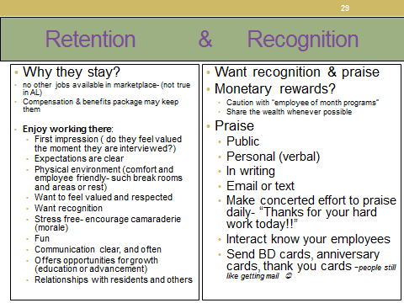

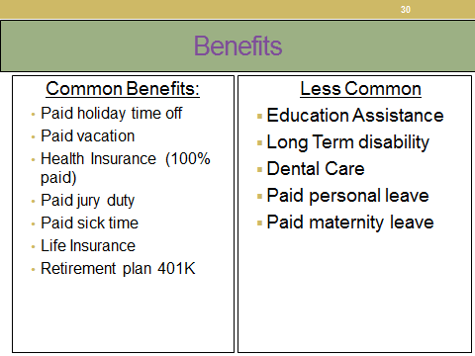

Chapter 5 Leadership & Governance (Legal Management)
CHAPTER 5:

Leadership and Governance:
- Read chapter 5 “NAB” Text pages 67-80 and do practice questions at end of chapter.
- It is important to be knowledgeable of key terms of the chapter pages 77-86

Overview:
The term “administrator” used throughout this chapter and book is the title that many states use to describe the person who has general administrative charge of the day-to-day operations of the ALF. He or she could be the owner or may have been hired by the organization. Licensing and/or certification requirements differ from state to state.

In Arizona, this person is called an Assisted Living Manager and are certified via statues of the state and governed by the Arizona Board of Examiners of Nursing Care Institution Administrators and Assisted Living Facility Managers (NCIA/ALFM). Commonly we call it and it is known as, “The NCIA Board”. We will examine the certification requirements of an Arizona Assisted Living Manager later in this chapter.

The scope of an administrator / manager responsibilities begins with understanding the philosophy of the AL. There is not one common definition to describe the services/care allowed or provided to residents in assisted living through-out the United States. Care services vary from state to state. Because of the diversity in provisions and regulation the overall philosophy of most AL facilities is focused on person-centered care delivered within a hospitality model of service delivery.

Person-centered care can be described as optimizing well-being by balancing tasks that need to be done by enabling and encouraging the resident to participate in their care, staff encourage and incorporate key principles of dignity, independence, self- determination, privacy, & choice into all tasks that must be accomplished and do so in an environment that is kind, caring, friendly and home–like. Chapter 8 in NAB Text outlines full details of Person-Centered Care (PCC).

Corporate Structures: Governance of Assisted Living
Know these terms and difference between:
- For-profit and not-for-profit organizations.
- Governing body vs board of directors
- Corporation
- Partnership
- Management
- Advisory Board
- Policies and Procedures
- Authority
- Organizational Charts
- Team Building
- Consensus Building
- Leadership styles & Ethics

Again it is important to read this chapter and study glossary of all terms
!

Five Attributes of Leadership that drive performance
CHAPTER 5:

- A focused visionary
- Strategic management
- Caring leader
- Communications
- Supports change

Leadership is a process of influencing people while meeting organizational requirements:
Four Components necessary for leadership to occur:
- Interactive in nature
- Involves influencing others
- Occurs in a group “one cannot be a leader without followers”
- Involves attaining goals

Leadership Styles, Three common styles:
- Authoritarian or autocratic (tells employee what needs to be done)
- Participative or democratic (others involved in decision making how or what will be done)
- Laissez-faire or free reign (allows employees to make the decision, however leader still responsible for outcome)
Typical Assisted Living Center “Organization Chart”
“Governing Authority / Licensee ”

Manager(s)
Any Ancillary Staff
(Housekeeping, Dietary, Maintenance, Office staff)
Outside Agencies and The Resident’s Medical Practitioner

R

Caregivers, Med Techs or Nurses
Caregivers & Assistant Caregivers
Residents

Sample Organizational Charts

Typical Assisted Living Home “Organization Chart”
“Governing Authority / Licensee”
Manager(s) /and or Owner
Outside Agencies and The Resident’s Medical Practitioner

R

Caregivers & Assistant Caregivers
Residents

Functions of Management:
CHAPTER 5:

- Planning
- Mission statement & Vision statement
- Who directs the mission and vision?
- Sets goals and objectives
- Evaluates/ Feedback, Organizing
- Span of management (how many people to supervise effectively)
- Line vs Staff (pg71), Staffing
- Decision making, Team building, and Consensus building. Organizational chart

Quality Improvement:
Quality care equates into quality of life and resident “customer” satisfaction. In AZ we must have quality management programs in place to measure and improving quality indicators the facility wishes to monitor, at a minimum standard AZ mandates we track and monitor all incident reports. We will cover later in this chapter. Read pages 75-76 to understand the different terms used to describe the process of quality improvement. Also pg. 20 this text.

Ethics:
- Ethics—moral principles, rules of conduct
- Code of Ethics online- website great examples:
        - Better Business Bureau
        - Oath of Hippocrates
        - International Council of Nurses

In “NAB” Text pg. 84 you will find the American College of Health Care Administrators Code of Ethics

SAMPLE WORDING OF CODES:
        - “Equality-Trust- Honesty- Integrity- promote values, customs, spiritual beliefs,, confidentiality, high standards, abstain from voluntary acts of mischief & corruption”
        - WHAT are the KEY principles of your Business???

- For the elderly, ethics is about how they want to be treated and allowed to make their own decisions.
- For Caregivers, ethics is about doing what is right even when no one is looking.
- For licensed professionals providing care, ethics is about adherence to established ethical statements (Code of Ethics) of conduct crafted by their licensure organization.
- The development and promulgation of a code of ethics sets a minimum standard of practice to which members are held accountable. The code not only directs practice, but also offers a means of self-regulation by fellow professionals and the development of trust within the community they serve

As a young child, we start learning ethics first by learning the difference between “Right and Wrong.” As we grow older, it quickly becomes clear there is more to ethics then just “Right and Wrong” it includes concepts like the “Golden Rule” and then our personal morals and ultimately to include the laws of our society.

Standards of conduct under R4-33-407
CHAPTER 5:

(Changes effective June 6, 2015.)

R4-33-407. Standards of Conduct; Disciplinary Action
A. A manager shall know and comply with all federal and state laws applicable to the operation of an assisted living facility.
B. A manager shall not:
1. Engage in unprofessional conduct as defined at A.R.S. § 36-446;
2. Be addicted to or dependent on the use of narcotics or other drugs, including alcohol;
3. Directly or indirectly permit an owner, officer, or employee of an assisted living facility to solicit, offer, or receive any premium, rebate, or other valuable consideration in connection with furnishing goods or services to residents unless the resulting economic benefit is directly passed to the residents;
4. Directly or indirectly permit an owner, officer, or employee of an assisted living facility to solicit, offer, or receive any premium, rebate, or other valuable consideration for referring a resident to another person or place unless the resulting economic benefit is directly passed to the resident;
5. Willfully permit the unauthorized disclosure of information relating to a resident or a resident’s records;
6. Discriminate against a resident or employee on the basis of race, sex, age, religion, disability, or national origin;
7. Misrepresent the manager’s qualifications, education, or experience;
8. Aid or abet another person to misrepresent that person’s qualifications, education, or experience;
9. Defend, support, or ignore unethical conduct of an employee, owner, or other manager;
10. Engage in any conduct or practice contrary to recognized community standards or ethics of an assisted living facility manager;
11. Engage in any conduct or practice that is or might constitute incompetence, gross negligence, repeated negligence, or negligence that might constitute a danger to the health, welfare, or safety of a resident or the public;
12. Procure or attempt to procure by fraud or misrepresentation a certificate or renewal of a certificate as an assisted living facility manager.
13. Violate a formal order, condition of probation, or stipulation issued by the Board.
14. Commit an act of sexual abuse, misconduct, harassment, or exploitation; or
15. Retaliate against any person who reports in good faith to the Board alleged incompetence or illegal or unethical conduct of any manager.
16. Allow the manager’s certificate to be displayed as required under R4-33-108(B) unless the manager has been appointed as specified in R4-33-411; or
17. Manage an assisted living facility in violation of R4-33-411.

C. The Board shall consider a final judgment or conviction for a felony, an offense involving moral turpitude, or direct or indirect elder abuse as grounds for disciplinary action under A.R.S. § 36-446.07, including denial of a certificate or certificate renewal.

- A manager who violates any provision of A.R.S. Title 36, Chapter 4, Article 6 or this Chapter is subject to discipline under A.R.S. § 36-446.07.

Board-prescribed requirements for certification and re-certification;

R4-33-401 Requirements for Initial Certification by Examination Changes Effective June 6, 2015
To be eligible to receive an initial certificate by examination as an assisted living facility manager, an individual shall:
1. Education:
a. Earn a high school diploma or G.E.D., and
b. Complete, within one year before the date of application for certification, a training program in personal, supervisory, and directed care and management of an assisted living facility that is:
i. Approved by the Department under A.A.C. R9-10-724, and
ii. Provided by an institution licensed by the Board of Private Postsecondary Education under A.R.S. Title 32, Chapter 30 or exempt from licensing by the Board of Private Postsecondary Education, or Hold a license in good standing issued under A.R.S. Title 32, Chapter 13, 15, or 17 or Article 2; an assisted living facility caregiver training program that is approved by the Board under
A.A.C R4-33-701, and
c. Completed an assisted living facility manager training program that is approved by the Board under
A.A.C.R4-33601, or
c.d. Hold a license in good standing issued under A.R.S. Title 32, Chapter 13, 15, or 17 or 4 A.A.C. 33,
Article 2;
2. Work experience. Complete at least 2,080 hours of paid work experience in a health-related field within the five years before application;
3. Examination. Obtain a score of at least 75 percent on the Arizona examination;
4. Training. Complete an adult cardiopulmonary resuscitation and basic first-aid training program;
5. Fingerprint clearance card. Have a valid fingerprint clearance card issued under A.R.S. Title 41, Chapter 12, Article 3.1; and
6. Submit all applicable information required under R4-33-403.
B. An individual who holds a license in good standing issued under A.R.S. Title 32, Chapter 13, 15, or 17 or 4
A.A.C. 33, Article 2 is exempt from the requirements specified in subsections (A)(1)(b) and (4).

R4-33-403 Initial Application
A. An individual who desires to be certified as a manager of an assisted living facility shall submit the following information to the Board on an application form, which is available from the Board:
1. Full name of the applicant;
2. Other names that the applicant has used;
3. Mailing address of the applicant;
4. Home, work, and mobile telephone numbers of the applicant;
5. Applicant’s date and place of birth;
6. Applicant’s Social Security number;
7. Address of every residence at which the applicant has lived in the last five years;
8. Education information regarding the applicant, including:
a. Name and location of last high school attended;
b. Date of high school graduation or date on which a G.E.D. was earned; and
c. Name and address of every accredited college or university attended, dates of attendance, date of graduation, and degree or certificate earned;

9. Information regarding professional licenses or certifications currently or previously held by the applicant, including:
a. Name of issuing agency;
b. License or certificate number;
c. Issuing jurisdiction;
d. Date on which the license or certificate was first issued;
e. Whether the license or certificate is current; and
f. Whether the license or certificate is in good standing and if not, an explanation;
10. Information regarding the applicant’s employment record for the last five years, including:
a. Name, address, and telephone number of each employer;
b. Title of position held by the applicant;
c. Name of applicant’s supervisor;
d. Dates of employment;
e. Number of hours worked each week;
f. Whether the employment was full or part time; and
g. Reason for termination;
11. Whether the applicant was ever denied a professional license or certificate and if so, the kind of license or certificate denied; licensing authority making the denial, and date;
12. Whether the applicant ever voluntarily surrendered a professional license or certificate and if so, the kind of license or certificate surrendered, licensing authority, date, and reason for the surrender;
13. Whether the applicant ever allowed a professional license or certificate to lapse and if so, the kind of license or certificate that lapsed, licensing authority, date, reason for lapse, and whether the license or certificate was reinstated;
14. Whether the applicant ever had a limitation imposed on a professional license or certificate and if so, the kind of license or certificate limited, licensing authority, date, nature of limitation, reason for limitation, and whether the limitation was removed;
15. Whether the applicant ever had a professional license or certificate suspended or revoked and if so, the kind of license or certificate suspended or revoked, licensing authority, date, and reason for suspension or revocation;
16. Whether the applicant ever was subject to disciplinary action with regard to a professional license or certificate and if so, the kind of license or certificate involved, licensing authority, date, and reason for and nature of the disciplinary action;
17. Whether any unresolved complaint against the applicant is pending with a licensing authority, professional association, health care facility, or assisted living facility and if so, the nature of and where the complaint is pending;
18. Whether the applicant ever was charged with or convicted of a felony or a misdemeanor, other than a minor traffic violation, in any court and if so, the nature of the offense, jurisdiction, and date of discharge; and
19. Whether the applicant ever was pardoned from or had the record expunged of a felony conviction and if so, the nature of the offense, jurisdiction, and date of pardon or expunging.

B. In addition to the application form required under subsection (A), an applicant shall submit or have submitted on the applicant’s behalf:
1. Education:
a. Copy of the applicant’s high school diploma or G.E.D., and
b. Certificate of completion issued within a year before the date of application from the training course described under R4-33-401(1) (b), or
c. Copy of the applicant's license issued under A.R.S. Title 32, Chapter 13, 15, or 17 or Article 2;
2. Documentation of 2,080 hours of paid work experience in a health-related field;
3. Copy of current certification in adult cardiopulmonary resuscitation and first aid;
4. Verification of license that is signed, authenticated by seal or notarization, and submitted directly to the Board by each agency that ever issued a professional license to the applicant;
5. “Character Certification” form submitted directly to the Board by two individuals who have known the applicant for at least three years and are not related to, employed by, or employing the applicant;
6. For every felony or misdemeanor charge listed under subsection (A) (18), a copy of documents from the appropriate court showing the disposition of each charge;
7. For every felony or misdemeanor conviction listed under subsection (A) (18), a copy of documents from the appropriate court showing whether the applicant met all judicially imposed sentencing terms;
8. Passport-size, color, full-face photograph of the applicant taken within the last 180 days and signed on the back by the applicant;
9. Fingerprint clearance card.
a. Photocopy of the front and back of the applicant's fingerprint clearance card;
b. Proof of submission of an application for a fingerprint clearance card; or
c. If denied a fingerprint clearance card, proof that the applicant qualifies for a good-cause exception hearing under A.R.S. § 41-619.55;
10. A completed Arizona Statement of Citizenship and Alien Status for State Public Benefits, which is a form available from the Board;
11. Signed and notarized affidavit affirming that the information provided in the application is true and complete and authorizing others to release information regarding the applicant to the Board; and
12. Fees required under R4-33-104(B) (1) and (B) (2).

C. If required by the Board under A.R.S. § 36-446.03(D), an applicant shall appear before the Board.

D. When the information required under subsections (A) and (B) is received and following an appearance before the Board required under subsection (C), the Board shall provide notice regarding whether the applicant may take the Arizona examination required under R4-33-401(3).

E. Because of the time required for the Board to perform an administrative completeness review under R4-33-103, an applicant shall submit the information required under subsections (A) and (B) at least 30 days before the applicant expects to take the Arizona examination.

Exam Schedule & Study Resources | Nursing Care Institution Administrators and Assisted Living Facility Managers

R4-33-405 Renewal Application

A. The Board shall provide a certificate holder with notice of the need for certificate renewal. Failure to receive notice of the need for certificate renewal does not excuse a certificate holder’s failure to renew timely.

B. A manager certificate expires at midnight on 30 days before and after birth date of each odd-numbered year. (bi- annually)

C. To renew a manager certificate, the certificate holder shall submit the following information to the Board, on or before 30 days or birthday, on a renewal application, which is available from the Board:

1. Current address;
2. Current home and business telephone numbers;
3. Whether within the last 24 months the certificate holder was convicted of or pled guilty or no contest to a criminal offense, other than a minor traffic violation, in any court and if so, attach a copy of the original arrest record and final court judgment;
4. Whether within the last 24 months the certificate holder was denied a professional license or had a professional license revoked, suspended, placed on probation, limited, or restricted in any way by a state or federal regulatory authority and if so, the kind of license, license number, issuing authority, nature of the regulatory action, and date;
5. An affirmation that the number of hours of continuing education required under R4-33-501 has been completed;
6. An affirmation that the certificate holder complies with the disclosure requirements under R4-33-408; and
7. The certificate holder’s dated and notarized signature affirming that the information provided is true and complete.
D. In addition to the renewal application required under subsection (C), a certificate holder shall submit:
1. A photocopy of the front and back of the certificate holder's fingerprint clearance card;
2. A completed Arizona Statement of Citizenship and Alien Status for State Public Benefits, which is a form available from the Board; and
3. The renewal fee required under R4-33-104.

E. An individual whose certificate expires because of failure to renew timely may apply for renewal by complying with subsections (C) and (D) if:
1. The individual complies with subsections (C) and (D) on or before July 31;
2. The individual pays the late renewal fee prescribed under R4-33-104; and
3. The individual affirms that the individual has not acted as an assisted living facility manager since the certificate expired.

F. An individual whose certificate expires because of failure to renew timely and who does not comply with subsection (E) may obtain a manager certificate only by complying with R4-33-401.

NOTE: These regulations were noted in the above statues. Please refer to regulation section to review and more details on the following:
- R4-33-104 (B) Fees
- R4-33-501 (A) (2) and (B-E) Continuing Education Requirements
- R4-33-408 Referral Disclosure

Delegation
CHAPTER 5:

R9-10-803(A)(3) (A)(6-10) and 803(B) Administration
- A governing authority shall
3. Designate, in writing, a manager who:
a. Is 21 years of age or older; and
b. Except for the manager of an adult foster care home has either a:
i. Certificate as an assisted living facility manager issued under A.R.S. § 36-446.04(C), or
ii. A temporary certificate as an assisted living facility manager issued under A.R.S. § 36-446.06;

6. Designate, in writing, an acting manager who has the qualifications established in subsection (A) (3), if the manager is:
a. Expected not to be present on the assisted living facility’s premises for more than 30 calendar days, or
b. Not present on the assisted living facility’s premises for more than 30 calendar days;
7. Except as provided in subsection (A)(6), notify the Department according to A.R.S. § 36-425(I) when there is a change in the manager and identify the name and qualifications of the new manager;
8. Ensure that a manager or caregiver who is able to read, write, understand, and communicate in English is on an assisted living facility’s premises; and
9. Ensure compliance with A.R.S. § 36-411. (this is finger-print clearance requirement)
10 Ensure the health, safety, or welfare of a resident is not places at risk of harm. ( effective 7-1-25)
B. A manager:
1. Is directly accountable to the governing authority of an assisted living facility for the daily operation of the assisted living facility and all services provided by or at the assisted living facility;
2. Has the authority and responsibility to manage the assisted living facility; and
3. Except as provided in subsection (A)(6),designates, in writing, a caregiver who is:
a. At least 21 years of age, and
b. Present on the assisted living facility’s premises and accountable for the assisted living facility when the manager is not present on the assisted living facility premises.

Appointment as Manager of Multiple Assisted Living Facilities (R4-33-411)Effective June 6, 2015
A. An individual certified under R4-33-401 shall not be appointed to manage more than two assisted living facilities at one time.
B. An individual certified under R4-33-401 who is appointed to manage two assisted living facilities shall:
1. Ensure that the two assisted living facilities are no more than 25 miles apart;
2. Designate in writing one or more individuals who are on the assisted living facility premises and accountable for the services provided at the assisted living facility when the appointed certified manager is not on the assisted living facility premises. A designated individual shall:
a. Be at least 21 years old;
b. Be a caregiver with at least three years’ experience as a caregiver or hold a temporary certificate issued under R4-33-402; and
c. Never have had licensure or certification suspended or revoked by the Board;
3. Ensure that the name of the designated individual is conspicuously displayed at all times in a manner that informs those seeking assistance who is accountable for the services provided;
4. Place the written notice of designation required under subsection (B)(2) in the personnel file of the individual designated; and
5. Be available to the individual designated under subsection (B)(2) by telephone or electronically within 60
minutes.

Other Legal Terms to Consider:
CHAPTER 5:

“Slander” is the repeating of harmful, inaccurate information about a resident, visitor, or coworker.

“Libel “is doing the same act as slander, but in writing.

“Theft” is taking something that does not belong to you.

“Assault and battery” is both intentional crimes.

“Battery” is actually touching another person’s body without consent, and

“Assault” is the attempt or threat to do bodily harm to another. You are aware that you frequently touch the bodies of your residents in performing the tasks of your job description. You do so with their consent. It is only when you threaten them or forcibly touch them without consent that you could be guilty of assault and battery. This can be avoided by explaining the procedure you must do before attempting it

“False imprisonment” is the unlawful restriction of a person’s freedom of movement. When restraining a resident with any kind of restraint or postural support, this could be false imprisonment
.
“Invasion of privacy” is a violation of a person’s right to keep his or her affairs confidential. When undressing a resident as in toileting or bathing, provide privacy to prevent exposure to the public. Also, be aware that anyone wishing to use the name or photograph of any resident for public purposes must first obtain the written consent of that individual.

Advanced directives and do-not-resuscitate orders

Start section with watching the Life Planning Video at https://www.azag.gov/seniors/life-care-planning

What is a DNR?- Do not resuscitate (DNR) order : An order by the physician, with respect to a specific patient, who has requested or wished that should cardiac arrest or respiratory arrest occur, no attempt should be made to give cardiopulmonary resuscitation to the patient.

Review terms Chapter 3 glossary

Frequently Asked Questions: Arizona Life Care Planning &, Advance Directives instructions and the current DNR form.
CHAPTER 5:

- What can I do to make sure that the Schiavo situation does not happen to me and to my family?
- Terri Schiavo was in her 20s when she had her catastrophic collapse. Unfortunately, she did not leave written instructions (an "advance directive") expressing how she would like to be cared for if something happened to her. Because she did not leave instructions, the courts had to intervene to determine what she would want.

Further complicating matters, her family did not agree on what her wishes would be, causing an incredibly painful situation for all involved. By taking the proper steps now, you can ensure that your wishes are known. Those steps include completing advanced directives, such as a Living Will and/or a Health Care Power of Attorney, and then discussing your choices with your loved ones so they can understand and support your wishes if you are unable to communicate for yourself.

- Where can I find these documents?
  - The Attorney General’s Office is just one of several sources from which to obtain forms and information on life care planning and advance directives. The forms made available by the Attorney General’s Office are free of charge and comply with Arizona law. These forms and information can be found on the Attorney General's website, www.azag.gov. However, please note that advance directives do not require any particular form, and information and forms are also available from medical, religious, aging assistance, and legal organizations.

- What are the different documents?
  - For example, what is a Durable Health Care Power of Attorney? The Durable Health Care Power of Attorney is a document lets you choose another person, called an "agent," to make health care decisions if you can no longer make those decisions for yourself. Unless the document includes specific limits, the agent will have broad authority to make any health care decision you could normally make for yourself. This could include a decision about whether or not to continue tube feeding

- What is a Living Will?
  - A Living Will is a written statement that expresses your wishes about medical treatment that would delay death from a terminal condition. It also applies to situations of persistent vegetative state or irreversible coma. A Living Will would speak for you in the event that you were unable to communicate. It gives direction and guidance to others, but is not as broadly applicable as a Durable Health Care Power of Attorney. For example, a Living Will does not permit health care providers to stop tube feeding - only an agent appointed by a Durable Health Care Power of Attorney or a court-appointed guardian may make such a decision.

- Can I sign both a Living Will and a Durable Health Care Power of Attorney?
  - Yes, but if you sign both you must attach a copy of your Living Will to the Durable Health Care Power of Attorney.

- What if I don't sign anything? Who will make decisions for me if I am unable to communicate?
  - Health care providers (for example, doctors and nurses) will first try to find out if a you appointed an agent pursuant to a Durable Health Care Power of Attorney. It is also possible that a court will appoint a guardian to act as the surrogate. If you did not leave a Durable Health Care Power of Attorney and there is no court appointed guardian, the health care providers will contact the following people, in this order, who will have the authority to make health care decisions for the you (following the your wishes, if known). These people are called "surrogates."
    - Your spouse, unless you and your spouse are legally separated.
    - Your adult child. If there is more than one adult child, the health care providers will seek the consent of a majority of the children who are available for consultation.
    - Your parent.
    - If you are unmarried, your domestic partner if no other person has assumed any financial responsibility for you.
    - Your brother or sister.
    - Your close friend.
  - If none of the above persons can be located, health care providers may make decisions on your behalf with the input of an ethics committee or a second physician. Again, only agents and guardians may make the decision to withdraw the artificial administration of food or fluid once it has begun. A surrogate decision-maker may not make such a decision under Arizona law.

- Should I complete a Do Not Resuscitate "DNR" Form?
  - If you are healthy and strong, you probably will not wish to complete a DNR. You can express your wishes about how you wish to be cared for should you become seriously ill without completing a DNR. DNRs are most appropriate for people who would probably not do well with CPR (cardiopulmonary resuscitation) because they are very sick, terminally ill or otherwise extremely weak. In any case, you will need to discuss the DNR with your doctor, who will also need to sign the form
.
- At what age should I think about filling out these documents?
  - Now, so long as you are at least 18 years of age. It is never too early to think about these things and make preparations.

- What should I do once I've filled out the documents?
  - First, it is critically important that you talk about the documents and your wishes with your family, your agent and your physician. An agent needs to know what your feelings are in order to act on your behalf. You also need to make sure that the appropriate people have copies of the documents, including your agent, your family and your physician. To register a copy of your documents please send them to the Secretary of State. Information on how to register your Advance Directive and other Life Care Planning materials can be found on the Secretary of State’s Web site at http://www.azsos.gov/.

- Do I have to use a lawyer to complete these forms?
  - No. You do not have to have a lawyer’s help to fill out these documents, but you may wish to consult with a lawyer if you have questions. If you do not know an attorney in your area, the State Bar of Arizona provides information on attorney referral services for persons of varying income levels.

Additionally, Community Legal Services provides free legal services to those in need of them.
Arizona State Bar Community Legal Services
602.252.4804 602.258.3434
www.azbar.org www.vlparizona.org
- Do I have to use a notary or have a witness to complete these forms?
  - Yes. The Durable Health Care Power of Attorney, Living Will and Durable Mental Health Care Power of Attorney must be signed by EITHER a witness OR a notary. Please note that the witness must be at least 18, cannot be family (related by blood, adoption or marriage), cannot be in your will to receive part of your estate, cannot be appointed as your representative, and cannot be a health care giver. A witness CAN be a neighbor, a friend, or an acquaintance who is an adult, is not in your will and is not caring for you or representing you.

- How does HIPAA apply to my Life Care Planning forms?
  - There is a difference of opinion as to whether HIPAA (Health Insurance Portability and Accountability Act of 1996) applies to life care planning documents, such as those provided here by the Attorney General's Office.
  - In an abundance of caution, we have placed a HIPAA release under the "Signature and Verification" section of both the Health Care and Mental Health Power of Attorney forms, just above the space for your signature. This release should reassure anyone concerned about HIPAA issues, especially medical personnel, that they may provide information about your care to your representative(s).

- What else should I know?
  - These documents are meant for you to express your wishes, whatever they may be, so you receive the treatment you want if you can no longer communicate. The Attorney General's Office is not recommending any particular choices but does urge you to think about these choices, discuss them with your loved ones, and complete the appropriate documents for your situation. Hopefully, having your wishes clearly expressed to your loved ones and in these documents will help those close to you avoid the anguish suffered by the Schiavo family.

The primary role of the Attorney General’s Office is to provide legal representation to the State of Arizona, its agencies, and State officials acting in their official capacities. The Office is not authorized to advise or represent private citizens on personal legal matters.

If you need help with a personal legal matter—such as filing a lawsuit, creating a will, or defending against a criminal charge—you may want to contact a private attorney.

Department of Health Services compliance and complaint inspections:
CHAPTER 5:

Survey” is an inspection conducted by the department of health services for the purpose of ensuring facility is in compliance with established regulations that govern ALF and to ensure that residents needs are be met and further to ensure the health, safety and welfare are maintained when the ALF is providing physical or mental health service

Surveys are conducted:

- Initial survey- when application at ADHS- office of Assisted Living Licensing has received and approved application for ALF licensure

- Renewal survey- annual survey conducted by ADHS to continue to operated ALF

- Complaint survey- conducted by ADHS based on a complaint received by the Department to investigate if allegations of the complaint are valid (substantiated)

- Follow –up survey- conducted by ADHS of ensure any violations noted on any survey was corrected

R9-10-803. H. A manager shall permit the Department to interview an employee, a volunteer, or a resident, or a resident’s representative as part of a compliance survey or a complaint investigation (effective 7-1-25)

Statement of deficiencies (SOD) is a formal statement of any violations of the required laws (regulations) that govern ALFs noted during any survey from the department

Substantial compliance means that the nature or number of violations revealed by any type of inspection or investigation of a health care institution does not pose a direct risk to the life, health or safety of patients or residents

Plan of Correction: (POC) - means plan written in response to violations (deficiencies) noted by a surveyor during any inspection of how the ALF will correct and prevent future the violations.

Informal Dispute Resolution or “IDR” is a process for the licensee / manager to have an opportunity to dispute any findings of non-compliance found on the statement of deficiency.

Enforcement Actions –is when the Department determines that an applicant or licensee is violating applicable statutes and rules and the violation poses a direct risk to the life, health, or safety of a patient, the Department impose actions deemed necessary based on the severity of the violation(s). Examples: civil penalties, sanction, suspend or revoke a license etc.

Department of Health Services compliance and complaint inspections:

SAMPLE: Statement of deficiencies (SOD)

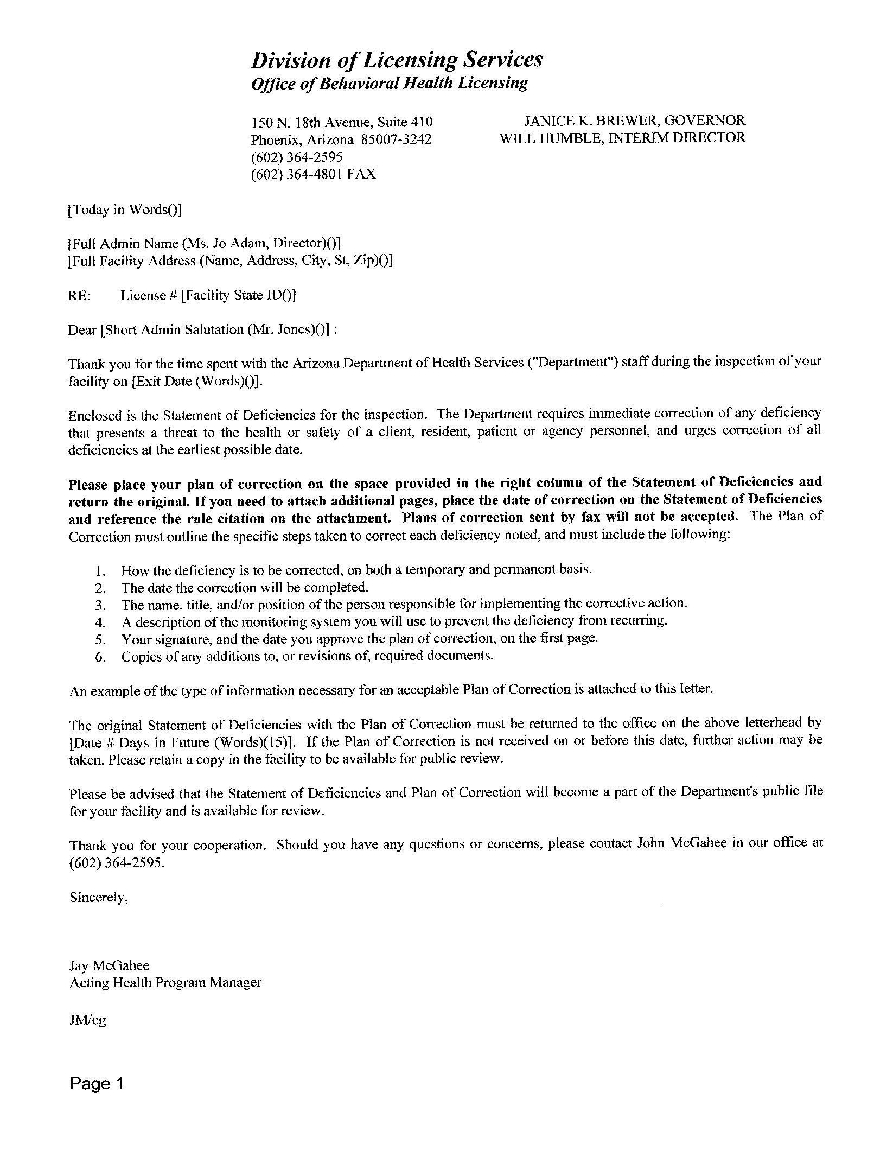

Plan of Correction (POC) and Informal Dispute Resolution Process (IDR)

Six Step to Plan of Correction Action Process
- How the deficiency is to be corrected, on both a temporary and permanent basis.
- The date the correction was completed
- The name, title, and/or position of the person that will be responsible for implementing the corrective action.
- A description of the monitoring system you will use to prevent the deficiency from reoccurring.
- Your signature, and the date you (the manager) approved the plan of correction, on the first page.
- Copies of any additions to, or revisions of, required documents.
If you feel that the State of Deficiency is incorrect then the process used to open a dialog with DHS is via the Informal Dispute Resolution Process.

Informal Dispute Resolution Process
Upon receipt of a Statement of Deficiencies, the Licensee does have an opportunity to dispute any findings of non-compliance through an Informal Dispute Resolution (IDR).

If a Statement of Deficiencies arrives with a “Notice of Enforcement” attached (which will inform you not to send in a plan of correction (POC) until the Department requests it.); the Licensee still maintains the opportunity to utilize the IDR process
.
Here are the steps for the IDR process:
1. The IDR must be in a written format and separate from the plan of correction.
- The Department must receive the written request for an IDR no later than 14 calendar days after you have received a Statement of Deficiencies.
- You must still complete an acceptable plan of correction for all deficiencies cited (even the areas you are disputing) unless you have received a “Notice of Enforcement” along with the Statement of Deficiencies.

- In writing your IDR, you must indicate each specific deficiency being refuted and a detailed explanation of the reason(s) the deficiency should not have been cited.
- You must also attach any documentation, if applicable, which shows the facility was in compliance at the time of the inspection.
- The IDR must pertain only to the accuracy of the findings and cannot refute the professional judgment of the Department’s staff regarding the level, extent, scope, or severity of the deficiency.

7. The IDR must be sent to the attention to the Office Chief, Office of Assisted Living Licensing.
8. The Department’s management team will review the information and documentation provided and will notify you of the Department’s decision.
9. Please direct all IDR questions to the Office Chief, Office of Assisted Living Licensing.

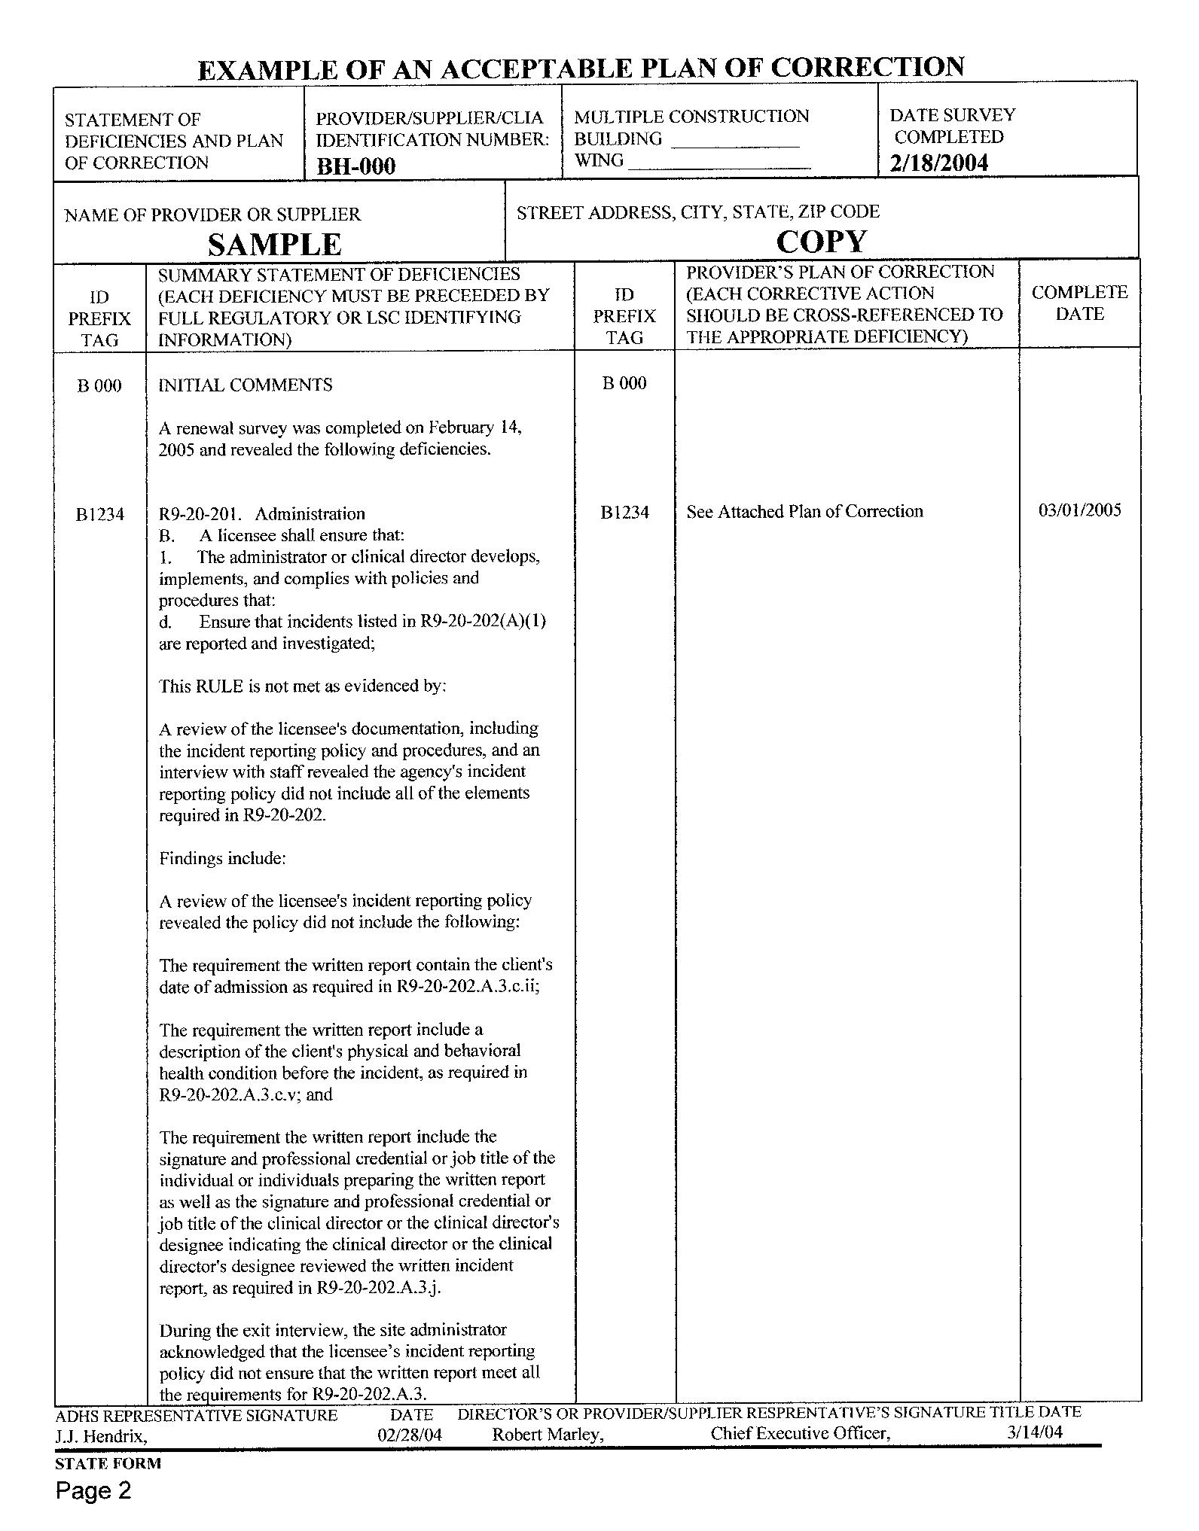
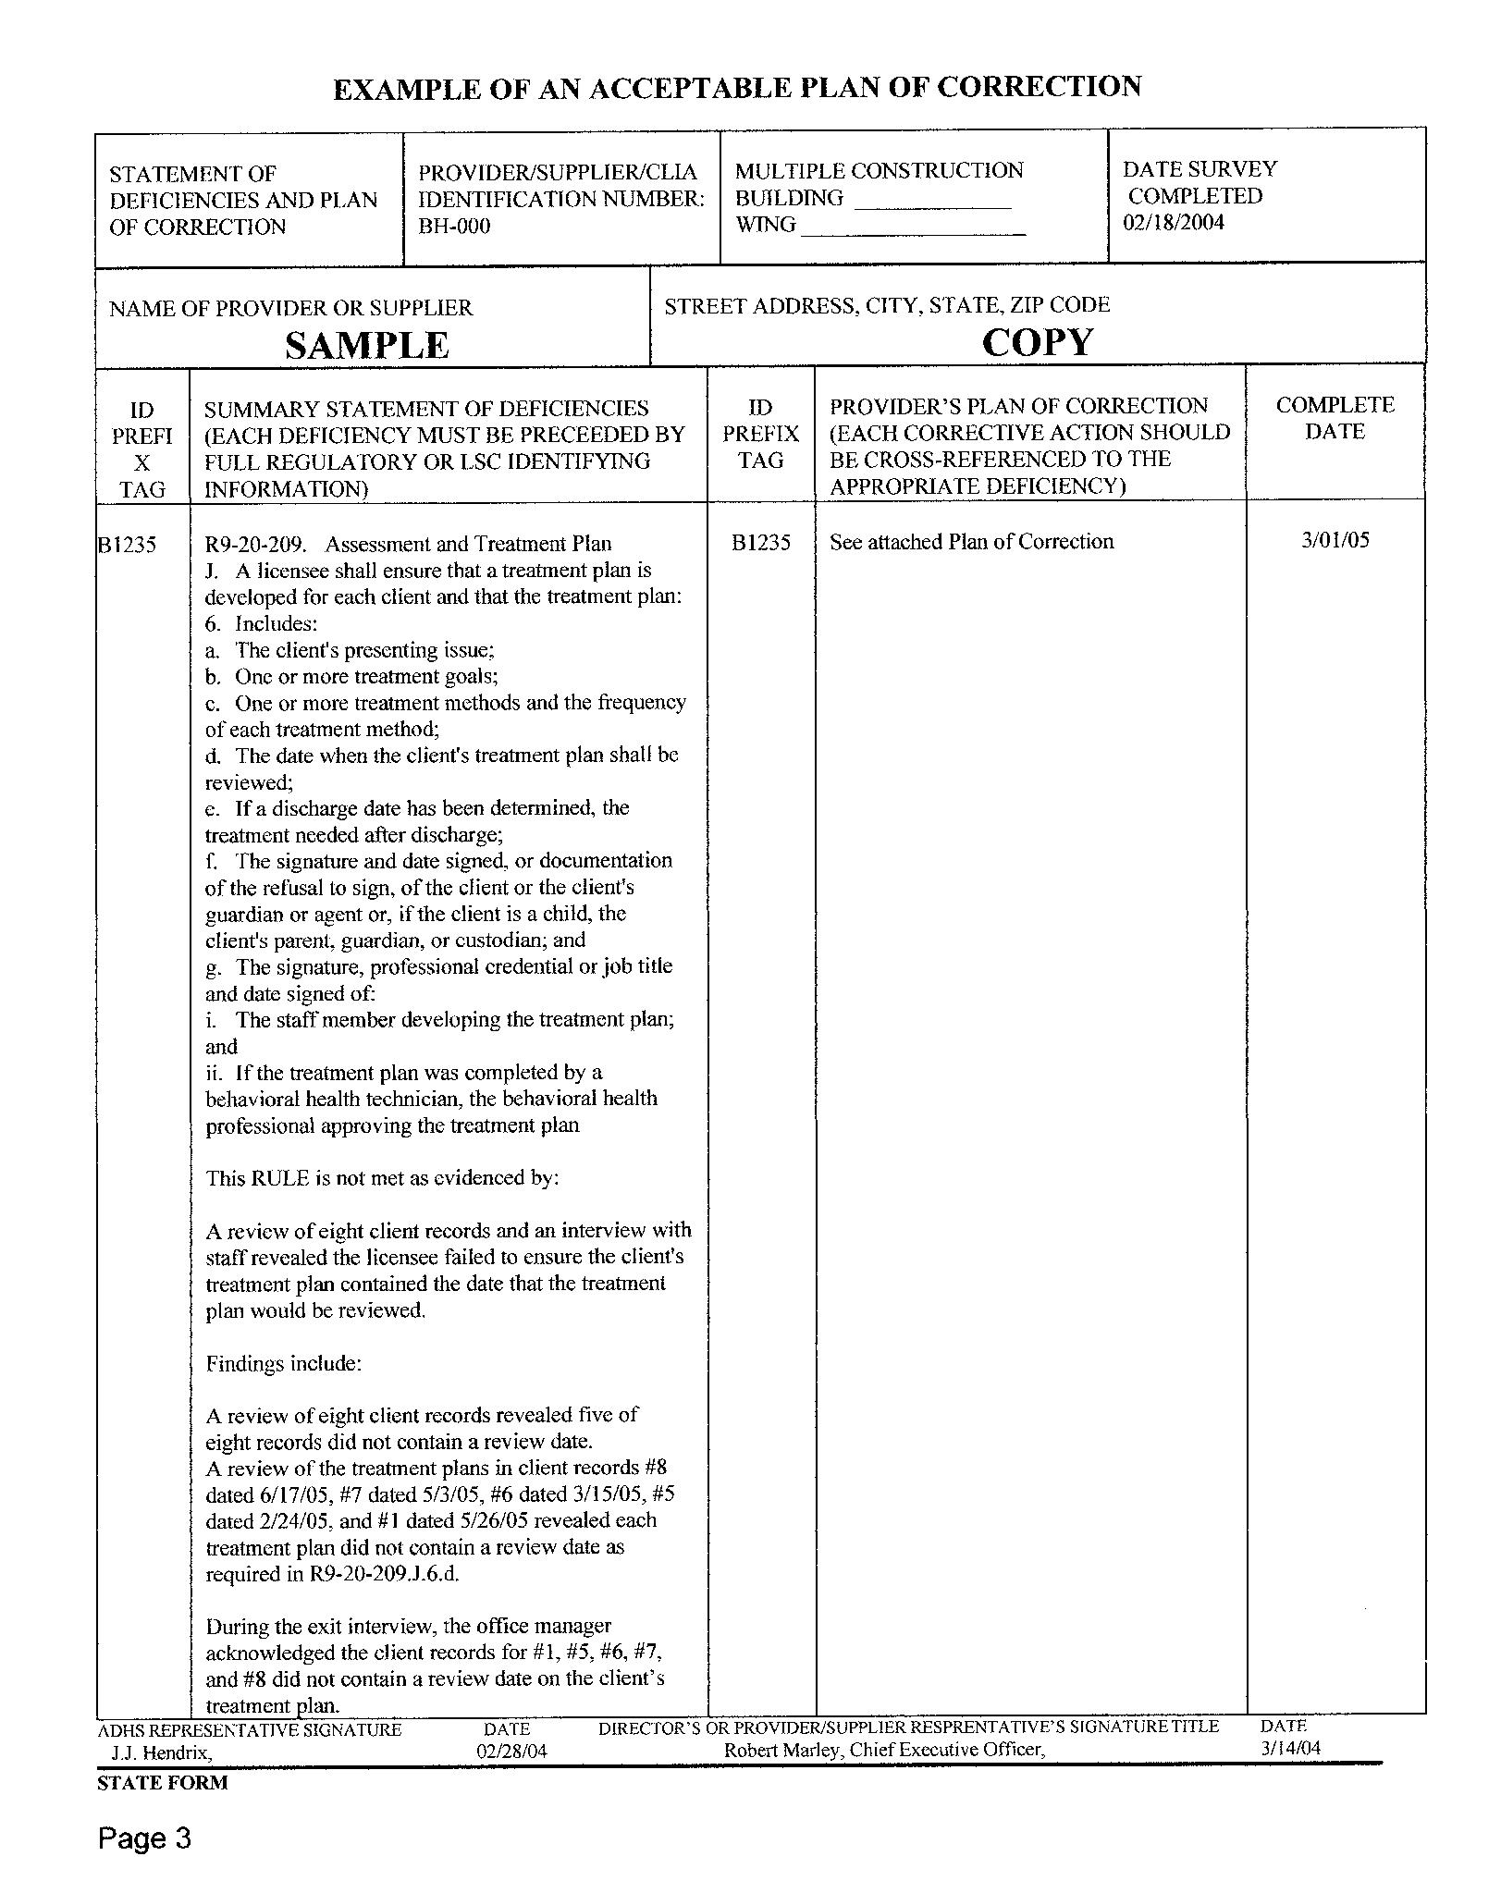

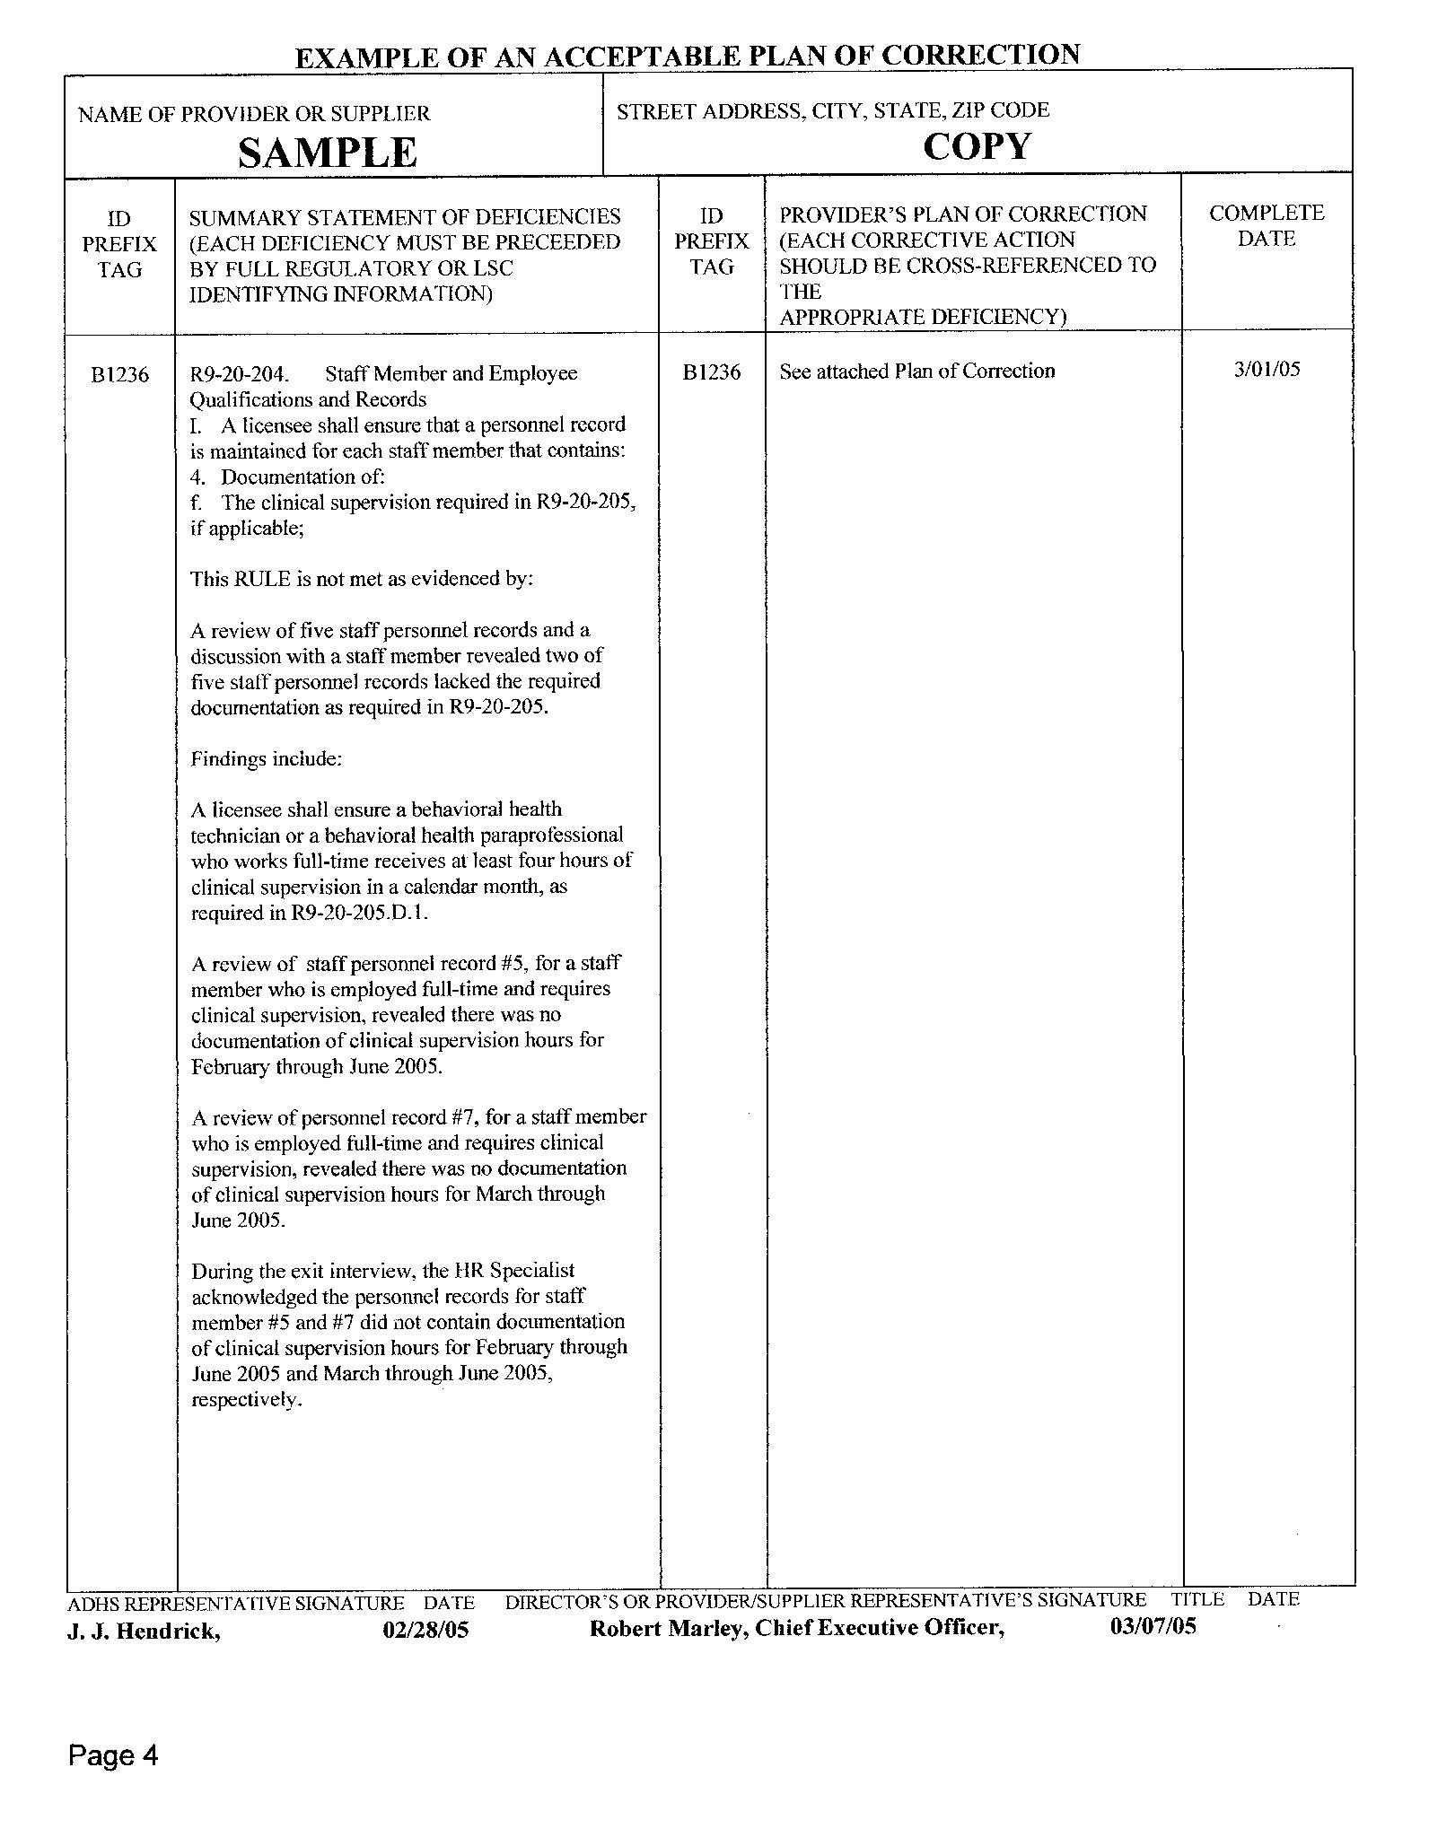
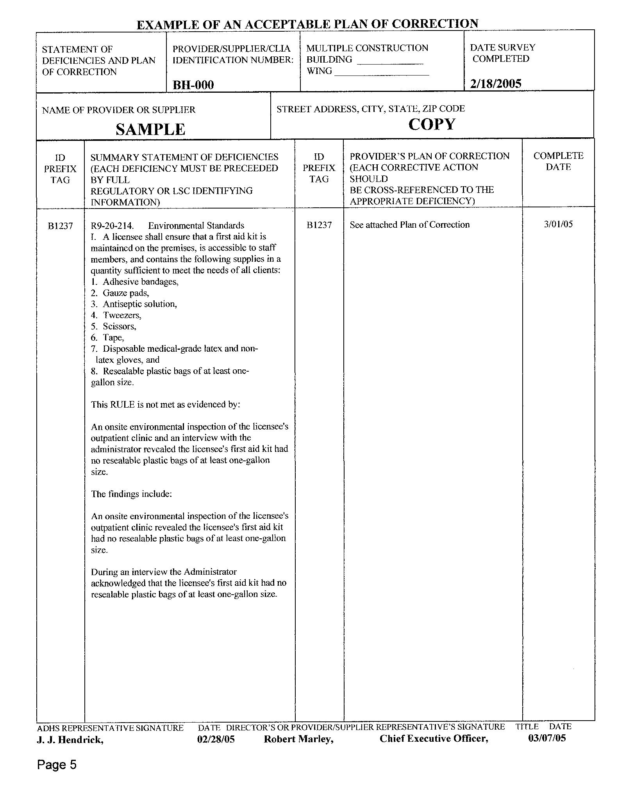

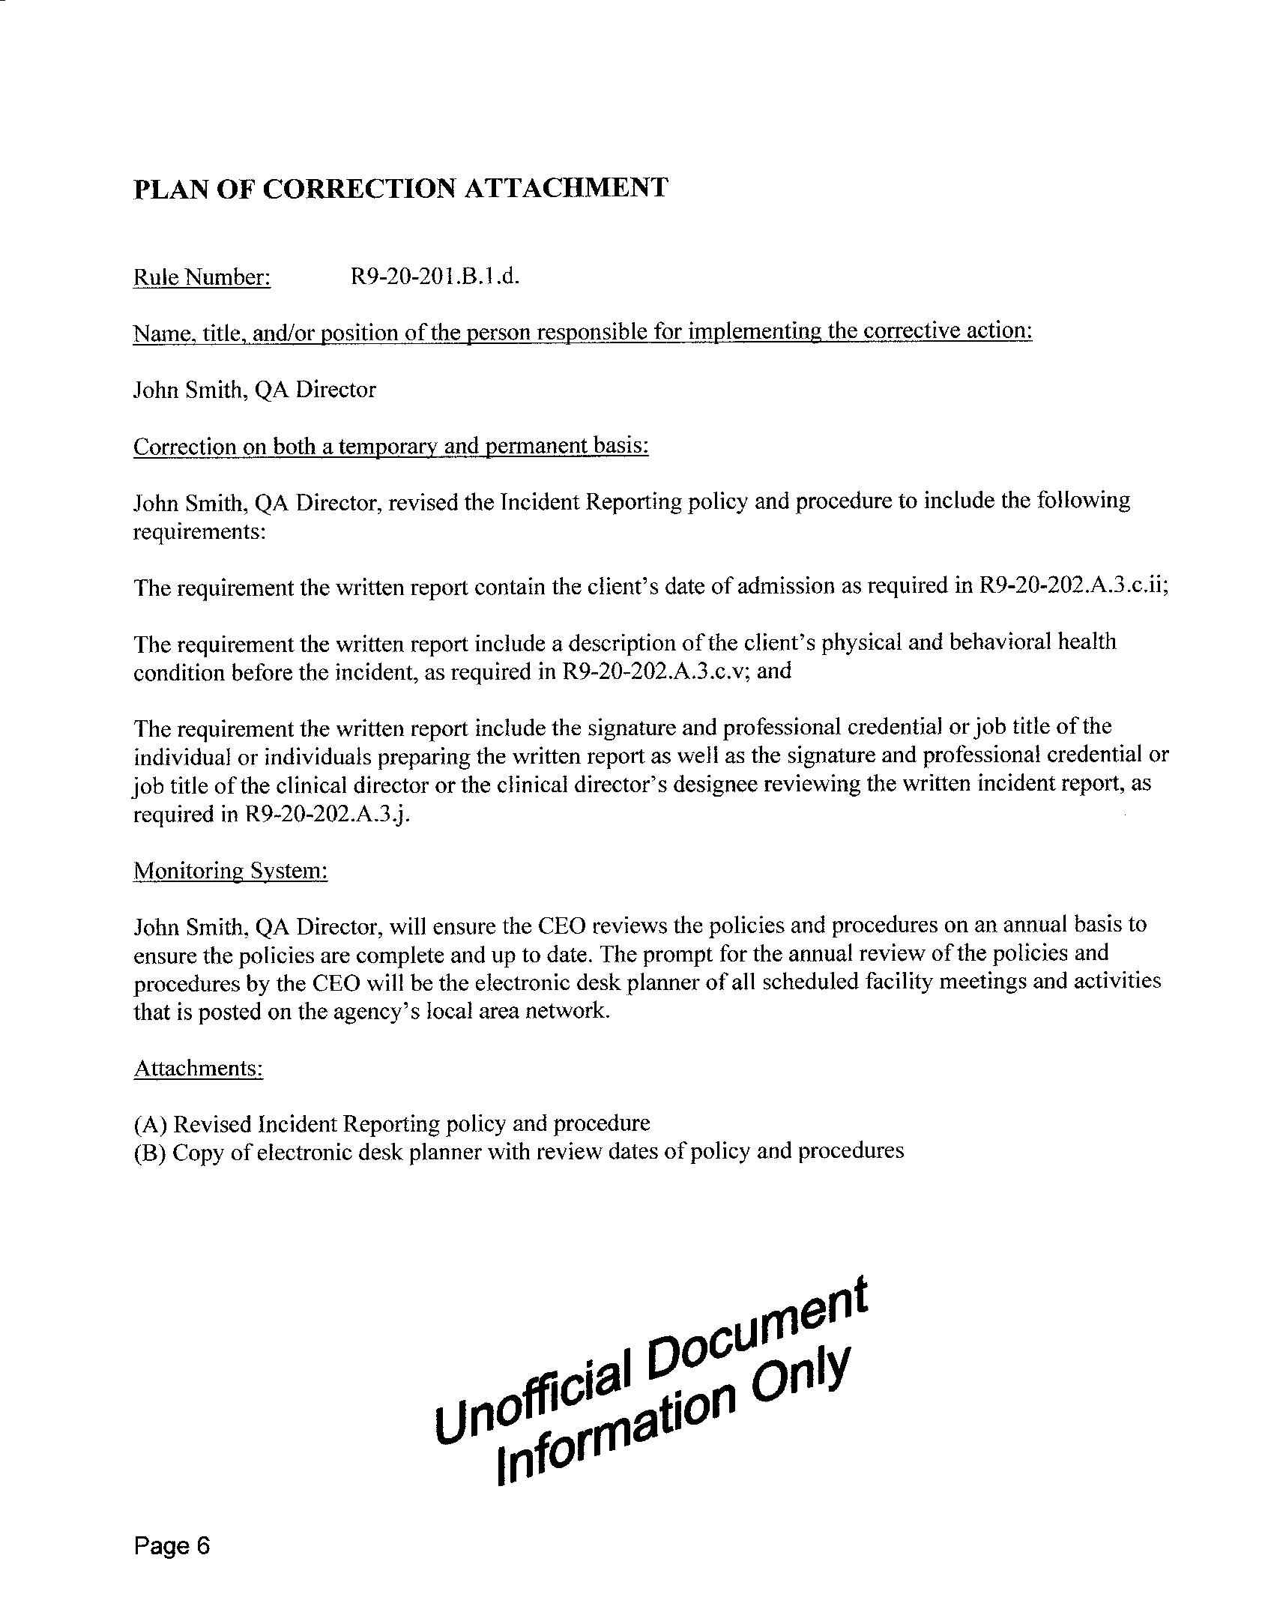

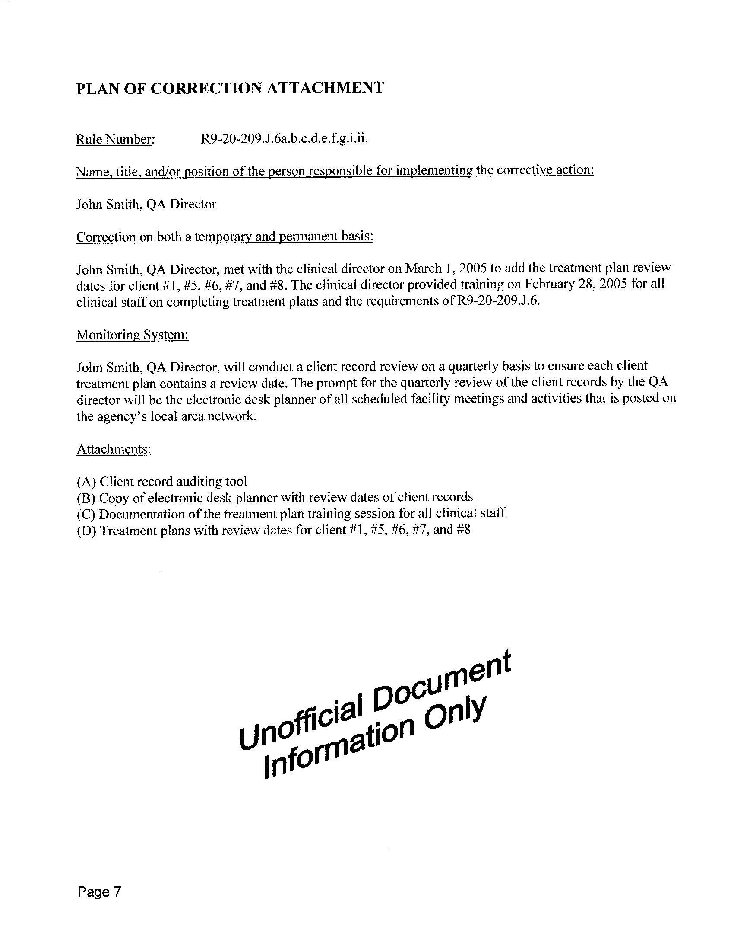

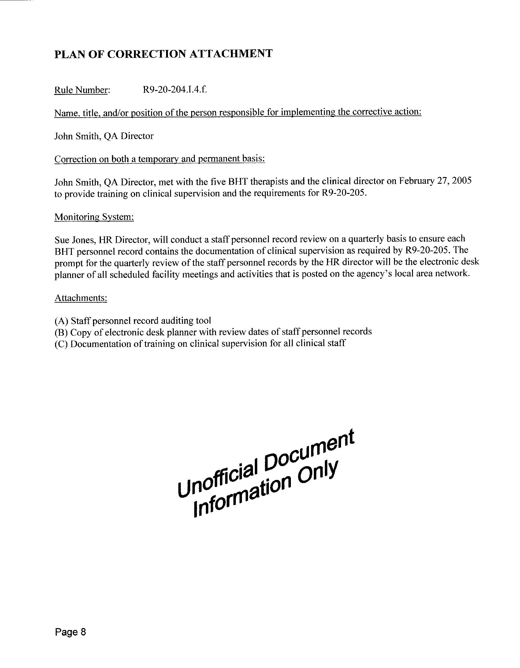

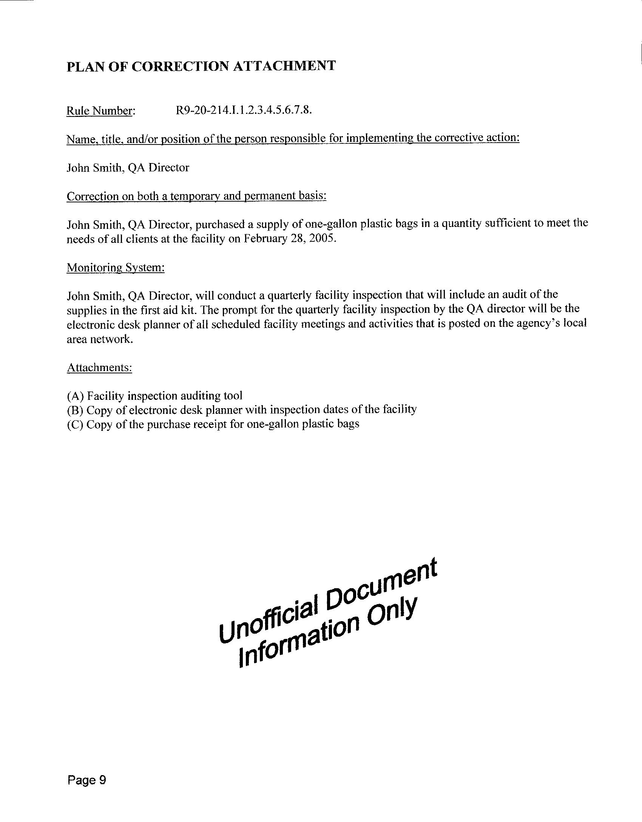

Enforcement Actions

R9-10-111. Enforcement Actions
        - If the Department determines that an applicant or licensee is violating applicable statutes and rules and the violation poses a direct risk to the life, health, or safety of a patient, the Department may:
      - Issue a provisional license to the applicant or licensee under A.R.S. § 36-425,
      - Assess a civil penalty under A.R.S. § 36-431.01,
      - Impose an intermediate sanction under A.R.S. § 36-427,
      - Remove a licensee and appoint another person to continue operation of the health care institution pending further action under A.R.S. § 36-429,
      - Suspend or revoke a license under A.R.S. § 36-427 and R9-10-111,
- Deny a license under A.R.S. § 36-425 and R9-10-111, or
- Issue an injunction under A.R.S. § 36-430.

        - In determining which action in subsection (A) is appropriate, the Department shall consider the direct risk to the life, health, or safety of a patient in the health care institution based on:
      - Repeated violations of statutes or rules,
      - Pattern of violations,
      - Types of violation,
      - Severity of violation, and
      - Number of violations.

A.R.S. § 36-425 Inspections; issuance of license; posting of deficiencies; provisional license; denial of license
- On receipt of a properly completed application for initial licensure, the director shall conduct an inspection of the health care institution as prescribed by this chapter. If an application for an initial license is submitted due to a planned change of ownership, the director shall determine the need for an inspection of the health care institution. Based on the results of the inspection, the director shall either deny the license or issue a regular or provisional license.

- The director shall issue a provisional license for a period of not more than one year if an inspection or investigation of a currently licensed health care institution or a health care institution for which an applicant is seeking initial licensure reveals that the institution is not in substantial compliance with department licensure requirements and the director believes that the immediate interests of the patients and the general public are best served if the institution is given an opportunity to correct deficiencies. The applicant or licensee shall agree to carry out a plan to eliminate deficiencies that is acceptable to the director. The director shall not issue consecutive provisional licenses to a single health care institution. The director shall not issue a license to the current licensee or a successor applicant before the expiration of the provisional license unless the health care institution submits an application for a substantial compliance survey and is found to be in substantial compliance. The director may issue a license only if the director determines that the institution is in substantial compliance with the licensure requirements of the department and this chapter. This subsection does not prevent the director from taking action to protect the safety of patients pursuant to section 36-427.

36-431.01. Violations; civil penalties
- The director may assess a civil penalty against a person who violates this chapter or a rule adopted pursuant to this chapter in an amount of not to exceed five hundred dollars for each violation. Each day that a violation occurs constitutes a separate violation.
- The director may issue a notice of assessment that shall include the proposed amount of the assessment. A person may appeal the assessment by requesting a hearing pursuant to title 41, chapter 6, article 10. When an assessment is appealed, the director shall take no further action to enforce and collect the assessment until after the hearing.
- In determining the civil penalty pursuant to subsection A of this section, the department shall consider the following:
      - Repeated violations of rules or rules.
      - Patterns of noncompliance.
      - Types of violations.
      - Severity of violations.
      - Potential for and occurrences of actual harm.
      - Threats to health and safety.
      - Number of persons affected by the violations.
      - Number of violations.
      - Size of the facility.
      - Length of time that the violations have been occurring.
- Pursuant to interagency agreement specified in section 36-409, the director may assess a civil penalty, including interest, in accordance with 42 United States Code section 1396r. A person may appeal this assessment by requesting a hearing before the director in accordance with subsection B of this section. Civil penalty amounts may be established by rules adopted by the director that conform to guidelines or regulations adopted by the secretary of the United States department of health and human services pursuant to 42 United States Code section 1396r.
- Actions to enforce the collection of penalties assessed pursuant to subsections A and D of this section shall be brought by the attorney general or the county attorney in the name of the state in the justice court or the superior court in the county in which the violation occurred.
- Penalties assessed under subsection D of this section are in addition to and not in limitation of other penalties imposed pursuant to this chapter. All civil penalties and interest assessed pursuant to subsection D of this section shall be deposited in the nursing care institution resident protection revolving fund established by section 36-431.02. The director shall use these monies for the purposes prescribed by 42 United States Code section 1396r, including payment for the costs of relocation of residents to other facilities, maintenance of operation of a facility pending correction of the deficiencies or closure and reimbursement of residents for personal monies lost.
- The department shall transmit penalties assessed under subsection A of this section to the state general fund.

A.R.S. § 36-427 Suspension or revocation; intermediate sanctions
- The director, pursuant to title 41, chapter 6, article 10, may suspend or revoke, in whole or in part, the license of any health care institution if its owners, officers, agents or employees:
      - Violate this chapter or the rules of the department adopted pursuant to this chapter.
      - Knowingly aid, permit or abet the commission of any crime involving medical and health related services.
      - Have been, are or may continue to be in substantial violation of the requirements for licensure of the institution, as a result of which the health or safety of one or more patients or the general public is in immediate danger.
      - Fail to comply with section 36-2901.08.
- If the licensee, the chief administrative officer or any other person in charge of the institution refuses to permit the department or its employees or agents the right to inspect its premises as provided in section 36-424, such action shall be deemed reasonable cause to believe that a substantial violation under subsection A, paragraph 3 of this section exists.
- If the director reasonably believes that a violation of subsection A, paragraph 3 of this section has occurred and that life or safety of patients will be immediately affected, the director, on written notice to the licensee, may order the immediate restriction of admissions or readmissions, selected transfer of patients out of the facility, reduction of capacity and termination of specific services, procedures, practices or facilities.
- The director may rescind, in whole or in part, sanctions imposed pursuant to this section upon correction of the violation or violations for which the sanctions were imposed.

A.R.S. § 36-429 Removal of licensee; temporary management continued operation
- If the director reasonably believes that a violation of this chapter by a licensee endangers the health, safety or welfare of one or more of the licensee's patients, in addition to other remedies provided by this chapter, the director may enter into an agreement with the licensee or bring an action requesting the superior court to:
      - Remove the administrative officers, agents or employees of such licensee by injunction, enjoin the licensee from continued operation and revoke the license.
      - Appoint temporary personnel to continue operation of the health care institution under conditions and requirements set by the court pending correction of the violation and restoration of the licensee, revocation of the license or correction of the violation and change of ownership.
- The action shall be brought in the name of the people of the state through the attorney general in the superior court in the county in which the health care institution is located.

R9-10-112. Denial, Revocation, or Suspension of License
  - The Department may deny, revoke, or suspend a license to operate a health care institution if an applicant, a licensee, or a controlling person of the health care institution:
      - Provides false or misleading information to the Department;
      - Has had in any state or jurisdiction any of the following:
  - An application or license to operate a health care institution denied, suspended, or revoked, unless the denial was based on failure to complete the licensing process within a required time-frame; or
  - A health care professional license or certificate denied, revoked, or suspended; or
      - Has operated a health care institution, within the ten years preceding the date of the most recent license application, in violation of A.R.S. Title 36, Chapter 4 or this Chapter, that posed a direct risk to the life, health, or safety of a patient.
- The Department shall suspend or revoke a hospital’s license if the Department receives, pursuant to A.R.S. § 36-2901.08(H), notice from the Arizona Health Care Cost Containment System that the hospital’s provider agreement registration with the Arizona Health Care Cost Containment System has been suspended or revoked.

A.R.S. § 36-430 Unlicensed operation prohibited; injunction
The operation or maintenance of a health care institution which does not hold a current and valid license or which exceeds the range of the services authorized by the class or subclass for which it is licensed is a violation of this chapter and is declared a nuisance inimical to the public health and safety. The director, in the name of the people of the state, through the attorney general, may bring an action for an injunction to restrain such violation or to enjoin the future operation or maintenance of any such health care institution until substantial compliance with the provisions of this chapter and the rules and regulations and standards adopted pursuant thereto is obtained.

Risk Management and Quality Improvement:
CHAPTER 5

Key Terms:

Managing risk- A program of policies and procedures that is established by the administrator as a proactive means of anticipating problems in the facility that could lead to illness, injury, or financial loss.

Negotiated risk- A process of negotiating the way that services are going to be provided in dealing with exceptions, unusual circumstances, or problem situations outside the regular practices and service plans.

Quality assurance- A planned and systematic pattern of all actions necessary to ensure that services conform to established technical requirements or standards.

Quality improvement- A method of evaluating and improving processes of resident care that emphasizes a multidisciplinary approach to problem solving and focuses not on individuals but systems of resident care that might be the cause of variations.

Quality management- A broad term that encompasses both quality assurance and quality improvement, and describes a program of evaluating the quality of care using a variety of methodologies and techniques.

Regulations- administrative agency at the federal, state, or local level. A law that has been coded and advertised and is to be monitored by a specific regulatory agency.

Shared responsibility- This term means exploring the options available to a resident in a facility and the risks involved with each option when making decisions pertaining to the resident’s abilities, preferences, and service needs, thereby enabling the resident and, if applicable, the resident’s representative or designee, and the facility to develop a service plan or negotiated risk agreement that best meets the resident’s needs and seeks to improve the resident’s quality of life.

Negotiated risk agreements:

In some states, facility employees identify potential and actual risks for residents. Residents or family members do not create risk agreements. The Negotiated Risk Agreements, initiated by the facility only, become active after staff reports risky behaviors by a resident. If the resident agrees to discontinue the behavior, there's no formal NRA written
An Assisted living facility that responds to a resident's changing needs by adjusting services and level of care criteria means that the resident is less likely to be discharged to a higher level of care, such as a nursing home, and will "age in place." A "managed" or negotiated risk agreement (NRA) can facilitate aging in place by accommodating a resident's choices and potential risks of remaining in the residence

Why use negotiated risk agreements?
There are some facilities that will utilize NRAs as:
- a tool for identifying and reducing risks,
- a communication tool for discussing risks and setting expectations, and
- a method to support residents’ rights to make choices that entail risk. Some states and proponents also view NRAs as a method for assigning responsibility and limiting provider liability.

Pros and Cons of NRAs
- The strongest opponents tend to view NRAs as having a sole purpose--an attempt to avoid liability for negative outcomes resulting from negligence.
- Others recognize that “good” providers may use NRAs to identify and reduce risks, but fear that “bad” providers will use them to force residents to accept substandard care because they have no practical alternative or fear discharge to an institutional setting.
- Several argue that residents are in an unequal bargaining position due to frailty, lack of acceptable alternatives, and the difficulty with relocation.
- In contrast, NRAs are used when a resident wants to deviate from the service plan or to address “lifestyle” issues not typically covered in service plans. They also believe that NRAs offer a unique process that requires providers and residents to discuss the consequences of choosing to take a risk, a discussion not typically present in service planning.

When to use a Negotiated Risk Agreement
NRAs are typically used when a resident continuously exhibits a behavior that may cause risk of harm to their health, safety or welfare. Most issues can be addressed by adjusting services/care needs and updating the service plan to reflect the plan of care.

Examples of when a NRA may be utilized are:
Resident is
- Refusing Medications
- Refusing to Use a Walker
- Refusing to follow prescribed diet
- Smoking
- Consuming alcohol

Many factors must be taken into consideration before allowing the resident to be at risk, their medical practitioner, family and or responsible party all may need to be involved in the decision. All outcomes should be noted on the individual service plans also.

After careful consideration the manager and governing authority must still consider if the facility is the best placement for this resident. If the facility is unable or unwillingly to provide the care or the potential risks involved are a threat to others (i.e. smoking in the building or alcohol use that leads to threats to others) the residency agreement should be terminated within time-frame provided by law.
(See hand-out Sample NRA)

Quality management programs:
Remember chapter 3 page 23 outlined the regulation for minimum standards of the QM program
and the definition of quality management is broad term that encompasses both quality assurance and quality improvement, and describes a program of evaluating the quality of care using a variety of methodologies and techniques.

There are many benefits to quality management programs the most important is continuous quality improvement (CQI) tools like surveys measures satisfaction that allows company to set goals to improve service which will enhance the care and quality of life of the residents we serve. Monitoring incident reports, contracted services and delivery of services (these are quality indicators) should be included in the QM plan, you and your team may want to add other areas or your company may already mandate other areas.

Once your facility has identified “quality indicators” next is important to have established policies on how to monitor, collected and analysis/evaluate the data. Remember QM findings are reported on a routine basis to the owner of the facility. Facility policies drive the reporting on what and how you will collect and utilize data. Page 24 was a sample of a flow sheet /report that listed quality indicators to be monitored on a monthly basis.

QM does not have to be overwhelming, as Managers we are consistently monitoring all aspects of operations and many things we do already are part of quality management, the regulation is mandating us to report it, this ensures that our owners are in the loop. Brainstorm with your team of how to make this fun, delegate part to others, include all the things you do already into the QM plan and document all efforts to improve the quality of care you and your team deliver each day. Why not get credit for what you do?

Below are just a few examples of methods of doing QA, and QI that all adds up to or affords the opportunity for a quality management program to be established and thrive.

Quality assurance- A planned and systematic pattern of all actions necessary to ensure that services conform to established technical requirements or standards.
- Life safety checks- fire equipment, water temps, food temp, refrigerator temps, electrical equipment
- Incident reporting- writing, reporting and developing action plans for preventing future incidents
- Disaster Drills
- Documenting meal percentages and ensuring hydration

Quality improvement- A method of evaluating and improving processes of resident care that emphasizes multidisciplinary approach to problem solving and focuses not on individuals but systems of resident care that might be the cause of variations.
- Safety Committee
- Food Committee
- Resident Council Meeting
- Resident, Family and Employee Surveys
- Mock Survey
- Department Head meetings
- Staff meetings/ continuous education training
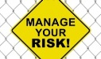
Rather your facility is a home or a center you must have a QM program, how elaborate it will be is up to you and the creativity of your team.

Chapter 6 Physical Environment Management:
CHAPTER 6

Key Terms

Americans with Disabilities Act (ADA) - Federal law that gives individuals with disabilities opportunity for employment. It requires employers to make reasonable accommodation for persons with disabilities to be employed.

Assisted living facilities (ALFs) - A program approach within a prescribed physical structure on a 24-hour basis. Provides and/or coordinates a range of supportive personal services and may provide various levels of health services.

Building codes - Codes set forth by various local, state, and federal agencies requiring various degrees of application; processes and guidelines to be followed when building or renovating a building.

Centers for Medicare and Medicaid Services (CMS) - A federal agency that regulates federal monies that are available for services to individuals who qualify for Medicare and Medicaid. This federal agency prescribes guidelines for state agencies that regulate licensed care facilities.

Continuous quality improvement (CQI)- system put in place that uses various tools such as resident satisfaction surveys and other measures that allow an organization to improve the quality of services based on past performance and future goals.

Disaster preparedness - Preparation and training of staff and residents in the event of an unexpected event of a great magnitude that affects operation of the healthcare facility and ensures the safety of everyone during this event. Disasters include tornadoes, hurricanes, bomb threats, floods, chemical spills (both internal and external), explosions, fires, and electrical outages.

Employee right to know - Safety Data Sheets are located so that they can read about the chemicals with which they work, and what the hazards of working with those substances may be.

Equal Employment Opportunity Commission - A federal agency that sets guidelines to ensure equal opportunity for employment based on a person’s ability to perform the job and does not allow an employer to discriminate.

Family Medical Leave Act (FMLA) - A federal regulation that allows an employee to take time off work for a term because of a medical condition such as pregnancy and illnesses.

Food and Drug Administration (FDA) - A federal agency that regulates food and drug safety for consumers. It regulates meat processing plants and other producers of foods for human consumption, and it regulates medication approval before pharmaceuticals can sold to the consumer.

Foster care homes - A prescribed physical structure that provides care and services. The number of residents served in these homes may vary from state to state but usually is considered to be a homelike setting.

Life Safety Code - Codes described by the National Fire Protection Association to provide state and local building departments guidelines for regulating building codes. These codes are usually adopted by local and state agencies, but are not mandated by the federal government.

Material Safety Data Sheets (MSDSs) - Explanation of the contents of the chemical products with which an employee uses in the healthcare facility. MSDSs provide the chemical name for the product as well as the commercial name, chemical contents of the product, hazards of the product, what to do in the event of physical exposure to the product, as well as combustibility information and how to use the product safely. Can be obtained from the retailer of the product or the manufacturer.

Medical model of care- Care that focuses on the medical or disease-oriented needs of the resident and the treatment and outcome of the medical care.

National Fire Protection Association (NFPA) - A national association that prescribes safety codes and definitions for state and local agencies to adopt as building regulations.

Occupational Health and Safety Administration - Federal guidelines that include safety requirements of the workplace to protect employees and reporting guidelines for illnesses, injuries, and exposure to hazardous substances that occur in the workplace.

Preventive maintenance - Proper maintenance of equipment as designated by the manufacturer to ensure the continuing functioning of equipment, safely and properly

Residential care homes - program approach, similar to that of an assisted living facility, that provides 24-hour housing and services. In some states, residential care and assisted living facilities are regulated by the same state rules and regulations.

Social model of care - Care that focuses on the entire person so that the resident may continue to function in a normal and accepted way.

Zoning laws - Laws established in a community that specify how buildings are to be constructed, what types of buildings may be constructed in what areas of the community, as well as established standards in building construction that ensure safety for the intended use.

Introduction:
As the person responsible for overall supervision of the facility the manager must have a working knowledge of the building physical plant assuring the resident live in clean and safe physical environment. This chapter will exam areas that affect the health, safety and welfare of your residents and staff.

.

Introduction to OSHA: Occupational Safety and Health Administration

Why is OSHA Important to You?
- OSHA began because, until 1970, there were no national laws for safety and health hazards.
- On average, 15 workers die every day from job injuries
- Over 5,600 Americans die from workplace injuries annually
- Over 4 million non-fatal workplace injuries and illnesses are reported

History of OSHA
- OSHA stands for the Occupational Safety and Health Administration, an agency of the U.S. Department of Labor
- OSHA’s responsibility is worker safety and health protection
- On December 29, 1970, President Nixon signed the OSH Act
- This Act created OSHA, the agency, which formally came into being on April 28, 1971

OSHA’s Mission
- The mission of OSHA is to save lives, prevent injuries and protect the health of America’s workers.
- Some of the things OSHA does to carry out its mission are:
  - developing job safety and health standards and enforcing them through worksite inspections,
  - maintaining a reporting and recordkeeping system to keep track of job-related injuries and illnesses, and
  - providing training programs to increase knowledge about occupational safety and health.

What Rights Do You Have Under OSHA? (Employees)
- You have the right to:
  - A safe and healthful workplace
  - Know about hazardous chemicals
  - Information about injuries and illnesses in your workplace
  - Complain or request hazard correction from employer
  - Training
  - Hazard exposure and medical records
  - File a complaint with OSHA
  - Participate in an OSHA inspection
  - Be free from retaliation for exercising safety and health rights

What Responsibilities Does Your Employer Have Under OSHA?
- Provide a workplace free from recognized hazards and comply with OSHA standards
- Provide training required by OSHA standards
- Keep records of injuries and illnesses
- Provide medical exams when required by OSHA standards and provide workers access to their exposure and medical records
- Not discriminate against workers who exercise their rights under the Act (Section 11(c))
- Post OSHA citations and abatement verification notices
- Provide and pay for PPE

What do the OSHA Standards Say?
- OSHA standards fall into four categories: General Industry, Construction, Maritime, and Agriculture.
- OSHA issues standards for a wide variety of workplace hazards
- Where there are no specific OSHA standards, employers must comply with The General Duty Clause, Section 5(a)(1)
- Are always “two prong” what the employer must do and what the employee must do; designed to be a partnership in making the workplace safe

What are the do’s of an OSHA Standard?
Typical all standards have 5 key elements; this graph outlines the employer and employee (“the two prong” process”) responsibility in complying with OSHA standards:
Employer Must | Employee Must
Have established policy & procedure for the standard | Must follow the established policy & procedure
Provide Training ( initial / new employee orientation) | Attend required training
Provide PPE, supplies as applicable to the standard | Properly use
Reporting system of exposure/ claim (incident/accident) | Report immediately
Annual Training of Standards | Attend required training

Required established programs:
Outlined here are typical OSHA required programs for assisted living visit www.osha.org. , for further guidance. Generally programs are required regardless of the number of employees a company has, however typical only
have to report to OSHA if employ 11 or more employees.

Required Programs
Name of Standard | Tips on what it covers
Posting OSHA notice | Workers’ rights under the law
Personal Protective Equipment (PPE) | When hazard cannot be removed or controlled appropriate PPE must be available & utilized  Varies depending on job i.e. gloves, goggles, ladders, tools, hard hats, masks, gowns etc.
Hazard Communications Standard | “Right to know” risk of exposure to chemicals, how to protect self from danger, PPE required and SDS-Safety Data Sheet available (new 2015) Kept 30yrs
“Lock Out” “Tag Out” | Requirement for any electric work to ensure safety
Blood-borne Pathogens Standard | Covers infection control, needle sticks, PPE
Medical Device OSHA requires, FDA oversight | Reporting failed devices that caused injury

OSHA required documentation:
For Employer with 10 or Fewer Employees:
It is required that employee work-related injury and illnesses be document on an OSHA 300 Log and OSHA 301 Log be posted annually for employee review (from Febuary1st to March 1st ) . All logs are to be maintained for 5 years. A separate log is maintained for needle sticks.

OSHA requirements for Needle Sticks: Should be established

Safety Committees:
Not required at federal or state levels but proactive safety programs can be part of the quality management program if required by facility policy and procedures. Utilizing a multidisciplinary committee to identify potential hazards to residents and employees; monitoring and evaluating all incident reports, education opportunities, and promotional / fun activities that promote safety.

What and When to report to OSHA?
 Employers with 11 or more employees: Starting January 1, 2015:
All employers* must report:
All work-related fatalities within 8 hours
Within 24 hours, all work-related:
- Inpatient hospitalizations
- Amputations
- Losses of an eye
How to Report Incident
- Call 1-800-321-OSHA (6742)
- Call your nearest OSHA area office, during normal business hours (www.osha.gov/html/RAmap.html)
- Visit http://www.osha.gov/report_online

How Are OSHA Inspections Conducted?
- The OSH Act authorizes OSHA compliance safety and health officers (CSHOs) to conduct workplace inspections at reasonable times.
- OSHA conducts inspections without advance notice, except in rare circumstances (e.g. Imminent Danger)
- In fact, anyone who tells an employer about an OSHA inspection in advance can receive fines and a jail term.

Where Can You Go For Help?
- Sources within the workplace/worksite
- Sources outside the workplace/worksite
- How to file an OSHA complaint

Filing an OSHA Complaint (OSHA-7 Form)

INSTRUCTIONS Provided on the Form:
- Open the form and complete the front page as accurately and completely as possible.
- Describe each hazard you think exists in as much detail as you can.
- If the hazards described in your complaint are not all in the same area, please identify where each hazard can be found at the worksite.
- If there is any particular evidence that supports your suspicion that a hazard exists (for instance, a recent accident or physical symptoms of employees at your site) include the information in your description. If you need more space than is provided on the form, continue on any other sheet of paper.
- After you have completed the form, return it to your local OSHA office.
Sample of Complaint Form

Other Safety Considerations: Review pages 93-96 NAB Textbook regarding
- NFPA
- Safety & Security Requirement and procedures
- Security Programs

Americans with Disabilities Act:

Introduction to the ADA

The Americans with Disabilities Act (ADA) was signed into law on July 26, 1990, by President George H.W. Bush.

The ADA is one of America's most comprehensive pieces of civil rights legislation that prohibits discrimination and guarantees that people with disabilities have the same opportunities as everyone else to participate in the mainstream of American life -- to enjoy employment opportunities, to purchase goods and services, and to participate in State and local government programs and services.

Modeled after the Civil Rights Act of 1964, which prohibits discrimination on the basis of race, color, religion, sex, or national origin – and Section 504 of the Rehabilitation Act of 1973 -- the ADA is an "equal opportunity" law for people with disabilities.

To be protected by the ADA, one must have a disability, which is defined by the ADA as a physical or mental impairment that substantially limits one or more major life activities, a person who has a history or record of such impairment, or a person who is perceived by others as having such impairment. The ADA does not specifically name all of the impairments that are covered.

TITLE 42 - THE PUBLIC HEALTH AND WELFARE
CHAPTER 126 - EQUAL OPPORTUNITY FOR INDIVIDUALS WITH DISABILITIES
What is the ADA?
The Americans with Disabilities Act of 1990 (ADA) is a federal law that says employers with 15 or more employees cannot discriminate against people because of their disabilities. Basically, the ADA says that individuals with disabilities who want to work and are qualified to work must have an equal opportunity to work. The ADA also requires employers to make “reasonable accommodations” so that people with disabilities can do their work.

Disability
Not every health problem counts as a disability under the ADA.
The ADA defines disability as: a physical or mental impairment that substantially limits a major life activity such as hearing, seeing, speaking, thinking, walking, breathing, or performing manual tasks or a record or history of such an impairment, or when people treat you like you have a disability, whether or not you really have one.

Some things are obviously “disabilities” under the ADA. For example, if you are paralyzed from the waist down, you are substantially limited in the major life activity of walking. But it is less clear if other impairments are “disabilities” under the ADA. There have been many lawsuits trying to figure out if specific impairments are “disabilities” protected by the ADA.

Some other examples of “disabilities” include
- AIDS and HIV- positive,
- Chronic back pain /injury or problem
- schizophrenia, and
- bi-polar disorder.

Reasonable Accommodation
A reasonable accommodation is any change to a job, the work environment, or the way things usually are done that would allow you to apply for a job, perform job functions, or enjoy equal access to benefits available to other individuals in the workplace. There are many types of things that may help people with disabilities work successfully.

Some of the most common types of accommodations include:
- Physical changes, such as installing a ramp or modifying a workspace or restroom;
- Sign language interpreters for people who are deaf or readers for people who are blind;
- Providing a quieter workspace or making other changes to reduce noisy distractions for someone with a mental disability;
- Training and other written materials in an accessible format, such as in Braille, on audio tape, or on computer disk;
- TTYs for use with telephones by people who are deaf;
- Hardware and software that make computers accessible to people with vision impairments or who have difficulty using their hands;
- Time off for someone who needs treatment for a disability.

Protection under the ADA
The ADA protects you from discrimination in all employment practices, including:
- Job application procedures;
- Hiring and Firing;
- Training;
- Pay and promotions, benefits, and leave;
- You also have a right to be free from harassment because of your disability;
- An employer may not fire or discipline you for using your rights under the ADA.
- You have a right to request a reasonable accommodation for the hiring process and on the job.

What to do if your rights have been violated
If you think your employer has discriminated against you because of a disability or does not accommodate you, you should contact the Equal Employment Opportunity Commission (EEOC) or the Civil Rights Division at the Arizona Attorney General’s Office to file a discrimination charge as soon as possible. There is a time limit to file a charge.

You have 180 days from the date of alleged harm to file a charge against employers of less than 15 employees (for race, color, national origin, sex, religion, and/or disability) or less than 20 employees (for age). These charges must be filed with the Civil Rights Division at the Arizona Attorney General’s Office.

You have 300 days from the date of alleged harm to file a charge with the EEOC against an employer with 15 or more employees for discrimination based on race, color, national origin, sex, religion, and/or disability in Arizona. You have 300 days from the date of alleged harm to file a charge with this office against an employer with 20 or more employees for discrimination based on age in Arizona. There is no cost to file a charge.

Fire and safety requirements for assisted living facilities;

Facility Evacuation
When the decision to evacuate the facility is made, do not panic. Exit in a controlled and calm manner through the exit closest to the area you are evacuating. The exiting plan is based upon the labeled floor plan of the facility.
To ensure the personal safety of all residents and employees, everyone needs to understand the process of evacuating the facility therefore; the following requirements are to be clearly understood and accomplishable.

R9-10-819(A) (4, 5, 6, 7,) & (B) (1, 2) Disaster and Evacuation Drills
4. A disaster drill for employees is conducted on each shift at least once every three months and documented;

5. An evacuation drill for employees and residents:
a. Is conducted at least once every six months; and
b. Includes all individuals on the premises except for:
i. A resident whose medical record contains documentation that evacuation from the assisted living facility would cause harm to the resident, and
ii. Sufficient caregivers to ensure the health and safety of residents not evacuated according to subsection (A)(5)(b)(i);

6. Documentation of each evacuation drill is created, is maintained for at least 12 months after the date of the evacuation drill, and includes:
a. The date and time of the evacuation drill;
b. The amount of time taken for employees and residents to evacuate the assisted living facility;
c. If applicable:
i. An identification of residents needing assistance for evacuation, and
ii. An identification of residents who were not evacuated;
d. Any problems encountered in conducting the evacuation drill; and
e. Recommendations for improvement, if applicable; and
7. If the assisted living facility is authorized to provide directed care services, an elopement drill for employees: (effective 7-1-25)
a. Conduct an elopement drill every six months on each shift and document the date, time, and description of each drill; and
b. Immediately investigate any elopement and notify the designated family member(s), legal guardian, or other responsible person within 24 hours.
8. An evacuation path is conspicuously posted in each hallway of each floor of the assisted living facility.

B. A manager shall ensure that:

- A resident receives orientation to the exits from the assisted living facility and the route to be used when evacuating the assisted living facility within 24 hours after the resident’s acceptance by the assisted living facility, and

2. The resident’s orientation is documented.

Implementation of Evacuation requirements

- Residents will be oriented to the evacuation plan within twenty-four hours of their admission. Employees will understand the evacuation plan before completing orientation. Each resident of representative will be oriented to the following by explanation and/or demonstration:
  - Entry/exit doors
  - How to open and close windows
  - Location and use of fire extinguishers
  - Smoke alarms and their location
  - Assembly areas during drill or emergencies
  - Location and operation of phones
  - Evacuation plan
  - Location of emergency phone numbers
  - Drills for evacuation

- Employee Disaster Drills will be conducted at least every three months on each shift.
  - Residents are not expected to participate in employee Disaster Drills.
  - The Disaster drill will begin by making a general announcement throughout the facility that a fire drill is being conducted.

- Resident Evacuation Drills will be conducted at least every 6-months.
  - All residents, visitors, employees and anyone else who reside in the facility are expected to participate.
  - The resident evacuation drill will begin by making a general announcement throughout the facility that an evacuation drill is being conducted.
  - Actual evacuation of residents will be completed per the evacuation plan.
  - Except for a resident whose service plan contains documentation that evacuation would cause harm to the resident will participate in the evacuation. (must have a doctors order stated would be unsafe or harmful)
  - Records of each staff and resident evacuation plan will be maintained on the premises for 12-months. The results of the plan will be recorded on the “Evaluation Report form.
    - The date and time of the evacuation.
    - Whether the evacuation drill was for employees only or for both employees and residents.
    - The amount of time taken for employees and, if applicable, residents to evacuate the assisted living facility.
  - If applicable:
    - An identification of residents needing assistance for evacuation, and
    - An identification of residents who were not evacuated.
  - Any problems encountered in conducting the evacuation drill; and
  - Recommendations for improvement, if applicable; and

- An evacuation path is conspicuously posted on each hallway of each floor of the assisted living facility.

Evacuation Action Plan
 In the event of Fire, evacuation drill or any incident involving the facility that presents real threat to the health, safety or welfare of the residents in regards to remaining in the building/dwelling the following acronym can help you remember an action plan by following these steps:

R-A-C-E-E
REMOVE THE RESIDENTS FROM DANGER – When an alarm sounds or a fire is discovered, all caregivers will quickly identify the location of each resident and any visitors that are in danger and quickly remove them from the danger.

ALARM – Sound the alarm (pull box if available) or after removing resident from danger call 911 do so from a safe place or send someone to call. (Hint: most pull boxes are located near an exit door)

CONFINE THE FIRE – Close doors as you exit rooms. If you are in a room and the door is closed, feel the door before opening it. If it is hot find another exit. A hot door indicates a fire burning on the other side. The door is a barrier for an estimated 7-10 minutes.

EXTINGUISH THE FIRE – Know the location and operation of all fire extinguishers in the facility. If the fire is not burning out of control use a fire extinguisher. Use your common sense. Remember that a fire extinguisher is meant for a small confined fire. Do nothing to cause harm to yourself or your residents by trying to extinguish the fire

EVACUATE – If the fire starts to burn outside of the confined small area evacuate the remaining residents.

ALL AREAS OF THE FACILITY - Upon hearing the smoke detector or fire alarm, all individuals will exit through the closest door in the facility and meet at the designated location(s).

Drill participation exceptions are:
- Those residents with doctor’s order that states would be harmful or medically unsafe to participate in the drill are exempt
- Must be adequate staff available to supervise those not participating in a drill

Order of Evacuation
- Remove those from immediate danger (close to fire), then
- Those that can ambulate- direct to nearest exit, ask them to help others if possible, next
- Assist those in wheelchairs to exit, (other ambulatory residents can help push w/c) last
- If no immediate danger to you get those who are bed-bound last, or exit the building, once fire department arrives on the scene inform them immediately who and where the person is and they will rescue

As horrible as it sounds the objective is to save as many life(s) as possible, including your own; the order of evacuation is critical to get those that can help themselves or others moving towards and out the exit. Then, attempt to rescue others who are less or not capable.

Remember in a fire situation TIME and SMOKE are the enemy!

General Evacuation Information

- In the event of a fire, always feel each closed door before opening it. If it feels very warm open it very slowly. If it feels hot you should seek a different means of exiting the room (i.e. the window.)

- If an exit route becomes blocked for any reason, exit the individual through the nearest window. They should then proceed to the designated meeting areas.

- Once the caregivers are reasonably sure that everyone is out of the facility, a head count of all individuals at each designated meeting place must be performed and tallied by the manager or trained caregiver so a report of missing persons can be relayed to the fire department personnel.
a. Remember; do not leave residents unattended for more than a few seconds once they are outside.
b. Also, be prepared to move them from the premises at the instruction of the manger or fire department personnel.

- Do not forget that the personal safety of all residents is the top priority. The name of the game is to get everyone out of the house quickly in the event of a fire. Use whatever resources or skills you possess to accomplish this task.

If for any reason any or all parts of the facility are deemed uninhabitable, proceed to the Disaster Plan.

R9-10-819 (A) (1, 2, 3) Disaster Planning
    - A manager shall ensure that:
- A disaster plan is developed, documented, maintained in a location accessible to caregivers and assistant caregivers, and, if necessary, implemented that includes:
  - When, how, and where residents will be relocated;
  - How a resident’s record will be available to caregivers and assistant caregivers providing services to the resident during a disaster;
  - A plan to ensure a resident’s medication will be available to administer to the resident during a disaster; and
  - A plan for obtaining food and water for individuals present in the assisted living facility or the assisted living facility’s relocation site during a disaster;

- The disaster plan required in subsection (A)(1) is reviewed and the review is documented at least once every 12 months and includes:
  - The date and time of the disaster plan review,
  - The name of each employee or volunteer participating in the disaster plan review,
  - A critique of the disaster plan review, and
  - If applicable, recommendations for improvement;

- Documentation of a disaster plan review required in subsection (A)(2), is maintained for at least 12 months after the date of the disaster plan review;

Implementation of Evacuation & Relocation Plan

- Once the determination that the facility cannot be used is made, the caregiver on duty should contact the manager and the licensee (owner) and notify them of the disaster. The caregiver and/or manager will contact the location that will be receiving the residents and make arrangements to transfer the residents to that location.
  - Resident’s medication will be transferred to the new location.
  - Transportation may be by the resident’s representative, family member, facility personnel or by transportation services, or by ambulance (if necessary.)
  - Personnel will insure that if oxygen tanks are being used, that they are transported and stored in the upright position.
  - Food and drinking water will be relocated or will be purchased once the residents are safely transported to the new location.
  - Annually a review of the facility’s disaster plan will be completed. Documentation of this review will be accomplished and maintained in facility file.
  - This will include:
    - Date and time of the disaster plan review
    - Name(s) of each employee or volunteer participating in the disaster plan review,
    - A critique of the disaster plan review, and
    - If applicable, recommendations for improvement;
  - This documentation will be maintained for at least 12 months after the date of the disaster plan review;

- The manager will then contact each resident or resident’s representative to determine if continued placement in one of these facilities is acceptable until it is safe to return.

- If not, the manager will make every effort to meet the desires of the resident or resident’s representative including referring the resident or resident’s representative to a referral/placement service for possible placement.

Preparedness for and prevention of fire, emergencies, and disasters;

Environmental Emergencies and Emergency Planning
An "emergency" by definition is a circumstance that requires an immediate response. We must act quickly and think clearly. The word "environment" calls to mind the physical facility, your work environment. Also for consideration would be facility location, in the desert, in the pines, rural vs. urban locale. We shall consider all these things. At the end this discussion, we will consider some smaller problems that get your adrenaline pumping.

Let’s begin with the hypothetical question: What happened? Or what can happen to your facility? Most emergencies or disasters that affect your facility are probably related to the building itself. Often beyond your control are emergencies that largely have a natural cause, such as:
Fire
Flood
Wind, Microburst
Storms
Earthquake

Other emergencies have community-related causes:
Electrical outage
Water shortage
Outside threat such as bomb threat, Hazmat situation, police chase

Emergencies require clear thinking from everyone, general orientation and ongoing training should include:
- Where utilities shut-off valves are- for water, gas and electricity. And how to turn them off. Is a wrench needed to turn off the gas? If so, where is it?
- If your facility has battery-powered fire alarms or is there a central monitoring company. Battery-powered alarms must be checked frequently for scheduled battery changes.
- Central monitoring company –what to do when alarms go off
- How to silence alarm and reset the system if all is clear. Investigate the source of the activated alarm. Reassure the residents. Password used to confirm that all is clear.

Assessing damages

Imagine that a disaster has occurred:
- Identify the problem - Walk around the building to assess from all sides. How serious is the problem? Is your problem confined to just a corner of the building or the whole building? Requires maintenance repairs, fire department, and evacuation??

Light Damage:
- Superficial, cosmetic
- Broken windows, fallen plaster: neighborhood kid threw a ball through a window
- Moving residents to other areas of the facility may be all what's needed
- Management would need to be notified for cleanup and repairs to be arranged
- Reassure your residents and notify families of changes in the resident's immediate environment

Moderate Damage:
- Notify management; reassure residents
- Questionable structural stability
- Cracks in walls, roof:
- What if a neighbor's palm tree was blown down and lands on your roof or maybe a drunk driver hopped the curb and struck your building
- May still be able to more residents to other areas of the facility
- Close off ventilation to affected areas
- Use plastic sheeting to seal off damaged areas
- Call Fire Department to assess, check the attic for any damage to utilities- gas, electricity, water.
- When the plan of action has been determined by management, notify families of what happened and how the needs of their loves ones will continue to be met.
- Can you shelter in place? YES?
- If Fire department has determined that it is safe to shelter in place, notify families and extra staff. Families may want to remove their loved ones to their home until things return to normal. That means: packing clothing, personal items, medications, instructions etc.
- Are your supply lines intact? food, water, supplies, medications,
- Management will need to contact their insurance carrier to begin restoration procedures.
- Notify DHS of your emergency and the steps taken to continue meeting the needs of the residents. DHS may become involved in the restoration process- any new requirements for new-build construction will need to be implemented. Repair work may need to be at a higher standard than just repairing to the way things were.

Heavy Damage:
- Microburst damage; fire
- Obvious structural instability; building becomes unsafe
- You need professional help; 911; Emergency responders will help direct and will help evacuate the injured to appropriate medical facilities.

Can you shelter in place? NO? Then you need to evacuate!
Your facility must have a disaster plan that should address the following items:

1. Someone must take charge; there should also be a name of an alternate if manager is absent

2. A second person on the scene will need to be a scribe, to record observations and decisions

3. Having called 911 in your emergency, emergency transport will be lining up: Know your destinations and be ready to go. Send with the resident: records, personal items, medications, oxygen/DME equipment (need to call DME company with relocation address), paper products, any pets?

4. Assess your resources: if phone is working,
- Call Manager if not on-site
- Off- duty staff (call back in to work) (current phone numbers must be handy)
- DHS
- Call families (they may take their loved one home)

5. Plan your methods of transport. Who can transport?
Families, other staff, ambulances, cab, referral agents, colleagues
Remember: your resident's mobility may have recently changed
Who is bedridden, who is bariatric, oxygen dependent?

6. Relocate based upon:
- Each resident's needs- must match with a destination's ability to provide
- Prior arrangements made with other care facilities
- Ultimately: What’s available today, right now?
- Family home, hospital, hospice IPU, sister facilities, other care facilities, hotel?

7. Need to plan to relocate staff, as well, to care for these residents

8. The scribe must be recording all of these activities: who went where, with whom, with what

9. DHS will need to be notified of your emergency and the steps taken to ensure the continuing care of your residents. Temporary lodging at a sister facility or a neighboring care facility is fine, even if your resident's presence causes the helping facility to exceed their licensed maximum.

About YOU:
- What are your personal limitations? How much can you carry?
- Need to keep yourself safe and injury-free
- Study the following rescue methods, remembering to evacuate the light-injured first to the area of safety as indicated on facility’s evacuation map:

Victims Evacuation Techniques
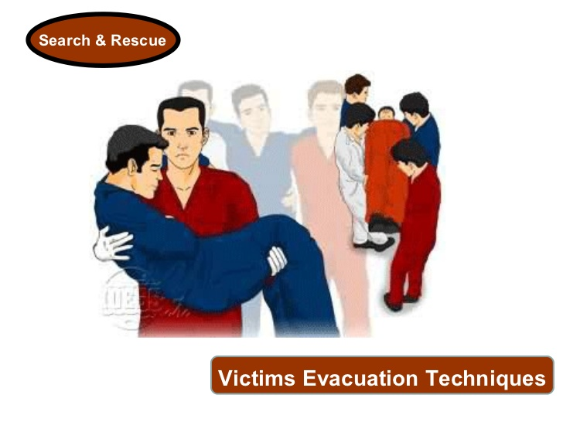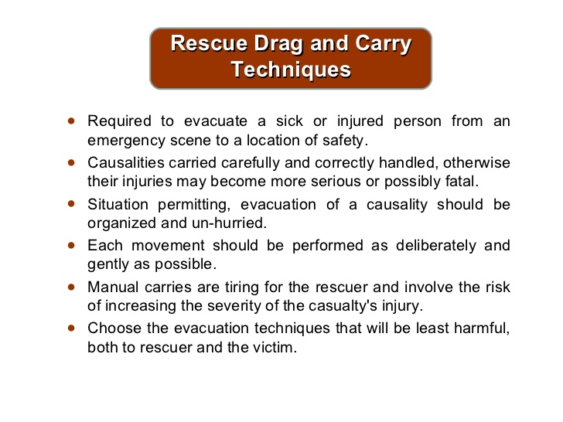
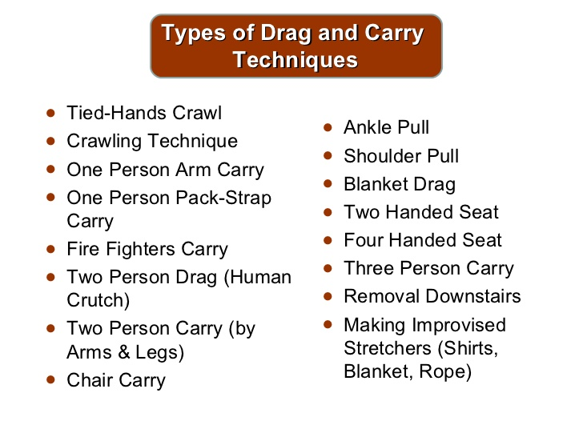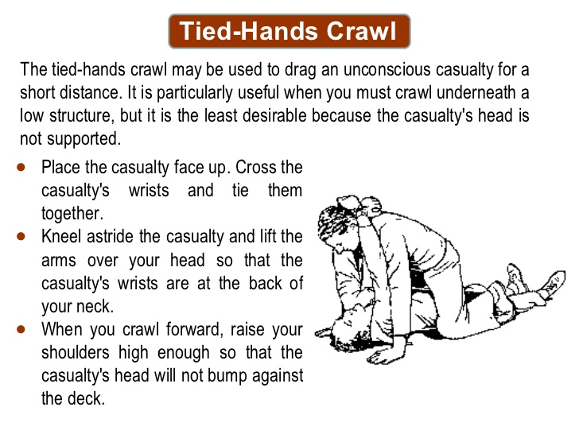
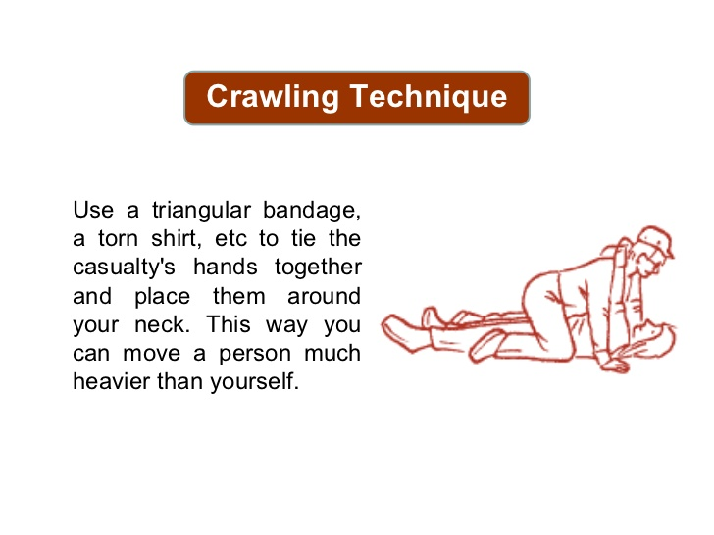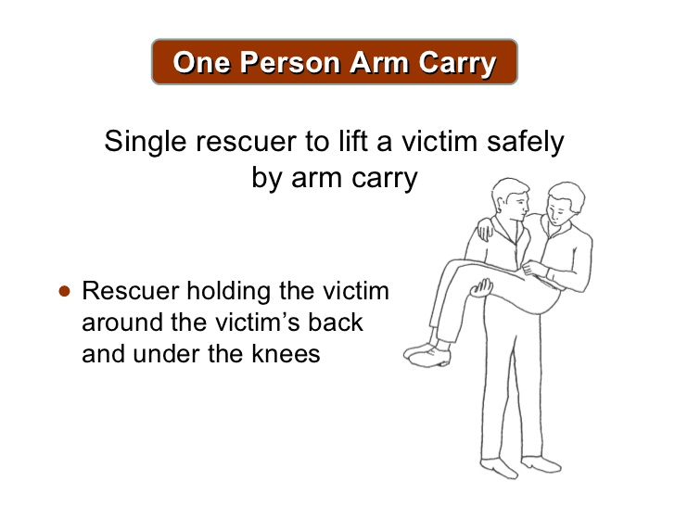

Victims Evacuation Techniques

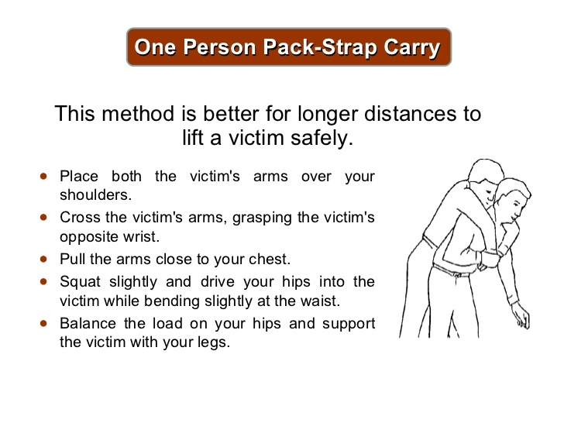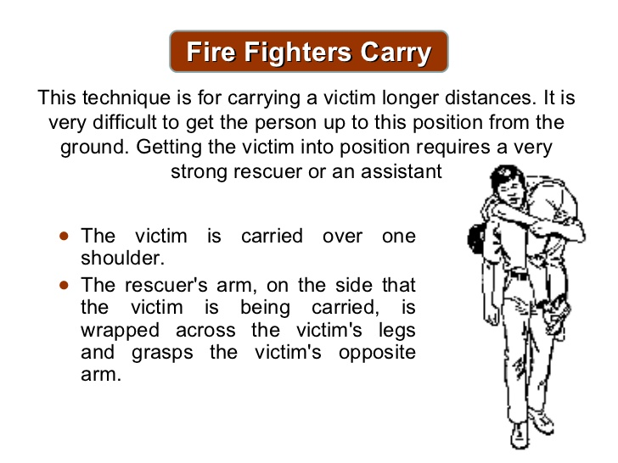
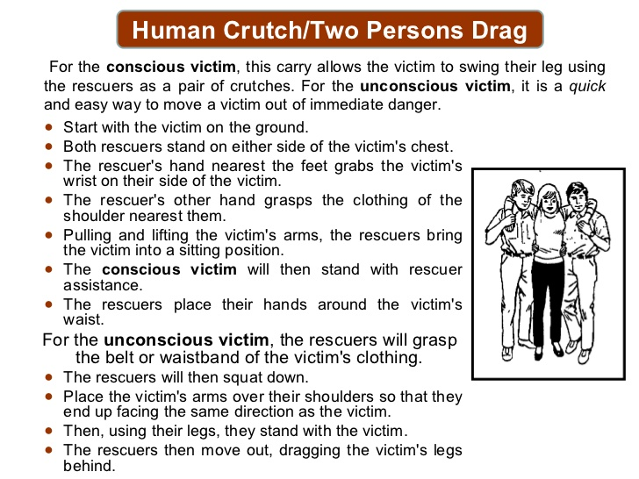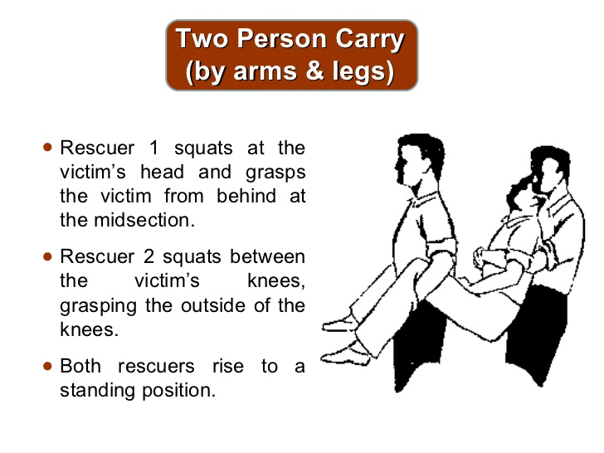
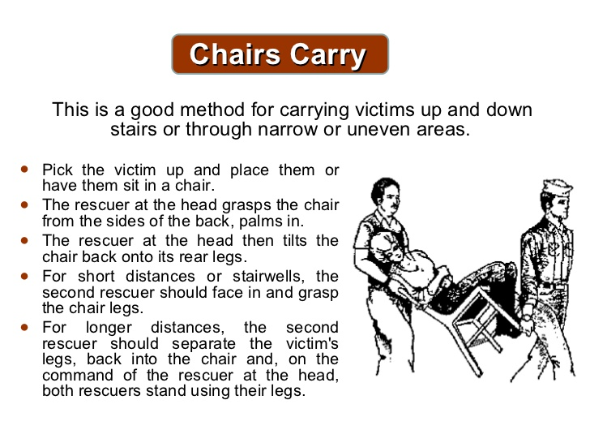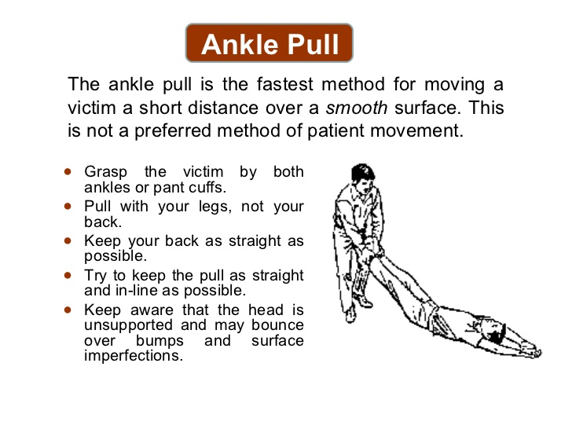

Victims Evacuation Techniques

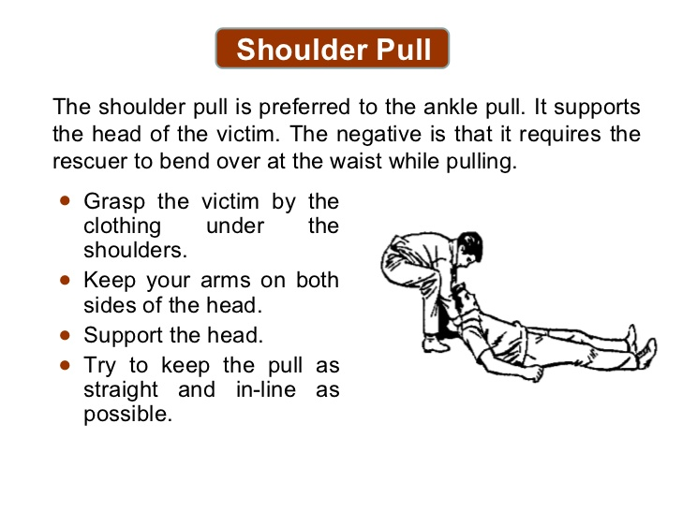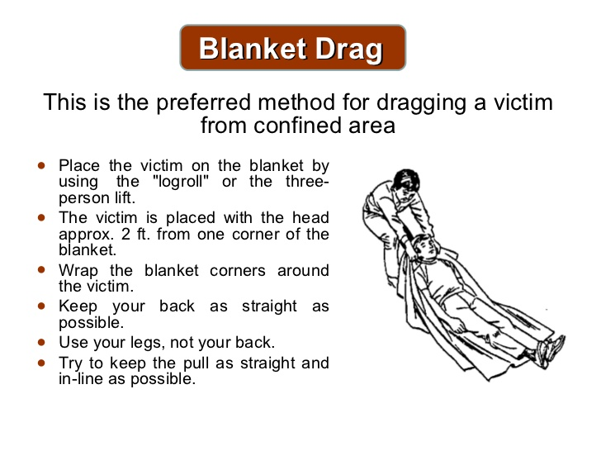
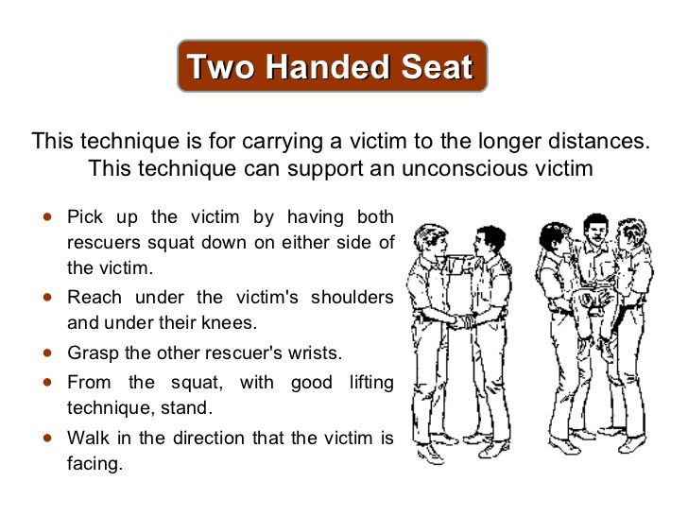

Our biggest fear is FIRE

- Remember, with a fire, never open a door that feels hot
- Most local ordinances require facilities have sprinklers.
- Management must arrange for inspections per city code.
- If your exit is blocked, stay in room with door closed and open a window a few inches, hang sheet outside.
- Smoke is the big killer: if possible, seal around doors and vents with wet towels to keep smoke out.
- Do you go back inside to evacuate a second person?
- Use your judgment. But know most fire departments will advise you to never re-enter a burning building once you have exited.

When is it safe to return? Approval may come from
  - Fire department
  - Insurance Company
  - Restoration Company
  - DHS may wish to re-inspect
Resident Evacuation- Regulations
R9-10-819A (5, 6, 8) Emergency and Safety Standards:
Manager shall ensure:
- An evacuation drill for employees and residents:
        - Is conducted at least once every six months; and
  - Includes all individuals on the premises except for:
    - A resident whose medical record contains documentation that evacuation from the assisted living facility would cause harm to the resident, and
    - Sufficient caregivers to ensure the health and safety of residents not evacuated according to subsection (A)(5)(b)(i);
- Documentation of each evacuation drill is created, is maintained for at least 12 months after the date of the evacuation drill, and includes:
        - The date and time of the evacuation drill;
        - The amount of time taken for employees and residents to evacuate the assisted living facility;
        - If applicable:
- An identification of residents needing assistance for evacuation, and
- An identification of residents who were not evacuated.
- Any problems encountered in conducting the evacuation drill; and
- Recommendations for improvement, if applicable; and
- Elopement drills as previously di if applicable ( report elopements w/I 24hours)
- An evacuation path is conspicuously posted in each hallway of each floor of the assisted living facility.

Resident Transportation
R9-10-809(A) (B) Transport
- Except as provided in subsection (B), a manager shall ensure that:
      - A caregiver or employee coordinates the transport and the services provided to the resident;
      - According to policies and procedures:
        - An evaluation of the resident is conducted before and after the transport, and
        - Information from the resident’s medical record is provided to a receiving health care institution; and
      - Documentation includes:
        - If applicable, any communication with an individual at a receiving health care institution;
  - The date and time of the transport; and
  - If applicable, the name of the caregiver accompanying the resident during a transport.
- Subsection (A) does not apply to:
      - Transportation to a location other than a licensed health care institution,
      - Transportation provided for a resident by the resident or the resident’s representative,
      - Transportation provided by an outside entity that was arranged for a resident by the resident or the resident’s representative, or
      - A transport to another licensed health care institution in an emergency.

Smoking Policies
Facility policies should include if smoking is allowed, and if allowed must have a designated smoking area, amount, type and frequency of assistance the resident may require and included on service plan.

AZ Law- Prohibits anyone including employees, vendors, and customers from smoking inside and within 20 feet of all entrances into any place of business. Required “No smoking” signs must be posted. Visit ADHS website “Smoke-free Arizona” for more information.
Community /External Emergencies:
If a disaster has happened to others in your neighborhood, consider that the 911 system may be overloaded and the responders may be delayed. Your thought-sequence remains the same.

Information for responding to a community problem can be heard on the radio: local radio stations, on-line information can be found on NOAA.gov (National Oceanic and Atmospheric Administration)

Here are some possible emergencies:
1. Hazmat, chemical spill
- Is your facility near a freeway, manufacturing plant?
- Safe relocation must go outside the affected area of your facility. It is advised to have a relocation plan within a five mile radius for those emergencies that are confined to your facility, and a second relocation plan within a ten mile radius for those community-based emergencies listen to the radio for community advice

2. Water contamination, broken water main
- Follow community advice
- Consider bottled water
- Relocate if necessary

3. Police chase or a bomb threat
- Consider your location in relationship to freeways and schools
- Listen to the radio for community advice
- Look all doors until emergency has passed.

4. Electrical Problem/ POWER OUTAGE affecting the neighborhood or entire community
- You have loss of air-conditioning?
- Is that due to an energy system failure or lack of power to the whole building? Remember the target temperature for a facility is 68-85 degrees.
- Heat illness causes more weather-related deaths than lightening, tornadoes, hurricanes and floods combined. Communities have electrical grids.
- The power company may know about your facility and the fragile nature of your residents, but this does not determine whose power gets restored first.
- Power is returned in sequence, their sequence.
- Arizona DHS has a Heat Emergency Response Plan that is available on line.

Consider then:
- Do you have a back-up generator? A generator can power small AC units
- Some facilities have back-up lighting to power the lights necessary for evacuation.
- Remember: candles, open flames, are not safe. Know where your flashlights are

If the problem is just the AC unit, use fans.
- Move residents to cooler areas of the facility, away from windows, offer fluids frequently.
- Close shutters, drapes to keep room cool, going out on the patio may not be cooler. If you do take a resident outside, in any weather condition, be sure to keep water handy and find shade.
- Need a cool place for a short time? Consider malls, libraries, community centers, and a family's home

Suggested Emergency Supplies
- First Aid Kits  - Battery operated radio and fresh batteries  - Flashlights and fresh batteries  - Blankets  - Disposable undergarments  - Disposable gloves, trash bags large and small  - Incontinency products, wipes and briefs  - 3 day emergency food supply  - Emergency water supply  - List of current employees with home telephone numbers | - All Resident Information Sheets  - Adhesive name tags or tape  - List of emergency vendor and pharmacy phone numbers  - MARs and medications  - Residence vehicle filled with gasoline( if applicable)  - Weather alert radio/ battery operated radio  - Ink pens and tablets (in a zip lock bag)  - Extra- large zip lock bags (to put Med. Records and other important paper in)  - Cell phone  - Cash (currency & coins)
Local news channels usually report issued heat watches/warnings which are days that can be deadly. Encourage residents to hydrate and avoid outdoors, monitor those frequently like to or do go outdoors routinely (i.e. smokers).

Signs of Heat Illness
- Sweating Dizziness
- Muscle Cramps Confusion
- Weakness Nausea
- Headaches Weak/rapid pulse

Conditions that increase risk to heat related illness:
- Humidity (monsoon season)
- Obesity resided has existing condition and exhibiting fever, dehydration
- Poor circulation, Heart disease
- Some medications that inhibit perspiration (Parkinson's disease medications)

Treatment:
- Get into a cooler place immediately or shade
- Use cool not cold water to begin cooling person (into the shower with caution)
- Give fluids to drink (room temp is best) if able to swallow
- Call 911 if condition does not improve or signs of distress
Other emergencies requiring staff preparedness and actions:

We have discussed the disasters most everyone fears and are less common to occur. The following problems happen more frequently and require staff preparedness and interventions.

1. Elopement: (Requires policy and procedure)
- Hopefully your facility has already targeted those residents most likely to elope and made you aware of that possibility.
- Special bracelets are obtainable that have GPS capability.
- Contracts can be made with monitoring companies.
- You should always know the whereabouts of all your residents, but there are some that require special attention.
- After you have checked with your coworkers to be sure that the resident is truly not on the premises and that a family member/friend has not taken the resident on an outing:
- Call the Police
- Call the family
- Call in other staff to help / Manager if not on-site must be notified
- Determine when resident was last seen, wearing what?

2. Residents with the same signs and symptoms of illness or condition
a. Call individual doctors to obtain treatment for each resident. Keep families informed. One individuals' blood testing or Chest X-ray may give insight into the infection that others could be sharing. Is there a trend? (Everybody’s sick with the same thing). If the condition is contagious (easily spread from on to another) it may be a good choice to send the resident elsewhere temporarily until symptoms have cleared and is no longer a risk to others.

b. Call your county's health department or Center for Disease Control for information on
  - What to do?
  - What diseases are contagious?
  - What areas need disinfecting?
  - Should the residents be quarantined away from others, visitors?
  - When is it advisable to have restrictions return to normal?

3. Plumbing problem
a. Overflow of toilet?
  - Know where and how to shut off water to the tank; notify management and have residents use other accommodations, commodes.
  - Big flood? Call Carpet Company / Restoration Company; seal off area with plastic sheeting as mold is often inevitable. We don't want mold spores to become airborne.

b. Remember: Electrical safety when there is standing water around appliances. Do not enter. Ask Fire Department to perform a safety evaluation

c. Seal off wet areas until dry

d. Have carpet/restoration Company confirm when mold is no longer a concern.

4. Small Fire
- Know where your facility's extinguisher is.
- This 2A-10BC extinguisher is ideal for a trash can fire but not much more.
- Do not under estimate the speed that a fire can progress to becoming too large to handle.
- Even after a successfully extinguished trashcan fire, call the Fire Department to assess for smoldering
- That could cause later outbreak.
- Electrical fires (appliances, computer equipment) can smolder within walls to cause a later outbreak.

5. Unexpected death
- Call the family, police, doctor and coroner

6. Bugs
- Call contracted exterminator for treatment
- Remove resident from room for treatment of infestation
- Follow professional advice of when is it safe to return resident to the room
- Follow advice to prevent re-infestation
- Follow doctor order if applicable (bed bugs, or scabies)

Resident Safety
R9-10-820 Environmental Standards
      - A manager shall ensure that:
      - The premises and equipment used at the assisted living facility are:
        - Cleaned and, if applicable, disinfected according to policies and procedures designed to prevent, minimize, and control illness or infection; and
  - Free from a condition or situation that may cause a resident or other individual to suffer physical injury;
- A pest control program is implemented and documented;
- Garbage and refuse are:
        - Stored in covered containers lined with plastic bags, and
        - Removed from the premises at least once a week;
- Heating and cooling systems maintain the assisted living facility at a temperature between 70° F and 84° F at all times, unless individually controlled by a resident;
- Common areas:
- Are lighted to ensure the safety of residents, and
- Have lighting sufficient to allow caregivers and assistant caregivers to monitor resident activity;
- Hot water temperatures are maintained between 95º F and 120º F in areas of an assisted living facility used by residents;
- The supply of hot and cold water is sufficient to meet the personal hygiene needs of residents and the cleaning and sanitation requirements in this Article;
- A resident has access to a laundry service or a washing machine and dryer in the assisted living facility;
- Soiled linen and soiled clothing stored by the assisted living facility are maintained separate from clean linen and clothing and stored in closed containers away from food storage, kitchen, and dining areas;
- Oxygen containers are secured in an upright position;
- Poisonous or toxic materials stored by the assisted living facility are maintained in labeled containers in a locked area separate from food preparation and storage, dining areas, and medications and are inaccessible to residents;
- Combustible or flammable liquids and hazardous materials stored by the assisted living facility are stored in the original labeled containers or safety containers in a locked area inaccessible to residents;
- Equipment used at the assisted living facility is:
  - Maintained in working order;
  - Tested and calibrated according to the manufacturer's recommendations or, if there are no manufacturer's recommendations, as specified in policies and procedures; and
  - Used according to the manufacturer's recommendations;
- If pets or animals are allowed in the assisted living facility, pets or animals are:
        - Controlled to prevent endangering the residents and to maintain sanitation;
  - Licensed consistent with local ordinances; and
  - For a dog or cat, vaccinated against rabies;
- If a water source that is not regulated under 18 A.A.C. 4 by the Arizona Department of Environmental Quality is used:
        - The water source is tested at least once every 12 months for total coliform bacteria and fecal coliform or E. coli bacteria;
        - If necessary, corrective action is taken to ensure the water is safe to drink; and
        - Documentation of testing is retained for at least 12 months after the date of the test; and
- If a non-municipal sewage system is used, the sewage system is in working order and is maintained according to applicable state laws and rules.

B. If a swimming pool is located on the premises, a manager shall ensure that:
      - On a day that a resident uses the swimming pool, an employee:
        - Tests the swimming pool’s water quality at least once for compliance with one of the following chemical disinfection standards:
          - A free chlorine residual between 1.0 and 3.0 ppm as measured by the N, N-Diethyl-p-phenylenediamine test;
    - A free bromine residual between 2.0 and 4.0 ppm as measured by the N, N-Diethyl-p-phenylenediamine test; or
    - An oxidation-reduction potential equal to or greater than 650 millivolts; and
- Records the results of the water quality tests in a log that includes the date tested and test result;
      - Documentation of the water quality test is maintained for at least 12 months after the date of the test; and
      - A swimming pool is not used by a resident if a water quality test shows that the swimming pool water does not comply with subsection (B)(1)(a).

R9-10-821(C) (3) (f,) (g) Physical Plant Standards states:
- A manager shall ensure that:
3. A resident bathroom provides privacy when in use and contains:
f. Grab bars for the toilet and, if applicable, the bathtub or shower and other assistive devices, if required to provide for resident safety; and
g. Nonporous surfaces for shower enclosures and slip-resistant surfaces in tubs and showers.

Daily and preventative maintenance plans for buildings, equipment, and grounds.

The previous regulations R9-10-819 & R9-10-820 “Environmental Services and “Physical Plan” gives the facility a framework for developing policies and procedures for effective and minimum standards of preventative maintenance. The manager must understand, monitor, and enforce these minimum standards and any specific company policy and procedures of preventative maintenance.
Building Preventative Maintenance ______________
- Maintaining a building can seem costly and time consuming. However, remember the quote from Benjamin Franklin — “An ounce of prevention is worth a pound of cure.”
- Performing preventive maintenance on your building will catch many problems before they occur and keep the building in prime operating condition indefinitely.
- Proper maintenance lowers operating cost by prolonging the life of building materials and the mechanical systems that keep a building working.
Preventative building maintenance is the collection of tasks that maintenance workers--or homeowners--perform in order to prevent problems from occurring in the buildings.

The most effective way to carry out this responsibility is to create a checklist of all the tasks t must be done for appearance, safety, and energy savings and to ensure that equipment runs properly and does not wear out prematurely. Rely on the checklist to help you, ensure that your efforts are structured and effective, and prevent the possibility of a task being overlooked.
Equipment Preventative Maintenance
R9-10-820(A) (13) Environmental Standards:
      - A manager shall ensure that:
- Equipment used at the assisted living facility is:
  - Maintained in working order;
  - Tested and calibrated according to the manufacturer's recommendations or, if there are no manufacturer's recommendations, as specified in policies and procedures; and
  - Used according to the manufacturer's recommendations;

Recommendations for common equipment in ALFs:

HVAC
- The heating and cooling system is vital to keep a tolerable temperature and keep the pipes from freezing in the winter. The furnace and air conditioning unit should be thoroughly cleaned at least once a year. Furnace air filters need to be changed at least monthly, and or more often for dirty environments. Dust and debris buildup in air vents can cause allergies and should be cleaned twice a year.

Plumbing
- To prevent major plumbing issues, preventive maintenance should be routinely performed. Check all toilets, faucets and spigots for leaks and fix accordingly. Water heaters should be flushed annually, especially if they are not used very often. In cold climates all exposed pipes must be wrapped with electrical heat tape to prevent freezing.

Electrical
- The electrical wiring of a building must be properly maintained to prevent outages, fires or personal injury from a shock. Inspect all exposed wires for fraying or worn casing and replace the damaged wire immediately. All outlets should be checked for signs of overheating. The electrical panel should be checked for loose wires and have the panel's breakers replaced according to the manufacturer's suggested guidelines. Include replacing light bulbs, back-up generator checks, exit signs lighting.

Exterior
- The exterior of most building are generally low maintenance except for window and door openings. Inspect these openings for water or air leaks and fill with an all-weather silicone caulk. It is also a good idea to inspect the exterior surface for paint flaking or erosion, which are the first signs it needs a fresh coat of paint.

Roof
- The roof of a building offers protection from the elements as well as falling tree limbs and debris. Depending on the roofing material it should be checked twice annually for damage or excess wear, which can cause leakage. Flat or rolled roofing should be checked for cracks and be repaired with tar accordingly. Metal roofs need to be checked for ice damage, seams caulked and replacement sheets installed. Composite shingle roofs should be checked for missing shingles or brittle weak shingles and replaced accordingly

Steps to Create Preventative Maintenance Checklists
      - Decide on which equipment to include in the preventive maintenance program. Equipment that is inexpensive or not designed for a long life may not benefit from preventive maintenance.

      - Consult with the manuals associated with all of the equipment for maintenance instructions. Create a log that includes how frequently equipment maintenance needs to be performed; what type of maintenance is required, the length of down time for the equipment in order to perform the maintenance, and the materials required to perform the maintenance.

      - Set up a schedule based on a yearly timeline. At periodic intervals, include dates for which preventive maintenance should be performed on a particular piece of equipment.

      - Include tags that have check boxes on each piece of equipment in the preventive maintenance program. The tag should also have a line for initials and dates to show that someone has performed preventive maintenance activities on the assigned dates.

      - Include an annual inspection of all of the equipment to check for problems that may be developing but have not yet fully materialized.

      - Document the tables/logs and instructions for preventive maintenance in a word processing file. This file should be a formal document that is read-only so that somebody cannot inadvertently alter the document. Print the document in order to have a hard copy.

      - Distribute the document to all people who use the equipment or are assigned to perform maintenance tasks on the equipment.
See Sample Life-Safety Checklist in handout section

Medical Equipment
Preventive maintenance of medical equipment standards require that medical equipment be stored in safe environments and kept in good operating condition. To establish this precaution, the health care providers who use the equipment need to consult the manufacturer's literature and information about the product.

Use of Medical Equipment
- After you determine what must be achieved for health equipment maintenance, it is important to establish the interval of maintenance. Any specific medical equipment that is used very often must be cleaned and checked more often than items that are used less frequently. The frequency indicated in the manufacturer's manual must be used as a guide. Usually, maintenance procedures are determined depending on the machine's use.

Why Preventative Maintenance?
- Preventative maintenance is a repetitive and regular type of work performed to keep the equipment in good functioning order and to optimize the efficiency and precision of its parts. This task can involve routine cleaning, testing, calibrating, checking and, if necessary, replacement.

Cleanliness and Maintenance
- When you keep an ALF clean, you are taking measures to prevent ALF associated infections. These measures include: having hand-washing facilities, maintaining adequate isolation and ventilation for rooms and providing a safe water supply. All these measures ensure the safety of medical care, avoiding accidents and occupational diseases of ALF staff.

Other Exterior Areas to consider:
- Landscaping
- Patio furnishing good repair, sturdy
- Walking paths or garden areas safe
- Parking Lots
- Outdoor lighting
- What’s your “curb” appeal?
- Designated smoking areas maintained clean and safe
- Training staff on how to secure building at sunset (windows,doors, alarms systems etc.)

Gardens and Landscape Maintenance
Gardens and Landscape maintenance is not difficult if specific tasks are assigned to specific seasons. Pruning and fertilizing in the spring, watering in the summer, winterizing in the fall and garden planning in the winter are examples of easy ways to categorize garden projects.
Spring
Spring is optimal for light garden tasks such as pruning and fertilizing. Remove winter damage such as dead or broken limbs from shrubs and trees, and prune lightly to maintain shape and form. Fertilize heavy feeding plants, like roses. A light coat of mulch such as ground bark applied in the spring will suppress weeds in the summer. Check hoses, sprinklers and drip irrigation for the hot weather to come.

Summer
In summer, fertilize lightly and prune to maintain shape and growth with trees, shrubs and perennials. Remove spent flower buds from perennials to encourage further blooming. Continue to monitor irrigation especially during the hottest
Fall
Fall cleanup will have a major impact on potential disease organisms. After the first hard frost, cut back perennials, rake leaves and add a light coat of mulch. Remove plant debris and either compost or burn it. Protect tender shrubs and perennials with heavy mulch or a frost blanket. (Yes, we get frost in Arizona )

Winter
Winter is a time to observe the garden and plan for the future. Some plants may have thrived and others have failed. Season-to-season examination of the garden is the best way to learn, and it will make a wise gardener despite the climate or other limitations.
Resident Security 
R9-10-815 (F)(1) Directed Care:
- A manager of an assisted living facility authorized to provide directed care services shall ensure that:
      - Policies and procedures are established, documented, and implemented that ensure the safety of a resident who may wander;

- Typically, DHS or your local Fire Department does not specify how to secure your facility, but does requires that we establish control of the possibility that a resident may wander off the property.

- However, in large ALC fire codes may dictated that any system used has panic bars that will open within 30-45 second (local ordinances vary from city to city).

- Remember, if a door was locked from the inside and there was an emergency requiring the residents to get out of the ALF and they do not have access to the key or means to escape through that door then that would typically not be allowed.

- Door alarms are used in most facilities to alert staff that a resident or individuals are attempting to access the exit.

- May use personal alarms, that alert staff of resident movement

- Preventive measures should also be addressed when developing policy and procedures such as
- Encouraging activities that can distract or keep resident busy
- Ensuring there is access to outdoors that is pleasant, comfortable and meaningful
- Staff planned and supervised outdoor activities on a routine basis

Article 11: Patient Safety Reporting and Non-retaliatory Policies
A.R.S. § 36-450. Definitions
In this article, unless the context otherwise requires:
1. "Health professional" has the same meaning prescribed in section 32-3201.
2. "Professional standards of practice" means practicing within the scope of licensure.
3. "Retaliatory action" means termination of or other adverse action against a health professional's employment taken by a health care institution because the professional has made a report pursuant to this article.

A.R.S. § 36-450.01. Reporting procedures
A. Each health care institution licensed pursuant to this chapter shall adopt a procedure for reviewing reports made in good faith by a health professional concerning an activity, policy or practice that the health professional reasonably believes both:
1. Violates professional standards of practice or is against the law.
2. Poses a substantial risk to the health, safety or welfare of a patient.

B. The procedure shall include reasonable measures to maintain the confidentiality of the identity of a health professional providing information to a health care institution pursuant to this section.

A.R.S. § 36-450.02. Non-retaliatory policy
A. Each health care institution licensed pursuant to this chapter shall adopt a policy that prohibits retaliatory action against a health professional who in good faith:
1. Makes a report to the health care institution pursuant to the requirements of section 36-450.01.
2. Having provided the health care institution a reasonable opportunity to address the report, provides information to a private health care accreditation organization or governmental entity concerning the activity, policy or practice that was the subject of the report.
B. This section does not prohibit a health care institution licensed pursuant to this chapter from taking action against a health professional for a purpose not related to a report filed pursuant to section 36-450.01.
C. Except as provided in section 23-1501, paragraph 3, subdivisions (a), (c) and (d), this section shall only be enforced through the provisions of this chapter.
D. There shall be a rebuttable presumption that any termination or other adverse action that occurs more than one hundred eighty days after the date of a report made pursuant to either subsection A, paragraph 1 or 2 of this section is not a retaliatory action.

Chapter 7 Financial Management
CHAPTER 7

Key Terms:
Account - A statement summarizing the record of transactions in the form of credits, debits, accruals, and adjustments that have occurred and have an effect on an asset, equity, liability, or past, present, or future revenue.

Account balance - The net of debits and credits for an account at the end of a reporting period. This applies for all types of accounts. A bank account balance shows the amount owed to you by the bank whereas a credit card balance shows the amount you owe to the credit card company.

Accounting period - A specific period of time in which the activities of a company are summarized, usually a year.

Accounts payable - Money owed by a company to those with which it does business. It is also an accounting entry that represents an entity’s obligation to pay cash to its creditors. The accounts payable entry is found on a balance sheet under the heading current liabilities. Accounts payable are often referred to as payables. Think of the phone company, the gas company, and the community food vendor as types of creditors. Each demands payment for goods or services rendered and must be paid accordingly. If a community doesn’t pay its bills, it is considered to be in default.

Accounts receivable - Money owed by customers (residents or others) to a community in exchange for goods or services that have been delivered or used but not yet paid for. Accounts receivable usually come in the form of operating lines of credit and are usually due within a relatively short time period, ranging from a few days or weeks to a year. Most accounts receivable in assisted living are for services billed in. If you look at the balance sheet of an assisted living community, you will usually see accounts receivable recorded as an asset because they represent a legal obligation for the customer to remit cash for its debts. Accounts receivable are not limited to businesses—individuals have them as well. People get receivables from their employers on a monthly or biweekly basis in the form of a paycheck. They are legally owed this money for services (work) provided.

Accrued interest payable - A current liability account that shows amount of interest accrued on a company debt even though it has not been charged with interest.

Amortization - Process of paying off a liability, deferred charge, or capital expense over some period of time.

Auditing - The process of checking records and reports to make sure they are accurate.

Assets - Property used in operation of the company, that includes cash, buildings, good will, land, and so forth.

Breakeven point - Level of operation at which dollars received from sales just cover fixed overhead and the variable costs involved in operations.

Budget - Operating road map of future financial performance. Budgets outline company and individual goals and responsibility and a measure for evaluating performance.

Chart of accounts - An index showing the order and numbering of all the accounts in a ledger.

Control systems - A system designed to manage a specific operating system. A control system for managing departmental purchases might include a beginning monthly budget amount that gets translated to a monthly budget control sheet. Monthly purchase order amounts are then recorded on the sheet showing a remaining balance. As goods are received, purchases are matched to invoices to ensure that the correct goods and prices are received and that payment is made.

Cost accounting - Deals with the measurement and allocation of costs to be assigned to a service or a phase of a service or production.

Cost creep - The increasing of costs (usually labor) as a result of increased resident acuity (need) without any corresponding increase in revenue as an offset.

Current assets - Cash and its equivalents, receivable, inventories.

Current ratio - Current assets divided by current liabilities; determines how financially sound the company is. The wider the margin by which current assets exceeds current liabilities, the sounder the company.

Debit/credit - Credit: An accounting entry system that either decreases assets or increases liabilities. Debit: An accounting entry that results in either an increase in assets or a decrease in liabilities on a company’s balance sheet or in your bank account.

Depreciation - System of allocating original cost of an item over the expected life of the item, which is charged off as part of the cost as an expense on each accounting period.

Equities - Rights to the assets. Either (1) creditors; through loans, are debts of business; (2) proprietors; through money invested by people in the company (owners’ equity).

FICA tax - Social security taxes, FOB Federal Old Age Benefits Tax.

Fiscal year - Yearly accounting period used by a company. Any 12-month period chosen by the company for computing and reporting profits.

Fixed assets - These assets fairly permanent, used in the business, not bought for resale.

Fixed charges - Interest charges, rent, lease payments, debt payments

Income statement - Shows revenues, expenses, and net results of a business operation for a given period.

Inventories - Goods on hand, raw material, supplies.

Journal - Primary record of every transaction in chronological order.

Ledger - Group of accounts used by a company.
CHAPTER 7

Liabilities - Debts, ownership by stockholders (payable), reserves, claims against company.

Modeling - A process by which various operational scenarios are tested using a computer-based program to determine the optimal solution for an operational problem.

Net worth - Represents excess of assets over liabilities, also known as stockholder’s equity or capital.

Salary - Compensations paid to those at managerial levels.

Time and acuity - Terms used to help providers understand the common elements of operation. Salary and wages are paid based on time just as care is delivered in time increments. Acuity is a means of translating resident care needs into segments of time.

Unearned revenue - Revenue collected in advance or prepaid revenue. Most assisted living communities collect rent in advance. This is then earned throughout the month.

Voucher - form on which a liability is recorded, in addition to information about how and when the liability is paid.

Wages - Describe sums paid to workers on an hourly or weekly basis.

Working capital - Equal to current liabilities minus current assets plus net income, depreciation, deferred taxes, and proceeds from any sale of noncurrent assets.

Regulatory Compliance: Starts with the NCIA Board: R4-33-603(C)(5)

Regulatory Compliance Federal, State and Local:
CHAPTER 7

In chapter 6 we covered many Local, state and federal agencies that have established requirements that affect the residence and its environment such as OSHA, NFPA, FDA, etc. In this chapter will be examining those requirements that ensure financial management policies, practices and compliance applicable with federal, state, and local laws, rules and regulations.

There are numerous requirements for ALF in the State of Arizona, some examples are as follows:
  - Arizona New Hire Reporting
  - Information Required for Your Employees
  - Employee Recordkeeping
(We will exam payroll and other employee issues later in this chapter)
Let’s review these requirements go to web-link: www.azdes.gov/main.aspx?menu=316&id=4008

The following are summaries of some of the most critical federal laws pertaining to financial management issues of assisted living, we will exam each separately:
- Medicare
- Medicaid
- Americans with Disabilities Act (ADA)
- Health Insurance Portability and Accountability Act (HIPAA)
- Sarbanes-Oxley Act of 2002
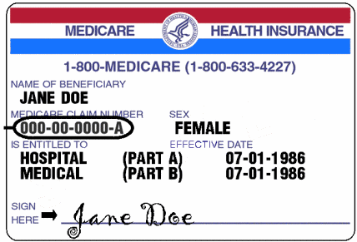

Medicare:
Medicare provides basic healthcare benefits to those
- Over age of 65
- People on social security disability for 26 months or longer
- People with end-stage renal disease

Medicare has two parts: Part A and Part B
- Part A is for hospital services
- Part B pays for home health services and hospice care for the terminally ill

The 1977 Fraud and Abuse amendments and later regulation: Prohibits business relationships that increase the utilization of Medicare by soliciting remuneration (monetary rewards) to induce referring or arranging services to be paid by Medicare or Medicaid programs. These Anti-kickback laws will penalizes violators who knowing and willing solicits, receives offers or pays for referring or arranging for services to be paid for by Medicare or Medicaid

The most significant and historic legislative change to Medicare and Medicaid was:
- Medicare Modernization Act ( MMA)
- Signed in law December 2003
- Enacted to add an out-patient prescription drug benefit of Medicare
- Is known as Medicare (Part D)- Residents in ALF can use Part D coverage
Official Medicare website; www.medicare.gov/

Medicaid:
- Was enacted in 1965 as an amendment to the Social Security Act of 1935
- Entitling low-income, blind and disabled persons to medical care
- Is a vendor plan-payment is made directly to the vendor( entity of person that provides the services)
- Only approved providers can receive payments
- Federal government subsidizes, and grants States waiver
- 26 states ( AZ included ) currently accept Medicaid waiver monies to pay for AL services

Americans with Disabilities Act (ADA)
- Purpose is to establish clear and comprehensive prohibition of discrimination on basis of disability
- Similar protections against discrimination as the Civil Rights Act of 1964
- After January 26, 1993 new constructed facility must meet or exceed the ADA standards of accessible design

Health Insurance Portability and Accountability Act (HIPAA)
- Enacted 1996 and amended through 2006
- Title I –protects health insurance coverage for worker and their families when the change of lose their job
- Title II -protects privacy of electronic health care transactions

Key Terms:
Confidentiality -the legal and ethical principle of keeping information private.

Protected health information (PHI) - a person’s private health information, which includes name, address, telephone number, social security number, email address, and medical record number

Is an ALF a Healthcare Provider?
Healthcare Providers include:
  - Doctors
  - Clinics
  - Psychologists
  - Dentists
  - Chiropractors
  - Nursing Homes
  - Pharmacies
...but only if they transmit any information in an electronic form

A Business Associate” is a person who performs a function or activity on behalf of, or provides services to, a Covered Entity that involves Individually Identifiable Health Information

Electronic Transmissions
- For all Healthcare Providers who transfer Individually Identifiable Health Information by a paper-to-paper fax machine is not considered an electronic transaction.

- However, computer-to-computer fax, paper-to-computer fax, and computer-to-paper fax qualify as electronic transmissions and are subject to HIPAA provisions (such as encryption).

PHI (Protected Health Information)

Defined : Any information that can be used to identify a patient – whether living or deceased and which relates to the patient’s past, present, or future physical or mental health or condition, including healthcare services provided and the payment for those services.

PHI: Employees may access PHI only when necessary to perform their job-related duties

Any of the following are considered identifiers under HIPAA
- Patient names  - Geographic subdivisions (smaller than state)  - Telephone numbers  - Fax numbers  - Social Security numbers  - Vehicle identifiers  - E-mail addresses  - Web URLs and IP addresses  - Dates (except year)  - Names of relatives | - Full face photographs or images  - Healthcare record numbers  - Account numbers  - Biometric identifiers (fingerprints or voiceprints)  - Device identifiers  - Health plan beneficiary numbers  - Certificate/license numbers  - Any other unique number, code, or characteristic that can be linked to an individual.

Forms of Sensitive Information
It is the responsibility of every employee to protect the privacy and security of sensitive information in ALL forms.
Sensitive Information exists in various forms…


Printed Spoken Electronic

Examples of Sensitive Information
- Social Security numbers
- credit card numbers
- driver’s license numbers
- personnel information
- research data
- computer passwords

Individually identifiable health information
The improper disclosure of sensitive information presents the risk of identity theft, invasion of privacy, and can cause harm and embarrassment to, staff, residents, and the facility.

Breaches of information privacy can also result in criminal and civil penalties for the company and for those individuals who improperly access or disclose sensitive information, as well as disciplinary action for responsible employees. Every employee must protect the privacy and security of sensitive information.
Access must be authorized

- If an employee accesses or discloses PHI without a patient’s written authorization or without a job-related reason for doing so, the employee violates Company policy and HIPAA.
- An employee may only access or disclose a patient’s PHI when this access is part of the employee’s job duties.
- It is never acceptable for an employee to look at PHI “just out of curiosity,” even if no harm is intended.
- It also makes no difference if the information relates to a “high profile” person or a close friend or family member – ALL information is entitled to the same protection and must be kept private.

These rules apply to all employees, including health care professionals.

REMEMBER:

- HIPAA applies to all healthcare providers.
- There are serious penalties for violating these regulations.
- Penalties differ depending upon the violation and can include fines ranging from $100 to $250,000 and/or prison sentences of up to ten years.
- Maintaining confidentiality is a legal and ethical obligation.
- It is part of respecting your residents and their rights.
- Discussing a resident’s care or personal affairs with anyone other than your supervisor or another member of the care team violates the law.



Sarbanes-Oxley Act of 2002

- Established oversight publicly traded companies
- Deals with truth in financial reporting to an established board (Public Company Accounting Oversight Board PCAOB) that operates under SEC-Securities and Exchange Commission
- Law requires to report finances and be checked by an independent auditor
- Key element companies must monitor and report on their company’s internal controls
- Annual assessments that outline the effectiveness of internal auditing are required to be submitting
- Holds executives responsible with both and criminal penalties
- Other parts of the Act include, Code of Ethics standard and protection for whistle-blowers, many “private-sector” companies have adopted these standards also

Generally Accepted Accounting Principles (GAAP)
CHAPTER 7

- Widely accepted set of rules, conventions, standards and procedures for reporting financial information
- Established by the Financial Accounting Standards Board (FASB)
- Imposed so investors have minimum level of consistency in financial statements used to analyze companies for investment purposes
- Companies are expected to follow GAAP when reporting financial data

Reporting Financial Data is done through annual reports that include:

- Balance sheet which shows the financial position at any given point in time. This statement gives information about assets, liabilities, and equities of a community
- Income statement which Shows revenues, expenses, and net results of a business operation for a given period
- Statement of change in financial position
- Auditor’s reports
- Description of company’s operations

Accrual Accounting vs. Cash Accounting
- Accrual-considered the standard accounting practice most common used in AL, provides most accurate financial picture, but expensive to implement.
- Cash is the opposite , it recognizes transaction only when there is an exchange of cash

Not-for Profit vs. For-Profit: Accounting differences:
Not-for Profit | For-Profit
Are mission based | Exist for financial benefit of owners/shareholders
Receive portion of income from contributions | Income from sales of services
Track contribution by level of restriction & function

Types of contribution restrictions (not-for-profit) are:
- Unrestricted (used for general benefit- donor has made no specific purpose or time frame it must be used)
- Temporarily restricted (specific purpose or during a specific time period)
- Permanently restricted ((form of endowment –can invest to generate income, but not allowed to spend original contribution

Financial Statement Analysis:
Readers of financial statement can learn a lot about how “healthy” a company is by examining the numerical information presented on key financial statements which include the following:
- Balance sheet
- Income Statement or Statement of Operations
- Cash Flow Statement

Income Statement or Statement of Operations differences:
Not-for Profit | For-Profit
Statement of Operations is the financial report | Income statement is the financial report
Financial indicators are: Surplus or deficit | Summarizes revenues and expenses
Income > expense = surplus | Shows net profit or loss (known as P & L)
Expense > Income = deficit | Most analyzed portion of a financial statement
No rule to indicate if should haves, surpluses, deficits or breakeven | Deficit would mean loss & viewed as negative financial indicator
Typically budgeted to breakeven | Budgeted to make money
(See Page 109 related Surplus and deficit details)

Variance Reports:
“Budget to actual for revenue and expense”- most commonly used financial indicator it compares the budgeted revenue to actual revenue and the budgeted expense to actual expense. Done on both a month and year-to date (YTD) basis. Variations from the budget are analyzed and are described as variances. This type of analysis is common in both for-profit and not-for profit companies.

Net Operating Income Margin: (NOIM)
Operating Expense
Total Revenue
This ratio indicates what the company’s pricing policy is and what its true operating margins are. This is a very useful tool when comparing against the margins of previous years. Use to calculate operating margin for total facility. Other ratios and financial indicators see pages. 110-112 NAB Text

Balance Sheet or Statement of Position
- Balance sheet- is utilized in “for-profit” companies
- Statement of Position is utilized in “not-for profit” companies

We will exam the balance sheet only. See NAB text pg. 110- for “not-for profit” Statement of Position

The balance sheet is the financial statement that summarizes a company’s assets, liabilities, and shareholder’s equity at a specific point in time.
- Called a balance sheet because the two sides balance out
- It is one of the most important pieces of the financial information issued by the company
- Is a snapshot of what a company owns and owes at that point in time
The three segments of the balance sheet give owners, investors, and other stakeholders a summary of what the company:
- Owns
- Owes and
- The amount invested by the shareholder
The income statement on the other hand shows revenue and profit a company has generated over certain time. Neither is better than other, are built to use together to present a complete picture of the company’s finances.

The balance sheet must follow the basic accounting formula (principle) which is:
Assets =Liabilities + Shareholder’s (owners) Equity

Basic Accounting Lesson
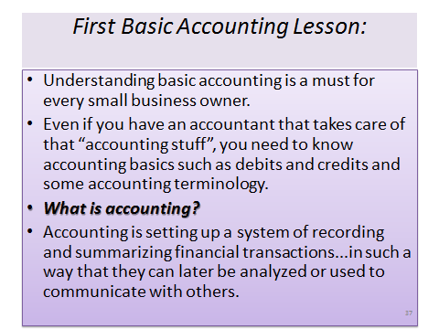

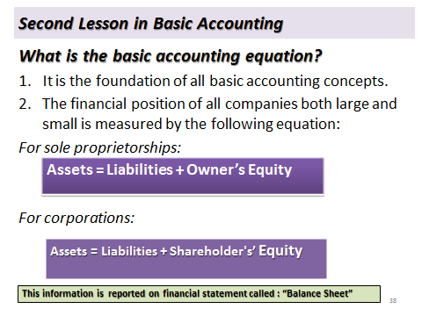
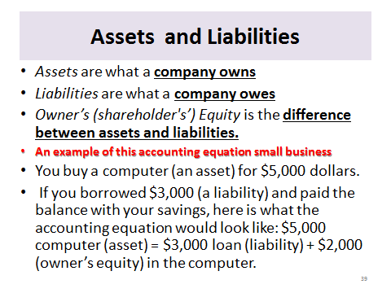

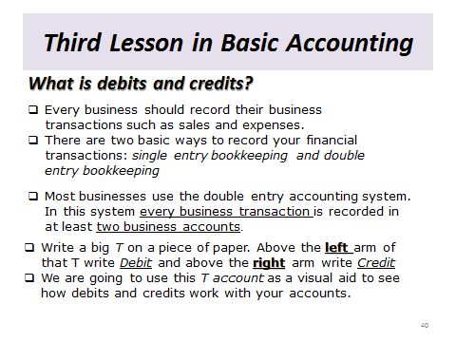

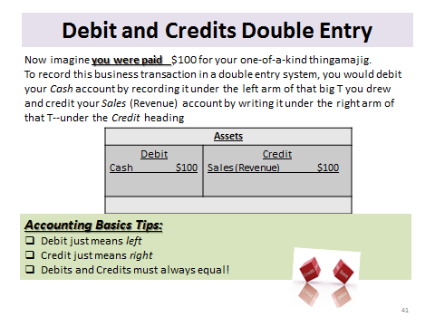

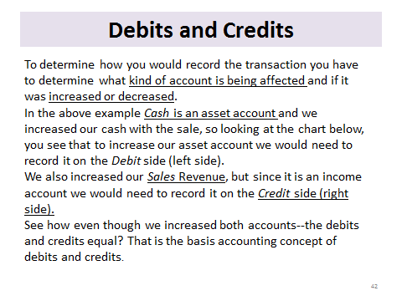
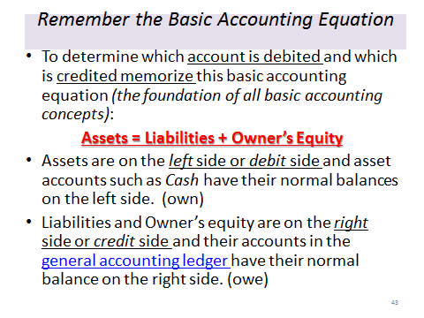

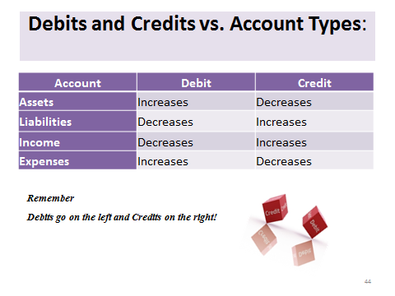



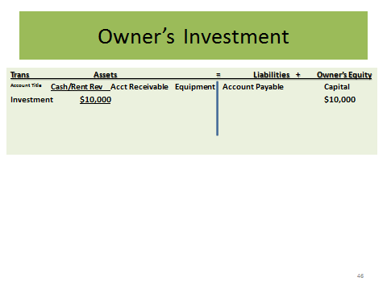
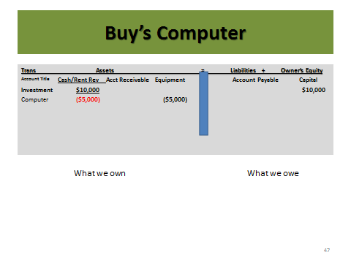

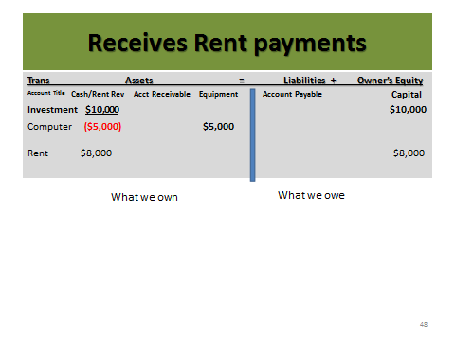

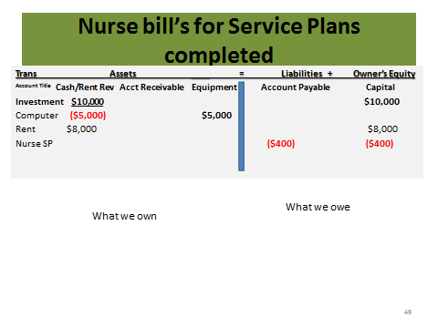

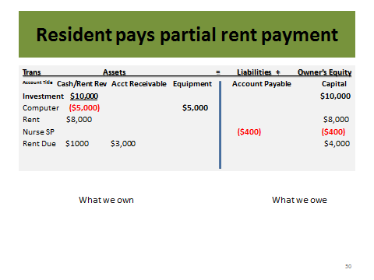
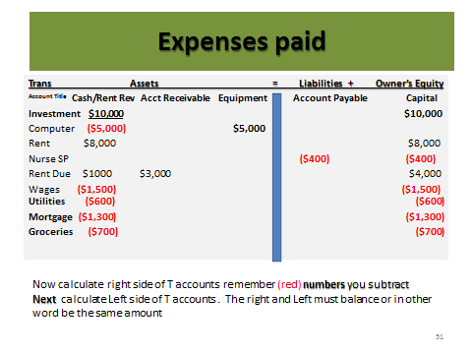

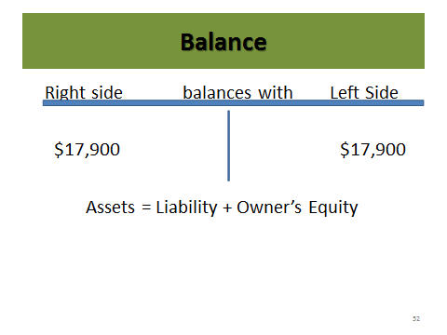

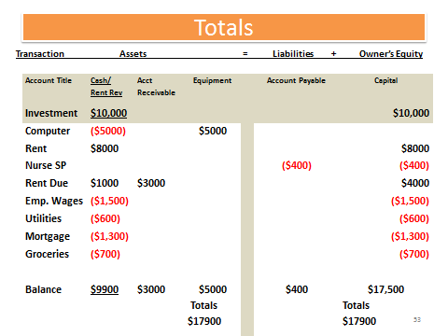

You did it!

Cash Flow or Statement of Change in Financial Position:

The cash flow or statement of change in financial position is a document providing aggregate data
Regarding all cash inflows received from both its operations and external investment sources, and all
cash outflows that pay for business activities and investments during a given time.

- To have positive cash flow company’s long term inflows need to exceed it’s long term outflows
- The balance sheet is snapshot for a given time of assets and liabilities
- The income statement indicates business profitability during a certain time
- The cash flow statement acts as a kind of corporate checkbook that reconciles the two statements
- General shows cash flow in and out of the organization three areas:
    - Cash flow from operating activities (day –to day operations revenuer & expense)
    - Cash flow from investing activities (dollars earned or spent investments ie money market )
    - Cash flow from financial activities ( cost of capital to refinance loan of capital equipment)

Internal Control
Is a series of procedures designed to provide sound management and financial practices, following internal control procedures significantly increases these four things:
- Financial information is reliable
- Assets and records are properly managed and maintained
- Policies are followed
- Proper accounting rules are followed

Elements of effective internal accounting control systems must include well-defined policy and procedures for managing the following accounting systems:
- Cash receipts (ensure all cash is received promptly deposited, recorded, reconciled and adequate security)
- Cash disbursements (disbursed only upon proper authorization)
- Petty Cash (disbursed properly, safeguarded and recorded)
- Payroll ( disbursed to bona fide employees, recorded, payroll taxes deposited , comply with all legal requirements)
- Grants, gifts ,bequests (received and recorded compliance with terms and restrictions)
- Fixed assets (are acquired and disposed with proper authorization, recorded and safeguarded)

Most important control is to segregation of duties –“one person shouldn’t manage all” Manager needs to over-see the day to day operations to ensure policy and procedures are implemented, followed and managed correctly.

Financial management encompasses planning, directing, evaluating and monitoring all of the facility’s management systems that effect revenues and expenses. This includes all budgeting activities related to the facility.

Budgeting:

Budget - Operating road map of future financial performance. Budgets outline company and individual goals and responsibility and a measure for evaluating performance

Common terms in building budgets – review Pages 114-115 NAB text book

Five (5) Steps to budgeting process:
- Assessing the environment
- Programming
- Developing the operating budget
- Building the cash budget
- Determining the capital budget

Review pages 117-118 NAB Text for details of the 5 steps of budgeting

Short- term Strategic Planning- (Budgeting)
Budgeting can be a form of strategic planning by where financial goals and objectives are projected over the next fiscal year. It does require the same skills and goals as long-term strategic planning. One most importantly is how do we excel in the next fiscal year? Step one of planning a budget requires internal and external analysis. The SWOT matrix gives us a framework to ask those questions what are our strengths, weaknesses, opportunities and threats. Typical all department heads, managers, owners and line-staff could be included will all brainstorm using the SWOT matrix, looking for ways to improve or expand services and drive revenues.

SWOT Matrix
Strengths and weaknesses are often internal to your organization, while opportunities and threats generally relate to external factors. For this reason, SWOT is sometimes called Internal-External Analysis and the SWOT Matrix is sometimes called an IE Matrix
Originated by Albert S Humphrey in the 1960s, the tool is as useful now as it was then. You can use it in two ways – as a simple icebreaker helping people get together to "kick off" strategy formulation, or in a more sophisticated way as a serious strategy tool. http://www.mindtools.com/pages/article/newTMC_05.htm

Long-term Projections or Strategic Planning
Is an organization's process of defining its strategy, or direction, and making decisions on allocating its
resources to pursue this strategy. In order to determine the future direction of the organization, it is necessary
to understand its current position and the possible avenues through which it can pursue particular courses of
action. Generally, strategic planning deals with at least one of three key questions:

- "What do we do?"
- "For whom do we do it?"
- "How do we excel?"

Many organizations view strategic planning as a process for determining where an organization is going over the next year or—more typically—3 to 5 years (long term), although some extend their vision to 20 years, or even (in the case of Mitsubishi) 500 years. George Friedman in The Next 100 Years summarizes "the fundamental principle of strategic planning: hope for the best, plan for the worst".

Strategic planning is a very important business activity. It is also important in the public sector areas such as education. It is practiced widely informally and formally. Strategic planning and decision processes should end with objectives and a roadmap of ways to achieve them. The goal of strategic planning mechanisms like formal planning is to increase specificity in business operation, especially when long-term and high-stake activities are involved.
One of the core goals when drafting a strategic plan is to develop it in a way that is easily translatable into action plans. Most strategic plans address high level initiatives and overarching goals, but don't get articulated (translated) into day-to-day projects and tasks that will be required to achieve the plan.

Terminology or word choice, as well as the level at which a plan is written, are both examples of easy ways to fail at translating your strategic plan in a way that makes sense and is executable to others. Often, plans are filled with conceptual terms which don't tie into day-to-day realities for the staff expected to carry out the plan.

The following terms have been used in strategic planning: desired end states, plans, policies, goals, objectives, strategies, tactics and actions. Definitions vary, overlap and fail to achieve clarity. The most common of these concepts are specific, time bound statements of intended future results and general and continuing statements of intended future results, which most models refer to as either goals or objectives (sometimes interchangeably).

One model of organizing objectives uses hierarchies. The items listed above may be organized in a hierarchy of means and ends and numbered as follows: Top Rank Objective (TRO), Second Rank Objective, Third Rank Objective, etc. From any rank, the objective in a lower rank answers to the question "How?" and the objective in a higher rank answers to the question "Why?" The exception is the Top Rank Objective (TRO): there is no answer to the "Why?" question. That is how the TRO is defined.

People typically have several goals at the same time. "Goal congruency" refers to how well the goals combine with each other. Does goal “A” appear compatible with goal “B?” Do they fit together to form a unified strategy? "Goal hierarchy" consists of the nesting of one or more goals within other goal(s).

One approach recommends having short-term goals, medium-term goals, and long-term goals. In this model, one can expect to attain short-term goals fairly easily: they stand just slightly above one's reach. At the other extreme, long-term goals appear very difficult, almost impossible to attain.

Strategic management jargon sometimes refers to "Big Hairy Audacious Goals" (BHAGs) in this context. Using one goal as a stepping-stone to the next involves goal sequencing. A person or group starts by attaining the easy short-term goals, then steps up to the medium-term, then to the long-term goals. Goal sequencing can create a "goal stairway". In an organizational setting, the organization may co-ordinate goals so that they do not conflict with each other. The goals of one part of the organization should mesh compatibly with those of other parts of the organization.

Revenue:
Defined as dollars earned from fees collected, products and /or services sold, and income earned from investments.
In AL most revenue comes from rent and services. To adequate forecast revenue must consider the following
- Current market conditions
- Census patterns and trends
- Resident acuity (care needs)
- Turnover
- Regulatory restrictions and
- Competition

Three (3) primary methods for managing service revenue:
- Combine service and rent for single price (all inclusive)
- Charge care based on level of care or per number (bundle numbers of ADLs and priced as levels)
- Charge a la carte or fee-for-service basis ( more often based on time )

See pages 118-119 NAB Text – sample budgets for all 3 methods

Expenses
If expenses exceed revenues over an extended period of time, without infusion of new capital, the company will cease to be a viable economic entity.

Types of Expenses /Costs:
Variable cost (changes with volume, but cost per unit does not change)
Fixed cost (does vary per unit with change in volume)
Semi-variable cost (vary with disproportionately with volume) ie healthcare salaries related to resident needs
See examples pg 120 NAB Text

Breakeven Point (analysis) is method of comparing revenues and expense that helps us understand the point at which available cash from operations is equal to zero.

Mortgage expense and other forms of debt:
Monitoring and comply with the facility’ financing obligations include all needs for cash, obligations to “pay bills” include short and long term obligations. Mortgage is typically a long-term obligation and most are designed so the borrower repays a level amount on a month-to month basis. Amortization payment allows for budgeting and easier management of cash flow.

Capital Expenditures (CAPEX or capex)
CAPEX or capex are expenditures creating future benefits. A capital expenditure is incurred when a business spends money either to buy fixed assets or to add to the value of an existing fixed asset with a useful life extending beyond the taxable year.

CAPEX are used by a company to acquire or upgrade physical assets such as equipment, property, or industrial buildings. In the case when a capital expenditure constitutes a major financial decision for a company, the expenditure must be formalized at an annual shareholders meeting or a special meeting of the Board of Directors.

          - In accounting, a capital expenditure is added to an asset account ("capitalized"), thus increasing the asset's basis (the cost or value of an asset adjusted for tax purposes). CAPEX is commonly found on the cash flow statement under "Investment in Plant, Property, and Equipment" or something similar in the Investing subsection.

          - For tax purposes, CAPEX is a cost which cannot be deducted in the year in which it is paid or incurred and must be capitalized. The general rule is that if the acquired property's useful life is longer than the taxable year, then the cost must be capitalized. The capital expenditure costs are then amortized or depreciated over the life of the asset in question.
          - Further to the above, CAPEX creates or adds basis to the asset or property, which once adjusted, will determine tax liability in the event of sale or transfer. In the US, Internal Revenue Code §§263 and 263A deal extensively with capitalization requirements and exceptions.
Included in capital expenditures are amounts spent on:
- acquiring fixed, and in some cases, intangible assets
- repairing an existing asset so as to improve its useful life
- upgrading an existing asset if its results in a superior fixture
- preparing an asset to be used in business
- restoring property or adapting it to a new or different use
- starting or acquiring a new business

An ongoing question for the accounting of any company is, whether certain expenses should be capitalized or expensed? Costs which are expensed in a particular month simply appear on the financial statement as a cost incurred that month.

Costs that are capitalized, however, are amortized or depreciated over multiple years. Capitalized expenditures show up on the balance sheet. Most ordinary business expenses are clearly either expendable or capitalized, but some expenses could be treated either way, according to the preference of the company. Capitalized interest if applicable can be spread out over the life of the asset. Amortization - Process of paying off a liability, deferred charge, or capital expense over some period of time.

Other forms of debt commonly used in buying or building or operating ALF can include
- Leases on building or equipment
- Lines of credit for working capital
- Vehicle loans and/or leases
- Vendor carry on inventories ( start-up inventories)

Types of Contracts seen in ALF:
- Professional (could be a healthcare provider, beautician
- Vendor (outside services ie dining linens , uniforms, pest control)
- Resident ( lease agreements)

Maintain appropriate insurance coverage

Typically five (5) different types:
- Property and casualty insurance
- Professional liability insurance
- Auto or vehicle insurance
- Employee health insurance
- Directors or officers insurance (errors and omissions)

Maintaining appropriate insurance coverage: AZ Assisted Living
No insurance is required by AZDHS to run a Licensed Assisted Living Facility in the State of Arizona. However, if an ALF is contracting with one of the AHCCCS providers like “Mercy Care, Evercare, or Bridgeway,” then the AHCCCS requirements for insurance are $1,000,000 per occurrence and $3,000,000 aggregate for both General and Professional Liability.
It is important to note there are currently two types of insurance use by insurance carriers to determine coverage when writing liability insurance. The two types of coverage are known as
- “Claims-Made and
- “Occurrence.”

Occurrence Policies - Coverage will only respond to claims for acts, errors or omissions that take place after the policy effective date and before the policy expiration date, regardless of when the claim is reported.

Claims-Made Policies - Coverage will only respond to claims which are reported during the term of the policy. The policy covers professional services rendered on or after the policy inception date or an earlier Retroactive/Prior Acts Date as shown on the policy declaration page.

There is no coverage for claims reported after the policy expiration date, even if the incident occurred during the policy period unless the policy is renewed or an Extended Reporting Period Endorsement (“Tail”) is purchased.

While “Occurrence Coverage” is based on when the claim occurred, “Claims-Made Coverage” is based on when the claim is reported (when the claim is made.) The Extended Reporting Period Endorsement (“Tail”) Coverage is available at expiration, for an additional charge, if the policy is non-renewable by either the insurance carrier or the insured.

However, it is important to note, if your policy is canceled for non-payment of premium, then “Tail” Coverage will not be offered and there will be no coverage for any claim after the date of cancellation.

AHCCCS will accept either type of insurance, but it is obvious that “Occurrence Coverage” provides less risk to the insured, but that low risk comes with a higher premium.

Another consideration would be to check to see if your insurance company will still provide insurance to you if you are operating an ALF out of your home. Many times insurance companies will not provide home owners / renters insurance if you are running an ALF from your home. So check with them before you have a claim.

Note: Arizona Health Care Cost Containment System (AHCCCS) is Arizona's Medicaid agency that offers health care programs to serve Arizona residents. Individuals must meet certain income and other requirements to obtain services

Liability Insurance Resources Assisted Living Homes

Philadelphia Insurance. My agent’s name is Dennis Gallagher. 602-443-7690

“It includes Home, Fire, and Liability. It is awesome. Worth the cost”. “When I had a pipe brake and 1/2 my home flooded with in minutes, they cleaned everything, restored it and paid me for income loss because I had to move patients to another care home”. “The income loss took the longest but worth it in the end. If anyone ever has a claim to file and needs help with them have them call me I can assist.”

Marta Logan
Extended Family Assisted Living Homes
480-833-6328
www.MesaAssistedLiving.com

Horizon insurance: Jim Mann at 602-992-9750

Provident Insurance Group: Agent Jeff Schmidt 602/ 790-8472

Developing and implement system to monitor and adjust financial performance:
Must monitor all the interlocking control systems may be managed by staff and all information flows up to the Manager. Policy and procedures should be in place to monitor and manage the following:

Revenue and Expenses:
Revenue and Expense management and monitoring, especially labor to avoid or adjust finances related to
cost creep, the increasing of costs (usually labor) as a result of increased resident acuity (need) without any corresponding increase in revenue as an offset.

Purchasing:
All department heads should be familiar with their department budgets and be held accountable for how the dollars allocated are controlled. They should track purchases using budget control forms (often called spend-down form) and a purchase order (PO) system. Invoices when received by accounting staff need to match purchase orders in order for disbursements to be scheduled (paid). All checks and balance in this area ensures proper flow of goods ordered and payments made.
.

Benchmarking:
Is published data that allows providers to compare operating performance (i.e. cost) against others in the industry. The concepts helps providers determine whether their operating cost /results are similar to others. Example is in the area of “per resident day” (PRDs) amount/cost. Can aid in getting a better understanding of how they are functioning in comparison to others in the industry. Publishing’s can be found at NIC.org (National Investment Center.

Resident issues that impact financial management:

Resident Fund
Is money given to the ALF for the purpose of having available money to pay for items, activities and services that the resident may desire while residing at the ALF.

R9-10-803 (G)
G. A manager shall:
1. Not act as a resident’s representative and not allow an employee or a family member of an employee to act as a resident’s representative for a resident who is not a family member of the employee;

2. If the assisted living facility administers personal funds accounts for residents and is authorized in writing by a resident or the resident’s representative to administer a personal funds account for the resident:

a. Ensure that the resident’s personal funds account does not exceed $2,000;
b. Maintain a separate record for each resident's personal funds account, including receipts and expenditures;
c. Maintain the resident's personal funds account separate from any account of the assisted living facility; and
d. Provide a copy of the record of the resident's personal funds account to the resident or the resident’s representative at least once every three months;

3. Notify the resident’s representative, family member, public fiduciary, or trust officer if the manager determines that a resident is incapable of handling financial affairs; and

4. Except when a resident's need for assisted living services changes, as documented in the resident's service plan, ensure that a resident receives at least 30 calendar days written notice before any increase in a fee or charge.

Other Financial Issues:
Refunds
R9-10-807(D)(6) requires:
D. Before or at the time of an individual’s acceptance by an assisted living facility, a manager shall ensure that there is a documented residency agreement with the assisted living facility includes:
6. The policy for refunding fees, charges, or deposits

R9-10-807(G) requires:
A manager may terminate residency of a resident as follows:
- With a 14 day written notice of termination of residency:
        - Nonpayment of fees, charges, or deposit;

R9-10-807(H) requires:
A manager shall ensure that a written notice of termination of residency includes:
- The policy for refunding fees, charges, or deposits;
- The deposition of a resident’s fees, charges, and deposits;

A facility must establish P &P to comply with the above rules: We will discuss in detail later in chapter!

Handling Fees, Deposits and Charges:

These vary from facility to facility
      - The monthly facility fee amount will be established at the discretion of the licensee and may be changed at any time as long as there is at least a 30 day written notice of the change.
      - Deposits are charged at the time of admission and will be established at the discretion of the licensee.
      - Deposits required by the facility will not exceed one month’s rate (landlord / tenant laws).
      - Deposits will be maintained in a bank account separate from the facility’s normal operating accounts and will not be used for the routine operation or expenditures of the facility.(optional to include in agreement)
      - Deposits may be waived at the discretion of the licensee. (or not required at all)
      - Refund of fees and deposits are based upon residency termination, advance written notice and reason for the termination.
      - Charges are acquired or requested by the resident are typically cost associated to ancillary items or services such as supplies, salon, special events, meal tray delivery, and housekeeping or in some facility where resident pays for care services al a carte. List of ancillary services available and pricing should be in the agreement (i.e. nursing service fees for service plans, TB testing, Flu shots will these be charged to resident or will facility absorb this expense/cost)

Residency and Residency Agreements (as related to financial management)
R9-10-807 (D)(6)(7) & (E-J)
A manager shall ensure
D. Before or at the time of an individual’s acceptance by an assisted living facility, a manager shall ensure that there is a documented residency agreement with the assisted living facility includes:
6. The policy for refunding fees, charges, or deposits

E. Before or within five working days after a resident’s acceptance by an assisted living facility, a manager shall obtain on the documented agreement, required in subsection (D), the signature of one of the following individuals:
1. The resident,
2. The resident's representative,
3. The resident’s legal guardian, or
4. Another individual who has been designated by the individual under A.R.S. § 36-3221 to make health care decisions on the individual’s behalf.

F. A manager shall:
1. Before or at the time of an individual’s acceptance by an assisted living facility, provide to the resident or resident's representative a copy of:
a. The residency agreement in subsection (D),
b. Resident’s rights, and
c. The policy and procedure on health care directives; and

2. Maintain the original of the residency agreement in subsection (D) in the resident’s medical record.
Note the importance of all of the above, the residency agreement is a legally binding document and it correlates with our ability to enforce and collect “rent” (revenues). Therefore all the key elements and must be met:
- Must have a residency agreement (developed to fit facility’s criteria and DHS requirements)
- Along with many other DHS requirements (see full regulation R9-10-807) must include in the document policy for refunding fees, charges, or deposits
- Must be signed by a responsible party, resident or other (this is typically the person responsible and capable of paying the bills). Best to do day of move-in and collect first months fees, however DHS allows us 5 working days to complete this.
- Ensure the party/person who signed the document receives a copy
- Then maintain the original document/ agreement in resident’s medical record (this can be a copy with the rent amount redacted and original maintained in a separated locked business file)

Terminating Residency the Agreement by the Manager:
G. A manager may terminate residency of a resident as follows

1. Without notice, if the resident exhibits behavior that is an immediate threat to the health and safety of the resident or other individuals in an assisted living facility;

2. With a 14 calendar day written notice of termination of residency:
a. For nonpayment of fees, charges, or deposit; or
b. Under any of the conditions in subsection (C); or

3. With a 30 calendar day written notice of termination of residency, for any other reason.

H. A manager shall ensure that a written notice of termination of residency includes:
1. The date of notice;
2. The reason for termination;
3. The policy for refunding fees, charges, or deposits;
4. The deposition of a resident’s fees, charges, and deposits; and
5. Contact information for the State Long-Term Care Ombudsman.

I. A manager shall provide the following to a resident when the manager provides a written notice of termination of residency:
1. A copy of the resident’s current service plan, and
2. Documentation of the resident’s freedom from infectious tuberculosis.

J. If an assisted living facility issues a written notice of termination of residency to a resident or the resident’s representative because the resident needs services the assisted living facility is either not licensed to provide or is licensed to provide but not able to provide, a manager shall ensure that the written notice of termination of residency includes a description of the specific services that the resident needs that the assisted living facility is either not licensed to provide or is licensed to provide but not able to provide.

Terminating Residency the Agreement by the Resident:
A manager shall ensure
D. Before or at the time of an individual’s acceptance by an assisted living facility, a manager shall ensure that there is a documented residency agreement with the assisted living facility includes:
7. The policy and procedure for a resident to terminate residency, including terminating residency because services were not provided to the resident according to the resident’s service plan;

This will vary from facility to facility listed below are some variables the facility may consider or write into their policy and procedures and ensure all policies and procedures are then written/included into the residency agreement

Resident terminating policies to consider:
- To receive full refund of the deposit, the resident or resident’s representative must give a full 30-day written notice of intent to terminate the agreement.
- There may not be any damage to the facility beyond the normal wear and tear of the resident’s area.
- Failure to give 30-day notice of termination will result in the funds being deducted from the deposit on a
pro-rated basis until the room is filled or the amount of the deposit is exhausted, whichever comes first.

In some instances a 30-day written notice to terminate may not be possible and full refund of the deposit and
un-used pre-paid rent days may be issued (if written in your P& P) for the following:
- The death of the resident.
- Has been admitted to a skilled nursing facility or a hospice in-patient unit
- 14 day written notice for facility’s failure to provide to the resident according to the resident’s service plan;
- Or after a death rent stops once the unit has been vacated and refund pro-rate from day of its vacated

Agreement should include provisions for deductions from deposits or fees:
- At what rate your facility will be pro-rating any refunds
- Includes verbiage that addresses any outstanding cost ( then list them i.e. supplies, salon services used) that will be deducted before refund is made)
- Damage to the facility that exceeds normal wear and tear. For example, broken windows, doors, furniture, light fixtures, damaged wall paneling, molding, drapes/curtains, etc. caused by any acting up or abnormal behavior of the resident.
When can they expect their refund?
Deposits and other monies being refunded will be returned once all deductions or fees are paid, if any, by the terms of agreement, but not to exceed ____days (typically 30) from the date of the resident’s actual discharge from the facility.
Statement of Accounting:
Outline in P & P and agreement that with the refund a written statement will include:
a. The disposition of the resident’s personal property.
b. An accounting of all fees, resident personal funds, or deposits owed to the resident
c. An accounting of any deduction from the fees or deposits

Employee issues that impact financial management

Before you hire or pay employees: The eight steps below can help you start the process and ensure you are compliant with key federal and state regulations for managing employee financial issues.

Step 1 - Obtain an Employer Identification Number (EIN)
Before hiring your first employee, you need to get an employment identification number (EIN) from the U.S. Internal Revenue Service. The EIN is often referred to as an Employer Tax ID or as Form SS-4. The EIN is necessary for reporting taxes and other documents to the IRS. In addition, the EIN is necessary when reporting information about your employees to state agencies. Apply for EIN online or contact the IRS at 1-800-829-4933.

Step 2 - Set up Records for Withholding Taxes
According to the IRS, you must keep records of employment taxes for at least four years. Keeping good records can also help you monitor the progress of your business, prepare financial statements, identify sources of receipts, keep track of deductible expenses, prepare your tax returns, and support items reported on tax returns.
Below are three types of withholding taxes you need for your business:
- Federal Income Tax Withholding
Every employee must provide an employer with a signed withholding exemption certificate (Form W-4) on or before the date of employment. The employer must then submit Form W-4 to the IRS. For specific information, read the IRS' Employer's Tax Guide.

- Federal Wage and Tax Statement
Every year, employers must report to the federal government wages paid and taxes withheld for each employee. This report is filed using Form W-2, wage and tax statement. Employers must complete a W-2 form for each employee who they pay a salary, wage or other compensation. Employers must send Copy “A” of W-2 forms to the Social Security Administration by the last day of February to report wages and taxes of your employees for the previous calendar year. In addition, employers should send copies of W-2 forms to their employees by Jan. 31 of the year following the reporting period. Visit SSA.gov/employer for more information.

- State Taxes
Depending on the state where your employees are located, you may be required to withhold state income taxes. Visit the state and local tax page for more information.

Step 3 - Employee Eligibility Verification
Federal law requires employers to verify an employee's eligibility to work in the United States. Within three days of hire, employers must complete Form I-9, employment eligibility verification, which requires employers to examine documents to confirm the employee's citizenship or eligibility to work in the U.S. Employers can only request documentation specified on the I-9 form.
Employers do not need to submit the I-9 form with the federal government but are required to keep them on file for three years after the date of hire or one year after the date of the employee's termination, whichever is later. Employers can use information taken from the Form I-9 to electronically verify the employment eligibility of newly hired employees by registering with E-Verify. Visit the U.S. Immigration and Customs Enforcement agency’s I-9 website to download the form and find more information.

Step 4 - Register with Your State's New Hire Reporting Program
All employers are required to report newly hired and re-hired employees to a state directory within 20 days of their hire or rehire date. Visit the New Hires Reporting Requirements page to learn more and find links to your state's
New Hire Reporting System. (see information later in chapter)

Step 5 - Obtain Workers' Compensation Insurance
All businesses with employees are required to carry workers' compensation insurance coverage through a commercial carrier, on a self-insured basis or through their state’s Workers' Compensation Insurance program.

Step 6 - Post Required Notices
Employers are required to display certain posters in the workplace that inform employees of their rights and employer responsibilities under labor laws. Visit the Workplace Posters page for specific federal and state posters you'll need for your business.

Step 7 - File Your Taxes
Generally, employers who pay wages subject to income tax withholding, Social Security and Medicare taxes must file IRS Form 941, Employer's Quarterly Federal Tax Return. For more information, visit IRS.gov.

New and existing employers should consult the IRS Employer's Tax Guide to understand all their federal tax filing requirements. Visit the state and local tax page for specific tax filing requirements for employers.

Step 8 - Get Organized and Keep Yourself Informed
Being a good employer doesn't stop with fulfilling your various tax and reporting obligations. Maintaining a healthy and fair workplace, providing benefits and keeping employees informed about your company's policies are keys to your business' success. Here are some additional steps you should take after you've hired your first employee:

Set up Recordkeeping
In addition to requirements for keeping payroll records of your employees for tax purposes, certain federal employment laws also require you to keep records about your employees. The following sites provide more information about federal reporting requirements:
- Tax Recordkeeping Guidance
- Labor Recordkeeping Requirements
- Occupational Safety and Health Act Compliance
- Employment Law Guide (employee benefits chapter)
- Apply Standards that Protect Employee Rights

Other employee (labor) laws
Complying with standards for employee rights in regards to equal opportunity and fair labor standards is a requirement. Following rules and regulations for minimum wage, overtime, and child labor will help you avoid error and a lawsuit. See the Department of Labor’s Employment Law Guide for up-to-date information on these rules and regulations.

What is FUTA?
One tax you don't hear much about is the federal unemployment tax, also called FUTA. FUTA is an acronym for the Federal Unemployment Tax Act, the law that establishes federal unemployment taxes. FUTA, along with state unemployment systems, pays for unemployment compensation to workers who have lost their jobs. Most employers must pay both state and federal unemployment taxes.

Employers alone are responsible for FUTA—they may not collect or deduct it from employees’ wages.
Technically, the FUTA tax rate is 6% on the first $7,000 of covered wages paid to each employee each year.
However, in practice, most don't pay this amount.

This is because employers receive a credit of up to 5.4% if they pay the applicable state unemployment tax in full and on time on all the same wages as are subject to FUTA tax. This means that the actual FUTA tax rate is usually .6%.

However, many states have experienced financial problems and have been unable to fund their state employment systems on their own. To make up for the shortfall, they have had to borrow money from the federal government. These loans are supposed to be repaid, but sometimes they're not. If a state defaults on its repayment of such a loan for at least 2 years, the normal 5.4% credit is reduced. This increases the employer's FUTA tax rate by .3% for each year in which the loan isn't repaid by the state involved.

Currently, the biggest deadbeat state is Indiana, which is three years behind in its loan repayments, resulting in a .9% credit reduction for FUTA payers in Indiana--in other words, Indiana employers must pay a 1.5% FUTA tax instead of .6%.

These states are two years behind in their loan repayments, resulting in an .6% credit reduction: Arkansas, California, Connecticut, Florida, Georgia, Kentucky, Missouri, Nevada, New Jersey, New York, North Carolina, Ohio, Rhode Island, and Wisconsin. Employers in these states must pay 1.2% FUTA tax.

Arizona, Delaware, and Vermont are one year behind, resulting in a .3% credit reduction. Employers in these states must pay .9% FUTA tax.

You (the employer) must pay FUTA taxes if either of the following is true:
- You pay $1,500 or more to employees during any calendar quarter—that is, any three-month period beginning with January, April, July, or October.
- You had one or more employees for at least some part of a day in any 20 or more different weeks during the year. The weeks don’t have to be consecutive, nor does it have to be the same employee each week.

Arizona State New Hiring Reporting Law Requirements
Partnering with Employers to Guarantee the Support of our Nation's Children

Arizona Revised Rule 23-722.01 and the Personal Responsibility and Work Opportunity Reconciliation Act (PRWORA) of 1996, 42 U.S.C. 653a require that all employers report newly hired, and re-hired employees to a state directory within 20 days of their hire date.

Becoming mandatory in October, 1998, new hire reporting is now required by law in all 50 states. Pursuant to federal law, states even have the option of imposing civil monetary penalties on employers who fail to report new hires. The fine can be up to $25 per newly hired employee, and can be increased up to $500 if employer and employee conspire to avoid reporting.

The State of Arizona works with employers to help ensure that all new hires are reported as required, as the Federal Office of Child Support Enforcement (OCSE) provides states with a quarterly report containing information on employers who may not have properly done so. Using the quarterly report, our New Hire Reporting Center may mail notices to employers who appear to be non-compliant in reporting their new hires. To help employers avoid future notices, it provides information on legal requirements, as well information on how to comply with new hire reporting laws.

Using a different FEIN to report your new hires and your quarterly wage information may cause you to appear non-compliant with reporting protocol. If you have more than one FEIN, please be sure to use the same FEIN you use to report your quarterly wage information when reporting new hires. If you receive a non-compliance notice from our office and you believe you may be using multiple FEINs, please contact us.

New hire reporting is a valuable tool that contributes to the support of many families, and assists with preventing fraudulent unemployment payments and/or welfare benefit payments. To learn more about the benefits of new hire reporting,

On October 21, 2011, President Obama signed the Trade Adjustment Assistance Extension Act of 2011 (Public Law 112-40), which amends section 453A(a)(2) of the Social Security Act. The law amends section 453A of the Social Security Act, effective April 21, 2012 as follows: Definition of Newly Hired Employee-Section 453A(a)(2) of the Social Security Act (42 U.S.C. 653a(a)(2)) is amended by adding at the end the following:

NEWLY HIRED EMPLOYEE- The term "newly hired employee" means an employee who-(i) has not previously been employed by the employer; or (ii) was previously employed by the employer but has been separated from such prior employment for at least 60 consecutive days.

PAYROLL
It's a fact of business—if a company has employees, it has to account for payroll and fringe benefits. It is important for Managers to have a working knowledge of payroll accounting for payroll, fringe benefits, and the payroll-related accounts that a typical company will report on its income statement and balance sheet.

Many of these items are subject to state and federal laws; some involve labor contracts or company policies. Payroll is a financial record of wages, net pay, paid vacations, and deductions for an employee. Basically, anything that relates to giving money or benefits to an employee. Payroll is typically accounted for as an expense.

Payroll and benefits include items such as:
- salaries  - wages  - bonuses & commissions to employees  - overtime pay  - payroll taxes and costs  - Social Security  - Medicare  - federal income tax  - state income tax  - state unemployment tax  - federal unemployment tax  - worker compensation insurance | - employer paid benefits  - holidays  - vacations  - sick days  - insurance (health, dental, vision, life, disability)  - retirement plans  - profit-sharing plans

Payroll is one of the more complex tasks in accounting, because there are many different accounts, people, and agencies involved in paying salaries. For that reason managing payroll may be a delegated task of the ALF Manager. However, the Manager must have a working knowledge of all the applicable laws, policies and procedures and ensure monitoring systems are in place to ensure effective and accurate accounting of payroll.

Delegating Payroll Task:

Delegating the payroll task is very common and achieved differently in each ALF. The following are examples of how this task can or will be delegated.
- Handled at corporate level , operating policies and procedure outlines all tasks
- Accountant or Business Office specialist is hired and manages this task
- Outsourced to payroll specialists companies such as: ADP, Pay-Chex

No matter how it is delegated the Manager must ensure that facility complies with all federal, state laws and the companies established policies and procedures.

Financial management all the interconnected pieces are essential to bring together all areas of the organization and ensure practices comply with laws, policy, and the longevity of the company.


Workplace and Mandated Posting Requirements:
Additional information about workplace posters may be found at:
- Workplace Posters Required by Arizona
- Workplace Posters Required by the U.S. Department of Labor
SAMPLE OF DOCUMENTS NEEDED
AZ Article 8: Mandates the following to be posted in a conspicuous place:
- Facility License
- Manager License
- Employee Schedules
- Delegation of Authority
- Activity Calendar
- Menu dated (1 week in advance of serving)
- Exit signs
- Evacuation route (each hall, each floor)
- Resident rights
- Grievance procedure
- Facility rules
- Current phone numbers of:
  - a. The Arizona Department of Health Services' Office of Assisted Living Licensing,
  - b. Adult Protective Services in the Department of Economic Security,
  - c. The Department of Economic Security Long-Term Care Ombudsman,
  - d. The Arizona Center for Disability Law, and
  - e. The Governor's Office for Americans with Disabilities,
- The location at which a copy of the most recent Department inspection report and any POC.

Chapter 8 Medication Management & Person-Centered Care in AL

Person-Center Care (PPC) in AL
“In a Nutshell”
Person-Center Care is a philosophy of care that is weaved into the organization’s culture, the goals (outcome) is to optimizes the resident’s well-being

The Core Values of PPC are:
- Respect
- Self-determination (autonomy) (control)
- Dignity
- Choice
- Privacy
- Relationship-based philosophy

PPC depends on a stable workforce which everyone including corporation executives are oriented and trained and continually supported in the person-centered care techniques. The whole organizational culture is to engage every staff, every executive and resident.

All aspects of care and services are resident focused. There are several theories about how aging older with adapt to AL based on psychosocial factors and one is the continuity theory. This theory it is that lifestyle and personality plan key role and continuing one’s previous activity, roles and coping mechanisms is critical to adjustment.

Thus, if the person always was a very social person continuing to be social or was less social in life and continuing to be less social the better they will adjust. Person-center care would honor those choices by promoting the resident’s dignity, self-determination, privacy and choice.

Core Values
- Core values are the fundamental beliefs of a person or organization.
- The core values are the guiding principles that dictate behavior and action.
- Core values can help people to know what is right from wrong; they can help companies to determine if they are on the right path and fulfilling their business goals; and
- They create an unwavering and unchanging guide.

There are many different types of core values. However, core values need to be considered when writing policies and procedures for your business or even choosing an organization to work for.

- What will be your organization’s culture?
- If you are going to work for an AL do their core values match yours, can you live and breathe it?
- How will your lead and govern (governance is most essential element) Can you lead by example?
- How will your recruit and hire the person who can live the core values
- How will you orient and train the employees
- How will you incorporate it into resident care management?

The purpose and outcomes should be all the same “resident satisfaction” as this will ensure your company’s success and longevity.

Medication Management:
CHAPTER 8

Writing policies and procedures:
- Title of Procedure
- Purpose
- Steps (will the P & P need a form?)
- Who will be accountable ( if applicable)

POLICY: Medical Marijuana

Facility will [ ] will not[X] accept residents who are a “registered qualifying patient” for medical marijuana

POLICY: It is the facility’s policy to adopt reasonable restrictions on the use of medical marijuana by their residents as a “registered qualifying patient “as follows:
Sample

PROCEDURE:

1. The facility will not store or maintain the “registered qualifying patient’s “supply of marijuana.

- The facility, caregivers or hospice agencies serving the facility's residents are not responsible for providing the marijuana for qualifying patients.

3. That medical marijuana is consumed by a method other than smoking.

Regulation R9-10-817 (A) 9 A.A.C. 10, Article 8, effective July 1, 2014

R9-10-817. Medication Services
A. A manager shall ensure that:
1. Policies and procedures for medication services include:

a. Procedures for preventing, responding to, and reporting a medication error;
SAMPLE STEPS TO TAKE: Write the policy
- Take Vital Signs-if in distress call 911
- Call Manager or Supervisor and REPORT
- Call Physician
- Follow/complete Physician’s instructions
- Call Family, talk w/ resident reassure and Monitor closely
- Complete med/incident report –Document FACTS!
- Identify possible reasons why it occurred- “didn’t follow procedure!!!”
- Take Actions to prevent similar errors in the future- Manager will complete Action plan

b. Procedures for responding to and reporting an unexpected reaction to a medication;
Here are a few Tips: (How would your policy read? Purpose? Follow up, action plans??)

Policy Statement:
Unexpected Reactions occurs when the resident cannot tolerate an ingredient of the medication causing reactions such as:
- Rash
- Hives
- Coughing
- Choking
- Wheezing
- Difficulty in swallowing
- Swelling of tongue, lips

In the event of an unexpected reaction the staff will follow these steps:
- Call 911 if in distress
- Call primary provider to report observations of reactions
- Hold suspected medications until primary provider responds
- Follow Physician’s instructions/ orders (as applicable)
- Notify Manager
- Notify Responsible Party/ Emergency Contact
- Complete Incident Report

c. Procedures to ensure that a resident’s medication regimen and method of administration is reviewed by a medical practitioner to ensure the medication regimen meets the resident’s needs;
Here are a few Tips: Can you write the P & P?
- Typically called Med-reviews or Recaps
- Done every 90 days
d. Procedures for:
i. Documenting, as applicable, medication administration and assistance in the self-administration of medication; and
ii. Monitoring a resident who self-administers medication;
Tips & Considerations:
- For those we assist or adm. med - MARs (medication administration record) will be used
- How will you monitor those who self administer?
- Who will generate / transcribe doctor’s to the MAR,
- What will be your charting/documentation standard
e. Procedures for assisting a resident in procuring medication
POLICY: Obtaining and refilling Medications

PROCEDURE: Obtaining Medications

Our facility will coordinate and obtain and refill resident’s medications through
Facility preferred Pharmacy(s) as possible.

Write the Steps
f. If applicable, procedures for providing medication administration or assistance in the self-administration of medication off the premises; and
Tips and Considerations:
- Who will be giving resident the meds while they are away?
- Who responsible for preparing meds for LOA?
- Will there be a release form to be signed?
g. (effective 7-1-25) Procedures for administering medication to residents receiving memory care services and
Tips and Considerations:
- Be an advocate. Speak to providers about start low and go slow with psychotic meds
- Try proven caregiver approached for difficult behaviors
- Crush. Place/hide in food if have orders from medical practitioner
- Report and Document refusals

2. If a verbal order for a resident’s medication is received from a medical practitioner by the assisted living facility:
a. The manager or a caregiver takes the verbal order from the medical practitioner,
b. The verbal order is documented in the resident’s medical record, and
c. A written order verifying the verbal order is obtained from the medical practitioner within 14 calendar days after receiving the verbal order
Tips & Considerations:
- Must include all elements of the law
- What will the facility policy be about verbal orders?
- Will you allow caregivers to do this? Or will it be Manager only?
- If so, can you state Manager only in your P &P (the reg states manager or caregiver)
- Do you have a nurse on staff? Can you write “nurse only” into the policy?
- He/she have a caregiver or manager certification??
- If No, by the letter of the law can a nurse take verbal orders?
- What type of form will you use to record the order? “A verbal order form-do you have one?
- Will you only accept faxed orders, no verbal orders?
Now can you write the P & P?
- This is an example of the many elements that must be considered before writing your P & P.
- It’s not as simple as copying and pasting the regulations and turning them into a P & P manual.
- Many policies require documentation; so forms must be developed also!
We will discuss many elements of Medications throughout the classroom lecture to include tips and
considerations for writing P & P. Therefore, this chapter will not have tips and considerations for all
the medication regulations , they will only be injected randomly from this point on.

Regulation R9-10-817 (B)
B. If an assisted living facility provides medication administration, a manager shall ensure that:
1. Medication is stored by the assisted living facility;
2. Policies and procedures for medication administration:
a. Are reviewed and approved by a medical practitioner, registered nurse, or pharmacist;
b. Include a process for documenting an individual, authorized, according to the definition of “administer” in A.R.S. § 32-1901, by a medical practitioner to administer medication under the direction of the medical practitioner;

c. Ensure that medication is administered to a resident only as prescribed; and
d. Cover the documentation of a resident’s refusal to take prescribed medication in the resident’s medical record; and
3. A medication administered to a resident:
a. Is administered by an individual under direction of a medical practitioner,
b. Is administered in compliance with a medication order, and
c. Is documented in the resident’s medical record.
All of above will discuss later in the chapter tips, considerations and proper procedures.
Regulation R9-10-817 (C)
C. If an assisted living facility provides assistance in the self-administration of medication, a manager shall ensure that:
1. A resident’s medication is stored by the assisted living facility;
2. The following assistance is provided to a resident:
a. A reminder when it is time to take the medication;
b. Opening the medication container or medication organizer for the resident;
c. Observing the resident while the resident removes the medication from the container or medication organizer;
d. Except when a resident uses a medication organizer, verifying that the medication is taken as ordered by the resident’s medical practitioner by confirming that:
i. The resident taking the medication is the individual stated on the medication container label,
ii. The resident is taking the dosage of the medication stated on the medication container label or according to an order from a medical practitioner dated later than the date on the medication container label, and
Most facilities are not offering this level of assistance
iii. The resident is taking the medication at the time stated on the medication container label or according to an order from a medical practitioner dated later than the date on the medication container label;
e. For a resident is using a medication organizer, verifying that the resident is taking the medication in the medication organizer according to the schedule specified on the medical practitioner’s order; or
f. Observing the resident while the resident takes the medication;
3. Policies and procedures for assistance in the self-administration of medication are reviewed and approved by a medical practitioner or nurse; and
4. Assistance in the self-administration of medication provided to a resident:
a. Is in compliance with an order, and
b. Is documented in the resident’s medical record.

Regulation R9-10-817 (D)
D. A manager shall ensure that:
1. A current drug reference guide is available for use by personnel members, and
2. A current toxicology reference guide is available for use by personnel members.

DHS has suggested using this website: http://toxnet.nlm.nih.gov/

If there is not a computer available to caregivers to access the above referenced site, you will need to have hard copy toxicology
reference manual available for the AL staff, or some kind of procedure that enables the information to be looked up in a timely
manner.
Here’s a recommendation for a hard copy: Amazon.com (search word toxicology handbook) Approx. $80

Toxicology Handbook, 2e ALSO good idea to have Poison Control # posted 1-800-222-1222

Regulation R9-10-817 (E)
E. A manager shall ensure that a resident’s medication organizer is only filled by:
1. The resident;
2. The resident’s representative;
3. A family member of the resident;
4. A personnel member of a home health agency or hospice service agency; or
5. The manager or a caregiver who has been designated and is under the direction of a medical practitioner, according to subsection (B)(2)(b).

Regulation R9-10-817 (F)
F. When medication is stored by an assisted living facility, a manager shall ensure that:
1. Medication is stored in a separate locked room, closet, cabinet, or self-contained unit used only for medication storage;
2. Medication is stored according to the instructions on the medication container; and
3. Policies and procedures are established, documented, and implemented for:
a. Receiving, storing, inventorying, tracking, dispensing, and discarding medication including expired medication;
b. Discarding or returning prepackaged and sample medication to the manufacturer if the manufacturer requests the discard or return of the medication;
c. A medication recall and notification of residents who received recalled medication; and
d. Storing, inventorying, and dispensing controlled substances.

SAMPLE POLICIES:
POLICY: Handling Manufacturer Recall of Medications

POLICY: If a resident of the facility receives information of a recall of a medications due to reasonable probability that the use of or exposure to the volatile product will cause serious adverse health consequences the staff at the facility will assist the resident as necessary to discontinue , dispose of, or return the medications as appropriate or directed.

PROCEDURE: For medications recall or manufacturer request to return prepackage / sample meds, the staff will follow these steps:

- Notify the resident’s primary provider to have the medication discontinued immediately and instructions for care of the resident
sample Policy and Procedure
- Notify resident or responsible party immediately
- Follow instructions of the recalling manufacturer to discard or return the medications
- If not instructed to return or discard ask pharmacy if may return the medications for a refund
- If disposing of medications follow same procedure for disposing of all other medications and fill out disposing of medications form.
- Monitor resident for any adverse effect, notify physician immediately if any noted
- May call the Department of Health Services or FDA for further assistance if necessary
FDA toll free numbers and information:
(855) 543-3784 or
(301)796-3400 druginfo@fda.hhs.gov

POLICY: Disposing of Medications

POLICY: Disposing of meds will be coordinated as possible with the resident’s pharmacy, hospice or home health agency if applicable for all meds a requiring being disposed. The Manager or designee will alert the pharmacy that the unused medications are being returned if possible.

The pharmacy may accept the medication and adjust the resident’s bill for credit if applicable. If not accepted, the Manager will be responsible for disposing of the medication properly.

Hospice may destroy medications per their policy, the Caregiver or Manager will ensure this is completed with 72 hours of the resident’s death. Any meds destroyed by the Manager must be documented (witnessed by one other if the medication is a Narcotic Controlled Substance) and follow all safety guidelines.

PROCEDURE: All events that require disposing of meds will be handled by the Manager or designee, first securing the meds in med cabinet/cart/room. Then disposing of them within 72 hours of notice the resident has expired or will no longer be taking that medication or the form of medication has changed or the medication is outdated.
Sample Policy & Procedure

Medications may be destroyed by any of the following methods:

by diluting and placing in a bio-box.
by placing meds in a zip-lock bag and saturating old coffee grounds or damped cat litter, or soapy water
the bag of diluted meds may then be placed in facility community dumpster or home trash can

- At no time should meds be placed in a drain or flushed down toileting (visit AZDEQ website for “no pain in the drain” details and other local or state environmental concern)

- A disposing of med form will be filled out and placed in residents file or maintained by the Manager.

Reasons for destroying meds are:

- Resident has expired

- Doctor has discontinued med and pharmacy can’t credit

- The form of the medication has changed (i.e. from pill to a liquid)

- The medication is outdated

- Medication was recalled by manufacturer with recommendations to dispose

POLICY: Controlled Substance Narcotic Drug Count
PURPOSE: The purpose of the policy is to have in place an accountability process for handling all controlled drugs.

PROCEDURE: All staff that assist or administer medications will be trained and accountable for controlling all narcotics
ordered and stored for the residents.

- All medications received by the pharmacy that are identified as a controlled substance, regardless of the class/schedule of the drug will be counted at each shift change.

- The pharmacy or facility provides narcotic usage sheets; the staff will be trained by the pharmacy or designee on how to use these sheets. (see form- individual resident’s controlled substance record)
Sample Policy and procedure

- The narcotic count sheet will be signed off by those doing the counts at the end of every shift.

- Signatures on the narcotic count sheet indicate the count was done and was correct at the change of each shift.

- Any discrepancy in the count, the count is stopped and Manager notified.

- Failure to count and sign the count sheet is subject to disciplinary action.

- All discrepancies will be investigated by the Manager and actions taken as appropriate, which can include drug testing, and disciplinary action including termination of employment.

POLICY: Inventorying and Tracking Medications

POLICY: It is the facility’s policy that the health care staff track and inventory medications for all residents receiving medication administration or assistance with self-administration of medications.

PROCEDURE: All staff that assist or administer medication to the residents will ensure inventorying and tracking of medications is done routinely by the following:
Sample policy & procedure
- After each med pass the caregiver/ responsible for that pass will inventory the med cabinet/storage areas and restock as needed

- All extra, PRN, or overflow medications cabinets or storage areas will be check that adequate supplies are on hand and checked for expiration dates.

- If medications are low or require refill the staff will notify agency or persons responsible for providing either the refill orders and /or the medication; such as, the medical practitioner, the pharmacy, hospice or, family as applicable.

- Any expired medication will be reordered as applicable and the expired med disposed of according to the facility’s disposing of medications policy.

Regulation R9-10-817 (G)
- A manager shall ensure that a caregiver immediately reports a medication error or a resident’s unexpected reaction to a medication to the medical practitioner who ordered the medication or, if the medical practitioner who ordered the medication is not available, another medical practitioner.
Medication Errors: Manager must be addressed, what actions will be taken to prevent in future. It is important to understand that med errors only happen one way:
Staff did not follow procedures, if reading and confirming the Five Rights there should not be errors.
Remember, open MAR, confirm all 5 Rights, observe resident taking and document.
The 6 Rights of Medication Administration
    - Right Person
    - Right Medication
    - Right Dose and Amount
    - Right Route
    - Right Time
    - Documentation
Plus 2
    - Refusal
    - Reason for PRN

Regulation R9-10-817 (H)
H. If medication is stored by a resident in the resident’s bedroom or residential unit, a manager shall ensure that:
1. The medication is stored according to the resident’s service plan; or
2. If the medication is not being stored according to the resident’s service plan, the resident’s service plan to include how the medication is being stored by the resident

POLICY: Self-Administration of Medications:
POLICY: Many residents still have the ability to take their medications independently. When a resident takes his medications independently, he is referred to as “self-administering.” It is the facility’s policy that these residents must receive permission or approval from a Medical Practitioner before they can be responsible for taking their medications.

PROCEDURE: Once the Medical Practitioner approves the resident’s desire to take his/her own medication, the Manager must also approve the resident’s ability to self-administer medications. It is important to be certain that the resident is able to manage his/her medications appropriately on a daily basis to avoid potential medical problems.
Sample Policy & Procedure

- All residents should be encouraged to manage their own medications if they are physically and mentally capable. Residents may handle their total medications regimen or just a portion or certain medications as indicated / ordered by the medical practitioner.
- At a minimum the door to the resident’s room must be kept locked when the resident is not physically present.
- Service plan will reflect if applicable how any and all meds are being stored and controlled in each residents’ bedroom / or unit.

Medications Management:

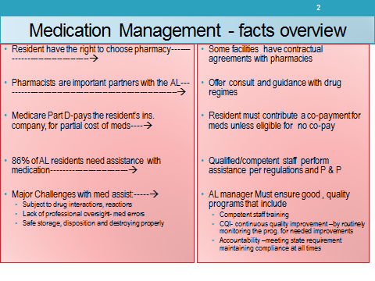
As the Manager you may not be the one giving medications to the resident this usually a delegated task in
assisted living, by hiring qualified caregivers that will be responsible for following the procedures.

Remember however the regulations say “a manager shall ensure” you must have a working knowledge of
“medication management”.

Key Terms:
Disposing Medications-proper disposal of medication is mandate by ADEQ (Arizona Dept. of Environmental Quality). Guidelines outline how to dispose medication are: dissolve in coffee grounds, moist kitty litter in a zip bag and then dispose into trash (do not flush or put into drain systems).
Signs: are what can be observed;
Symptoms are what the resident experiences or feels.
Hyperglycemia or high blood (glucose) is too little insulin. In a type 2 diabetic the body doesn’t produce enough insulin or the body fails to properly use insulin, called “insulin resistance.”
Hypoglycemia is low blood sugar (glucose) results from too much insulin or too little food
Hypertension (High Blood Pressure) also called” the silent killer” because a person can have it for years without realizing it or having any symptoms. The heart pumps with more force to move the blood through narrowed blood vessels. Narrowed blood vessels are usually the cause of high blood pressure.
Isolation precautions- Isolation" means the separation, during the communicable period, of infected individuals from others, to limit the transmission of infectious agents.
Insulin is an injectable hormone. The absence or reduction in the body's natural production of this hormone is a disease called Diabetes.
Medication" medication as a drug prescription or nonprescription, administered to, or self-administered by, a resident to maintain health or to prevent or treat an illness or disease; means one of the following used to maintain health or to prevent or treat a medical condition or behavioral health issue:
  - a. Biologicals as defined in A.A.C. R18-13-1401,
  - b. Prescription medication as defined in A.R.S. § 32-1901, or
  - c. Nonprescription medication as defined in A.R.S. § 32-1901
"Medication administration" means restricting a patient's access to the patient's medication and providing the medication to the patient or applying the medication to the patient's body, as ordered by a medical practitioner. A.R.S. § 32-1901
Medication assistance- or Assistance in self- administration of Medication- in summary means: staff stores, confirms dose to be taken complies with orders, resident removes the meds from the packaging or container, staff observes and documents medication was taken
Medications Classifications: drugs can be classified by their therapeutic use (ex. Antidepressants) or by their pharmacologic profile (ex. Selective serotonin reuptake inhibitors). Simply identify like drugs into groups or classification base on why they are use or how they work.
"Medication error” (or occurrence) means:
  - a. The failure to administer an ordered medication;
  - b. The administration of a medication not ordered; or
  - c. The administration of a medication:
    - i. In an incorrect dosage,
Medication Policies document that outlines required and the facility’s protocol to guide the medication services offered by the facility and per DHS regulation R9-10-817
Sliding scale insulin- refers to the progressive increase in the pre-meal or nighttime insulin dose, based on pre-defined blood glucose ranges. Sliding scale insulin regimens approximate daily insulin requirements.

6 Rights Plus 2

The Five Rights- this play on words helps nurses and those who administer medications a framework for remembering all the steps necessary to ensure the right medication is always administered.
Following procedures by checking the 5 rights, med errors can be avoided/prevented. The five rights are:

- 1. The Right Person
- 2. Right Drug
- 3. Right Dose and Amount
- 4. Right Route and
- 5. Right Time.
- 6. Right Documentation

Plus 2:
- Right to Refuse,
- Right Reason for PRN

Refusal of Medications- It is the resident’s right to refuse medication. If the resident refuses the medication, follow your policy and procedures how to handle. At a minimum we should report and document the refusal. This may include notifying the medical practitioner

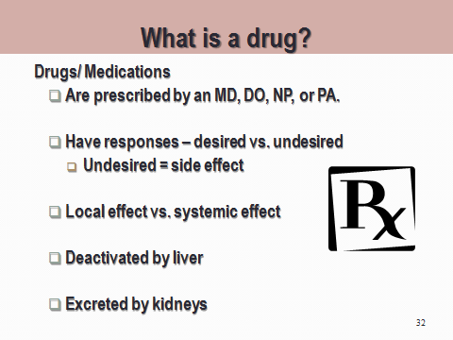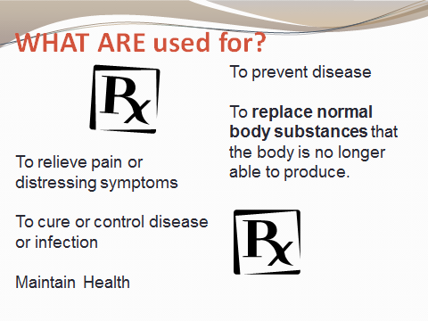

Drugs come from different sources
- Animal
- Plant
- Labs
- Chemical

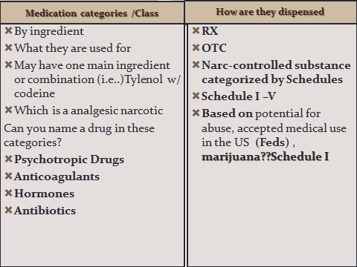

Examples Classifications of Drugs
- Antibiotics- kill or prevent the growth of organisms
- Cardiovascular Drugs- treat heart disease
- Nervous system- treat or cure related illness of nervous system- brain, spinal cord,
- Respiratory Drugs- resp tract- Lungs
- Gastrointestinal Tract- digestive system from month to anus
- Hormones- complex chemical substances produced in the body
- Topical Medications- forms of ointments, salves to cure conditions of the skin or body
- Nutritional Agents- used to supplement the nutrition of the body- meds, liquids,
- Psychotropic Meds- used to affect the mental function, behavior such as anxiety, sleeplessness, these are behavior altering meds,

Example of how they are dispensed:
“Tylenol 500mg take 2 tabs. By mouth PRN for Temp > 101 or mild pain”

A Note about PRNs
PRN medications- not to be administered routinely, only as needed for signs and symptoms for which they
ordered for- i.e pain, cough, anxiety. NOTE if given more than 3 times/days in a row- Must address cannot
exceed taking for 14 consecutive days without notifying the medical practitioner.

Remember always: Report & Document!

Some Medications Management Basics:

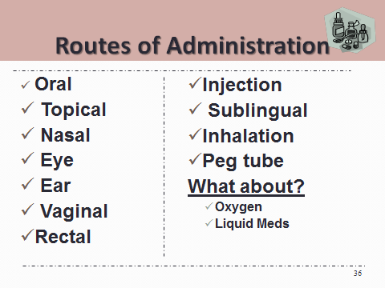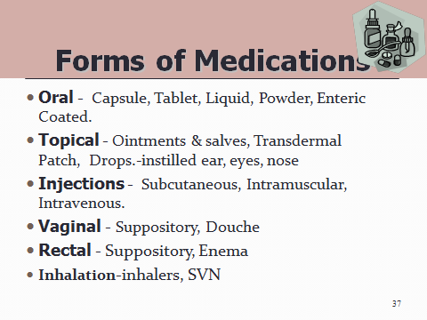

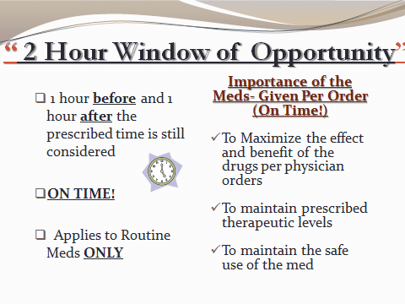

Scope of Practice defined:
- What a health professional can and cannot do to or for a patient is dependent on that health professionals scope of practice (SOP),
- which is defined by state boards of medicine, boards of nursing, etc., oftentimes with the guidance or instruction (via statute) of the state’s legislature

Think of the “Doctor’s” Umbrella as your scope of practice. If you stay under the umbrella you are safe and also ensures a safe medications management program. This area of care services, proper procedures must be followed, or harm could come to your residents. All the pieces have to be in place in order for manager or caregiver to give medications. Note, the “doctor” in this scenario is anyone with script writing privileges such as a MD,DO,NP,PA

The steps of the umbrella are a framework for policies and procedures that should be followed and for those that assist the residents or total administer them the medications it is mandated by statute R9-10-817

The Doctor’s Umbrella is as outlined below

- Starts with the doctor Delegates tasks (writes orders- authorizes caregivers to administer)
- We must have Orders for EVERYTHING!!
- Orders come from the “doctor” only
- Orders are found on M.A.R.’s
- Complete Order includes the 5 Rights!
- Level of Assistance noted w/ orders (3 levels by which residents in assisted living meds are managed)
- DHS governing body Not SBN

Medications management “101” (this is quick reference guide that summarizes all the key points of medication management:

1. Open the Book and use the MAR- EVERY TIME
2. Focus on ONE Resident at a Time (NO PRE-POURING)
3. READ and Confirm YOUR “6 Rights” Right Person
Right Medication/Drug
Right Dose & Amount (how strong/how many)
Right Route
Right Time
Right Documentatio

Plus 2 , Right to Refuse and Right Reason for PRN

4. MUST Have an ORDER for EVERYTHING from the Doctor to give any Medication –all OTC’s, Narcs, Rx and treatments! Orders are on the M.A.R. and must include ALL 5 Rights to be a complete ORDER!
5. Medications must be Kept LOCKED at all TIMES (double check cabinets and lock box in the refrigerator)
6. NEVER leave medication unattended – in resident room, at kitchen table- YOU MUST OBSERVE them take it
7. If a Med Error should occur contact Manager immediately or Call 911 if the resident is experiencing any distress. Notify the Doctor and family (responsible party)
8. Document, Document, Document---sign MAR after each medication is given—holes in the MAR means YOU did not give the medication!!! And an indicator you are not following proper procedure (See Step 1)
9. Report if any or all medications are not available or Resident Refuses to Take (then document)
10. May only give PRN for the Right Reason (according to the order written only)
11. Pay Attention to Detail, read and confirm orders, ask questions if you are not 100% sure
12. Narcotic count must be done between shifts NO EXCUSES, these drugs are to be controlled and count correct
at all times.
Managing services for those with diabetes:

Diabetes is one of the more common diseases we see in assisted living. It also is the most difficult at times for
staff to manage skills and knowledge are critical. This is one area manager should be asking all the questions:

- In our scope services will we be including resident who are insulin dependent?
- Will our staff be administering the insulin?
- Will it be routine or sliding scale? Do we accept or retain a resident on sliding scale?
- How is our staff trained to do this skill?
- Is there proof of that training in their file?
- How often do they have to take a refresher or CEU course?
- Are we safe with needles, how are they handled?
- Is staff knowledgeable on how to respond to a diabetic emergency?
- Do they know the difference between hypoglycemia and hyperglycemia?

Are you as the manager knowledgeable? Do you know all the terminology in all the above questions? If you
don’t you cannot effectively manage those who are responsible? This section we will cover many of the areas
and again it is your responsibility to have a working knowledge of how to best care for those who are
Diabetics. In a larger ALF remember it will be more that your care staff involved with the residents.

What about food / dining staff?
Activities director/ bus driver?
Are they trained also?? Will that be included in your plan, does your facility offer special diets?

Key Terms:

What is Diabetes?

Diabetes means too much sugar (glucose) in the blood.

Sugar (glucose) comes from the foods we eat, like:
- bread, cereals, pasta,
- rice, fruit, starchy vegetables and dairy items.

Sugar (glucose) is used by the body for energy— so we can function and do things like run, skip, golf, and swim

Understanding the endocrine system

Define the following terms:
- Glands organs that produce and secrete hormones.
- Hormone chemical substances created by the body that control numerous body functions.

Know these points about the endocrine system:

- Glands secrete hormones, which are chemical substances that control numerous body functions.
- Hormones are carried by the blood to organs in order to:
    - Maintain homeostasis
    - Influence growth and development
    - Maintain blood sugar levels
    - Regulate calcium and phosphate levels
    - Regulate the body’s ability to reproduce
    - Determine how fast cells burn food for energy
The endocrine system
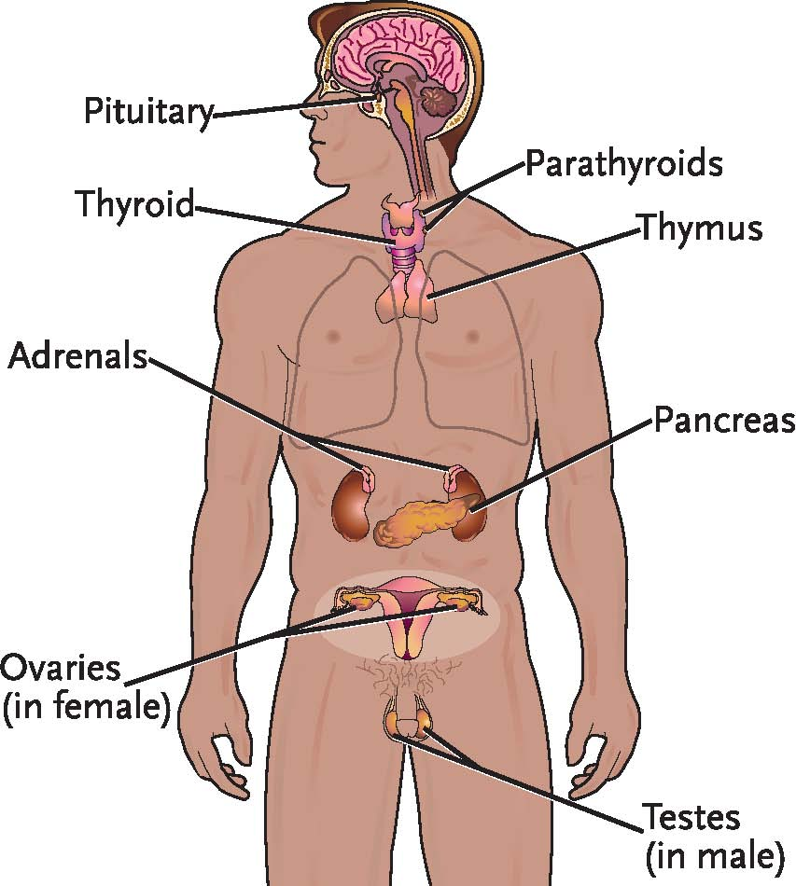
Common Disorders of the endocrine system:
- Diabetes is a condition in which the pancreas produces too little insulin or does not properly use insulin. Sugar builds up in the blood, causing problems with circulation and difficulty processing carbohydrates, fats, and proteins.
- Thyroid disorders include hyperthyroidism (too much thyroid hormone) and hypothyroidism (too little).
- OUR Focus here will be on diabetes

Define the following terms:
To best understand you must start with the basics, you must be able to know they difference between insulin and glucose and recognize the both are important to well-being.

- Diabetes a condition in which the pancreas does not produce enough or properly use insulin.
- Insulin a hormone that converts glucose into energy for the body.
- Glucose natural sugar.

Know these facts
- If Pancreas does not produce enough or properly use insulin.
- Glucose collects in blood, causing circulatory problems.
There are:
  - Two major types are
  - Type 1 and
  - Type 2.
  - Other types are pre-diabetes and gestational diabetes.

Let’s First Explore: HYPERGLYCEMIA
- High blood glucose(sugar)
- Too much food
- Decreased activity
- Physical stress
- Undiagnosed diabetes
- Normal BG levels are 70-100 mg/dl (finger stick)

Remember Insulin is a hormone that unlocks the cells in our body so glucose (natural sugar) can move into
cells to convert this” sugar” into energy!!

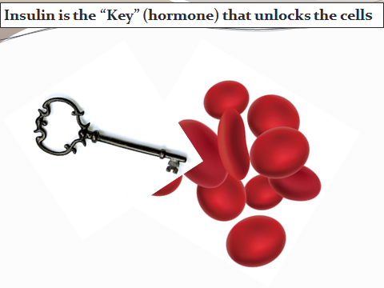 Let’s examine closer-
Insulin unlocks the cells!!
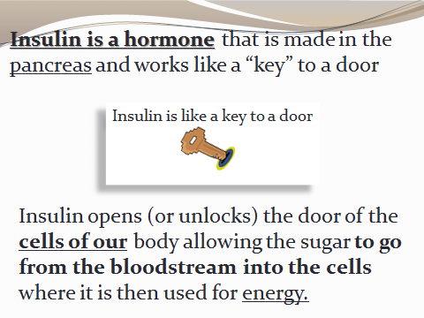
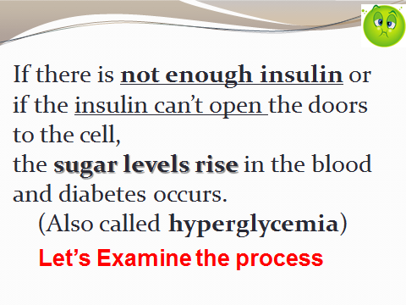
It Starts by eating food, the food moves into the stomach
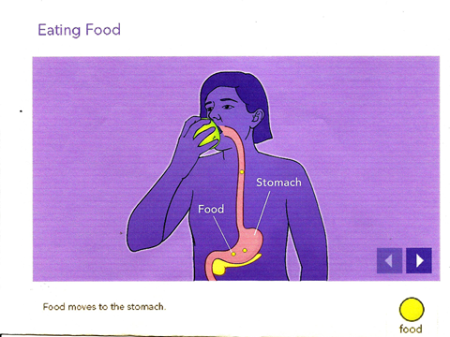
Food is converted into glucose (natural sugar )

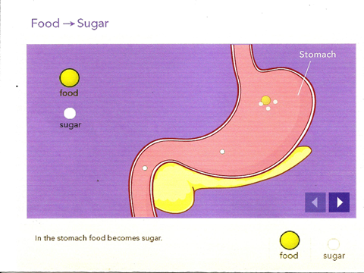

Glucose enters the bloodstream

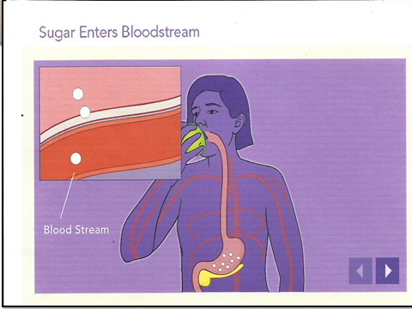
Insulin produced in pancreas now moves into bloodstream

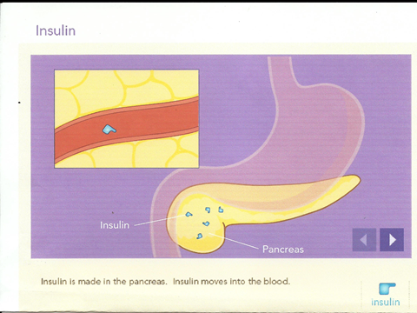

Insulin working “unlocks” the gates of the cells
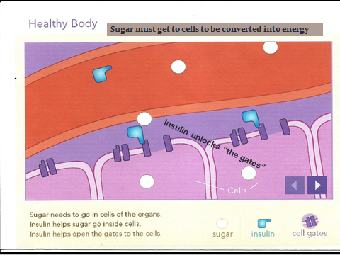
- Two primary Types of Diabetes
- We see Type 2 most frequently in assisted living
- This is someone who does not produce any enough insulin, or their body does not utilize the insulin so the “gates” either open a little or not at all

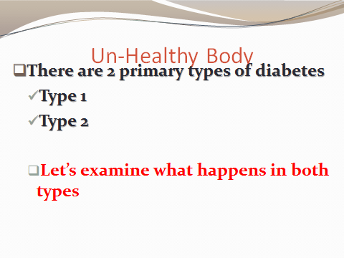
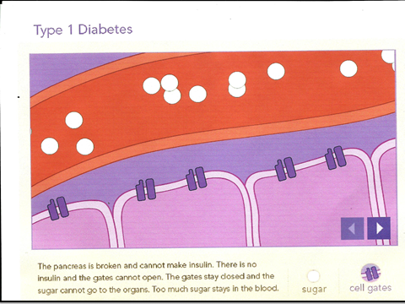
Type 1 above

Type 2 below
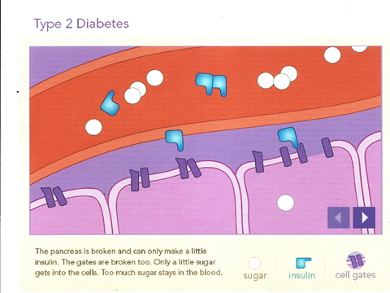

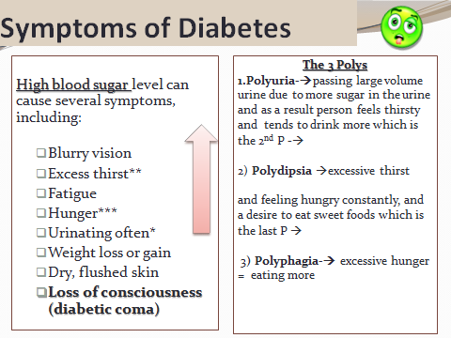

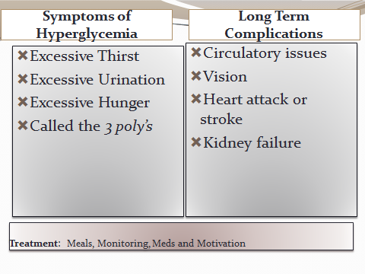
Blood Glucose Testing is Essential
- Normal range (finger stick) 70ml/dl-100ml/dl

- A1C test – q 3 months per doctor- gives snap shot of how controlled BG levels are over time

  - The A1C test result reflects your average blood sugar level for the past two to three months.
  - Specifically, the A1C test measures what percentage of your hemoglobin — a protein in red blood cells that carries oxygen — is coated with sugar (glycated).
  - The higher your A1C level, the poorer your blood sugar control and the higher your risk of diabetes complications (normal level is <7/mg/dL

Managing Blood Glucose (sugar)
- THE 4 M’s
- Monitoring BG, (finger stick) 70-100mL/dl
- Get motivated Light Exercise daily is helpful
- Proper meal choices and
- Taking medications will ensure good health.

Complications to consider:

- Diabetic Ketoacidosis (Hyperglycemia)

- Causes: too little insulin; undiagnosed diabetes; going without insulin or not enough; too much food; not
enough exercise; or physical or emotional stress

- Symptoms:
  - Increased to excessive thirst or urination; hunger; (3 poly’s)
  - weakness; rapid, weak pulse; headache;
  - low blood pressure;
  - dry skin; flushed cheeks;
  - drowsiness;
  - slow, deep, and labored breathing; nausea and vomiting; abdominal pain;
  - sweet, fruity breath odor; air hunger; unconsciousness

- Occurs gradually overtime of Uncontrolled blood glucose level ( running high for several days)

The Opposite Complication or Problem

- Insulin Reaction (Hypoglycemia)
- Low blood sugar ( below 70)
- Caused by: too much insulin, not enough food, too much exercise, vomiting and diarrhea
- Symptoms:
  - hunger; weakness; rapid pulse; headache;
  - low blood pressure; perspiration; cold, clammy skin;
  - confusion; trembling; nervousness; blurred vision; numbness of lips and tongue; unconsciousness
- Remember – comes on “Suddenly” in most cases
Facts about insulin

- Always injected subq ( Subcutaneous -under the skin)
- Can be out of refrigerator if properly dated for up to 30days from being opened
- Gently roll to warm or blend ( never shake)
- Dosage or is drawn up in units
- Can receive routinely or
- PRN(sliding scale)
- Site rotations plans need to be in place
- Onset- is 15-30mins for all insulin ( goes to work)
- Type 1 DM will always require insulin
- Type 2 may use oral agents that act like insulin to lower the BG levels

Sliding scale Insulin (given PRN)

- The term “sliding scale” refers to the progressive increase in the pre-meal or nighttime insulin dose, based on pre-defined blood glucose ranges.

- In order to fine tune some resident’s insulin doses and normalize the blood sugar levels, doctors may prescribe all or part of the insulin on a sliding scale basis.

- This means that the insulin is prescribed so that the dose or doses are selected on the basis of the blood sugar results.

Quick Quiz

Which condition is this person experiencing? Check the box you believe is correct:

Statement about the person | Hypoglycemia | Hyperglycemia
- Has too little insulin?
- Too little sugar? Skipped breakfast today?
- BG test reading was 238?
- BG test reading is 43?
- Takes sliding scale insulin PRN ac and h.s.?
- Pancreas doesn’t produce enough insulin?
- Is sweating, confused suddenly feels ill, is cold?
- Excessive thirst?
- Not enough glucose?
- Not enough insulin?


EXAMPLE: Sliding Scale Insulin Orders
Doctor orders to give Regular insulin based on blood sugar readings: ( doctor determines sliding scale)

Order is as follows: give regular insulin subq per sliding scale of:
  - 4 Units for blood sugar 110-180
  - 6 Units for blood sugar 181-240
  - 8 Units for blood sugar 241-320
  - 12 Units for blood sugar 321-400
  - If 401 or > give 14 units and Call Doctor
- Blood sugar test was 242-how much insulin are you giving? ________units

- What type of insulin are you giving??____________________
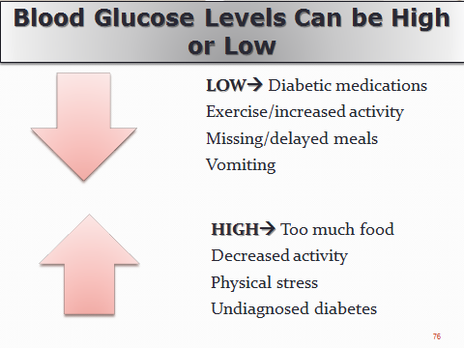

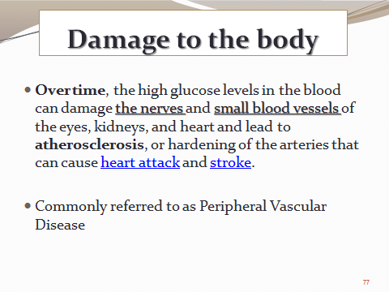
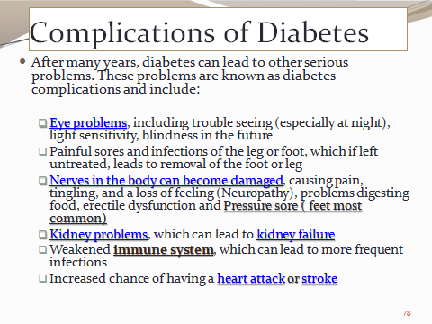

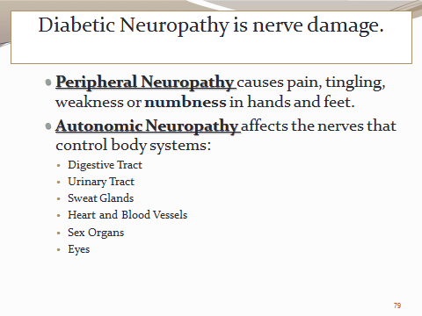

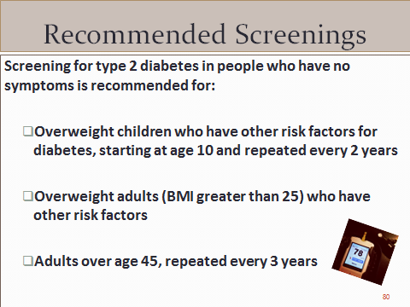

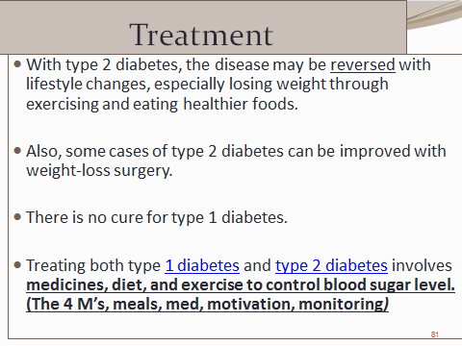

Glossary of Terms

Resident Services Management:
- Abuse" means:
(a) Intentional infliction of physical harm.
(b) Injury caused by negligent acts or omissions.
(c) Unreasonable confinement.
(d) Sexual abuse or sexual assault

- "Accept" or "acceptance" means:
- An individual begins living in and receiving assisted living services from an assisted living facility; or
- An individual begins receiving adult day health care services or respite care services from an assisted living facility.

- ADL’s- (activities of daily living) bathing, dressing, mobility/ transferring, eating, toileting

- Admission” means, after completion of an individual’s screening or registration by a health care institution, the individual begins receiving physical health services or behavioral health services and is accepted as a patient of the health care institution. In ALF referred to as “Move-in”.

- Acute illness / disease: word used to describe a disorder with rapid onset and relatively short recovery time, usually unexpected ( could be any episode of illness, accident or injury)

- Advance directive- A statement executed by a person while of sound mind as to that person's wishes about the use of medical interventions for him or herself in case of the loss of his or her own decision-making capacity

- Advocate: To speak, plead, or argue in favor of. Patient Advocate provides patients with arbitration, mediation and negotiation to settle issues with access to care, medical debt, and job retention related to their illness.

- Assessment means an analysis of a patient’s need for physical health services or behavioral health services to determine which services a health care institution will provide to the patient

- Behavior- manner of behaving or acting. When a resident acts in a manner deemed unsafe, with risk
immediate harm to self or others the facility must have policies and procedures in place that direct the staff in
managing the unsafe/harmful behavior.

- Care Models- Many different level of services and care models are available to the aging population ranging from independent living to skilled nursing. The following are typical of “models of care” available to meet physical and medical care needs as desired or required by the individual:
- Independent Living (IL) communities or called “Retirement Communities”
- Assisted Living Homes and Centers (typically are Social Models )
- Skilled Nursing Facilities (SNF) ( type of Medical Model)
- Continuous Care Retirement Centers (CCRC) combine independent living, assisted living and skilled nursing into one environment of care
- Respite Care and Adult Day Care
- Rehabilitation Centers (restorative nursing)
- May also include philosophy of care :i.e. Person Centered Care, hospitality model, and social model

- Chronic illness/ disease: a word used to describe a disorder or illness that in ongoing expanding possible over lifetime
- Conservator- A person, who has the legal authority and duty to protect the assets of another, protected person (a minor or incompetent). A conservator is appointed by a court, in the same way that a guardian is appointed, but can only make decisions about property, not about medical care or other decisions personal to the protected person.

- Discharge" means a documented termination of services to a patient by a health care institution. In ALF referred to as “Move-out”

- Do not resuscitate (DNR) order- An order by the physician, with respect to a specific patient, to the effect that, should cardiac arrest or respiratory arrest occur, no attempt should be made to give cardiopulmonary resuscitation to the patient.

- Durable power of attorney- A power of attorney that remains (or becomes) effective when the principal becomes incompetent to act for himself or herself. (It should be noted that in most states, even an agent with a durable power of attorney cannot make medical treatment decisions for an incompetent patient, unless state law provides that he or she can or a court has given him or her specific authority.)

- Falls: Caused often by slips or trips. Falls are one of the leading causes of unintentional injuries in the United States, accounting for approximately 8.9 million visits to the emergency department annually (NSC Injury Facts 2011). Adults 55 and older are more prone to becoming victims of falls, and the resulting injuries can diminish the ability to lead active, independent lives. The number of fall deaths among those 65 and older is four times the number of fall deaths among all other age groups.
- Food supply- a recommended 3 day non-perishable food supply is always available in the event of disaster. FEMA website on building kits provides helpful tips (http://www.ready.gov/food)

- Guardian- A person who has the legal responsibility, and the authority to make decisions, for an incompetent person or a minor. A guardian is appointed by a court. The written guardianship order specifically states the authority of the guardian, and might convey authority to make decisions only about money and property management, or authority to make personal decisions (such as those regarding health care), or might convey authority to make both kinds of decisions.

- HIPAA is the acronym coined from the Health Insurance Portability and Accountability Act of 1996. The US Department of Health and Human Services. The HIPAA Privacy Rule provides federal protections for individually identifiable health information held by covered entities and their business associates and gives patients an array of rights with respect to that information

- “Hospice" means a hospice service agency or the provision of hospice services in an inpatient facility.
- Hospice service" means a program of palliative and supportive care for terminally ill persons and their families or caregivers.

- "Hospice service agency" means an agency or organization, or a subdivision of that agency or an organization that is engaged in providing hospice services at the place of residence of its clients.

- Hospitality Model- “customer service”, kind, friendly and caring Is KEY to the longevity of the AL facility

- Infection control means to identify, prevent, monitor, and minimize infections. Infection control relates to practices and procedures that prevent the spread of infection. Single most important is hand washing

- Investigation policies- facility must have policies & procedures in place for the manager to direct the investigations, documentation and reports, with all law enforcement and agencies; Policy should include that for any allegation of neglect or verbal, physical, mental or sexual abuse will be investigated and reported to the appropriate state agencies.

- Living will- A will concerning the life of the person executing the will, in which the individual provides guidance for circumstances under which they wish to refuse, or discontinue the use of, life-support measures administered to themselves should they become incompetent. (A living will is in contrast with the usual last will and testament in which the subject matter is the disposition of property or custody of minor children.)

- Management: Management in business and organizations is the function that coordinates the efforts of people to accomplish goals and objectives using available resources efficiently and effectively. Management comprises planning, organizing, staffing, leading or directing, and controlling an organization or initiative to accomplish a goal

- Meals: Meals and snacks provided by the assisted living facility are served according to posted menus;
A meal is an eating occasion that takes place at a certain time and includes specific, prepared food, or the food eaten on that occasion.
- Breakfast is eaten within an hour or two after a person wakes in the morning[
- Lunch or dinner is eaten around mid-day, usually between 11 am and 2 pm. In some areas, the name for this meal depends on its content.
- Supper or dinner or tea is eaten in the evening. In some areas, the name for this meal depends on its content, but many English-speakers use "dinner" for this meal regardless of size.

- Neglect" -means a pattern of conduct without the person's informed consent resulting in deprivation of food, water, medication, medical services, shelter, and cooling, heating or other services necessary to maintain minimum physical or mental health.
- Negligence A failure to behave with the level of care that someone of ordinary prudence would have exercised under the same circumstances. The behavior usually consists of actions, but can also consist of omissions when there is some duty to act (e.g., a duty to help victims of one's previous conduct).

- Person-Centered Care-person centered care optimizes the quality of life and quality of care with the goal of enhancing the resident’s function and well-being (honor’s life experiences, interests, routines.

- Power of attorney- A written agreement under which one person (the principal) authorizes another (the agent) to act on his or her behalf. The agent need not be a lawyer. An ordinary power of attorney automatically terminates if the principal becomes incompetent. (See durable power of attorney.)

- Psychosocial adjustment- relating social conditions to mental health. Social influences such as peer pressure, parental support, cultural and religious background, socioeconomic status, and interpersonal relationships all help to shape personality and influence psychological makeup. Individuals with psychosocial disorders frequently have difficulty functioning in social situations and may have problems effectively communicating with others

- “Quality management program" means ongoing activities designed and implemented by a health care institution to improve the delivery of medical services, nursing services, health-related services, and ancillary services provided by the health care institution.

- Reportable events- as health care workers there is a duty to report abuse, neglect and exploitation of vulnerable adults; duty to make medical records available; and violations to appropriate authority which could include, police, APS, and DHS as appropriate.

- Records- "Medical records" means all communications related to a patient's physical or mental health or condition that are recorded in any form or medium and that are maintained for purposes of patient diagnosis or treatment, including medical records that are prepared by a health care provider or by other providers

- Refusal (meals, cares) - person denies assistance with care or refuses to eat may be caused by fear or decrease cognitive abilities, requires staff using gentle reassurance, guidance or cueing to complete tasks. Reporting and documenting any refusal of care or service is essential by the care staff

- Resident Care- programs and services that meet the physical, cognitive, medical and psychosocial needs of and individual.

- Resident Needs- refers to basic human needs, food, fluids, shelter, feeling secure, loved, and feeling of self-worth. In assisting living this could also include physical need for assistance with ADL’s (activities of daily living). It is necessary that the assisted living promotes and supports individuality, privacy, choice, dignity, respect and self-determination in order to meet the resident’s needs.

- Resident Smoking Policies- facility policies should include if smoking is allowed, designated areas, amount, type and frequency of assistance the resident may require and included on service plan, follow and abide by all city / local ordinance.

- Restraint: means any physical or chemical method of restricting a patient’s freedom of movement, physical activity, or access to the patient’s own body.

- Rights Per R9-10-810-B A manager shall ensure that:
- A Resident is treated with dignity, respect and consideration;
- A Resident is not subjected to:
- Abuse
- Neglect
- Exploitation
- Coercion
- Manipulation
- Sexual Abuse
- Sexual Assault
- Seclusion
- Restraint
- Retaliation for submitting a complaint to the Department or another entity or
- Misappropriation of personal or private property by an assisted living facility’s manager, caregivers, assistant caregivers, employees or volunteers
- Rights: 10 residents rights Per R9-10-810-C

- Service plan means a written description of a resident's need for supervisory care services, personal care services, directed care services, ancillary services, or behavioral health services and the specific assisted living services to be provided to the resident. (a plan that outlines the resident’s needs, assessed and how those needs will be meet by the facility)

- Significant change means an observable deterioration or improvement in a patient’s physical, cognitive, behavioral, or functional condition that may require an alteration to the physical health services or behavioral health services provided to the patient.

- Standard Precautions is the practice of treating all blood, body fluids, non-intact skin (such as cuts, pimples, and open sores) and mucous membrane as if they were infected. Under Standard Precautions “body fluids” refers to saliva, sputum (mucous coughed up), urine, feces, semen, vaginal secretions and pus or other wound drainage. It does not include sweat. Simply means to take precautions every time with every person

Human Resources (Personnel) Management
- Age Discrimination in Employment Act of 1987 (ADEA) - protects all persons over the age of 40 against job discrimination.

- At-will employment: The right of an employer and an employee to terminate the employment relationship without reason. is a term used in U.S. labor law for contractual relationships in which an employee can be dismissed by an employer for any reason (that is, without having to establish "just cause" for termination), and without warning. When an employee is acknowledged as being hired "at will", courts deny the employee any claim for loss resulting from the dismissal. The rule is justified by its proponents on the basis that an employee may be similarly entitled to leave his or her job without reason or warning.

- Behaviorally Anchored Rating Scale (BARS) - A performance appraisal system that uses scales anchored by descriptions of critical incidents to measure behaviors of employees on the job.

- Benefits: Employee benefits and (especially in British English) benefits in kind (also called fringe benefits, perquisites, or perks) include various types of non-wage compensation provided to employees in addition to their normal wages or salaries

- Bona Fide Occupational Qualification, A legal exception to discrimination whereby the employer may specify hiring based on gender, age, religion, sex, or national origin. that is, if it is a "qualification reasonably necessary to the normal operation of the particular business." For example, a movie studio may base a hiring decision on age if the actor they are hiring will play a youthful character in a film.

- Core issues or values- Core values are the fundamental beliefs of a person or organization. The core values are the guiding principles that dictate behavior and action. Core values can help people to know what is right from wrong.

- Discipline: A disciplinary counseling session is a meeting between a supervisor and employee. It may focus on a specific work place incident, or may be the result of a performance appraisal. A particular aspect of the employee's performance or conduct may have been identified by the supervisor as requiring attention, or the employee's overall performance or conduct may require adjustment. May be progressive in nature, such as verbal warning, written warning, suspension, and termination.

- Discrimination: is defined as distinguishing differences between things or treating someone as inferior based on their race, sex, national origin, age or other characteristics.

- Employee assistance programs (EAPs) - Services provided to employees to counsel and advice for problems interfering with work performance.

- Employee involvement groups-Groups of employees who meet to resolve specific problems in the organization

- Empowerment- Delegating power throughout the organization to encourage employees to make decisions concerning their own work.

- Equal Employment Opportunity- The treatment of employees in a fair and impartial way in all aspects of employment

- Ergonomics- The study of the design of equipment in the workplace. Equipment is fit to people to reduce the possibility of injuries.

- Ethics- Individual beliefs concerning right and wrong.

- Eustress- Positive stress that propels people to higher levels of performance.

- Exemptions: An exemption such as a tax exemption allows a certain amount of income or other value to be legally excluded to avoid or reduce taxation.

- Exempt employee, is one who is exempt from the Fair Labor Standards Act, i.e. is not entitled to overtime pay and other worker's benefits stated in the FLSA

- The Fair Labor Standards Act of 1938” (abbreviated as FLSA; also referred to as the Wages and Hours Bill]) is a federal statute of the United States. The FLSA introduced the forty-hour workweek, established a national minimum wage, guaranteed "time-and-a-half" for overtime in certain jobs and prohibited most employment of minors in "oppressive child labor", a term that is defined in the statute.

- Hierarchy of needs-Motivation theory developed by Abraham Maslow to explain the needs that drive people’s behavior

- Hiring: consists of putting right number of people, right kind of people at the right place, right time, doing the right things for which they are suited for the achievement of goals of the organization

- Hostile environment- Harassment that results from the creation of an offensive work environment.
- Human resource planning (HRP) - The process of identifying the future staffing needs of the organization.

- Human resources- The people of the organization

- Interviewing questions: A job interview is a type of employment test that involves a conversation between a job applicant and representative of the employing organization. Care to avoid questions regarding age, sex, religion, health, medical history, arrest records unless the questions are considered a “Bona fide occupational qualification.”

- Interpersonal skills.- Human relations skills

- Job analysis- The process of systematically gathering information concerning the tasks and responsibilities of a job.

- Job description- A document that itemizes the tasks and responsibilities of a job.

- Job enrichment - A job design technique that adds tasks on a higher responsibility level to increase job satisfaction.

- Just Cause- can only terminate employment for cause

- Labor- may refer to employment of any kind. Is the physical work done by people or delivery of services by person for payment

- Labor cost- refers to- wage which is monetary compensation (or remuneration) paid by an employer to an employee in exchange for work done

- Payroll: In a company, payroll is the sum of all financial records of salaries for an employee, wages, bonuses and deductions. In accounting, payroll refers to the amount paid to employees for services they provided during a certain period of time.

- Personnel File- is a collection of either electronic or printed material which provides a documentary history of a person's activities and accomplishments while serving as a member of a given organization. Personnel file offer contains documents pertinent to the employment such as; credentials, education, and skills required.

- On-the-job training- Training provided in a hands-on approach.

- "Orientation" means the initial instruction and information provided to an individual before starting work or volunteer services in a health care institution. In assisted living employees must receive orientation before providing care or services of the residents that reside in the assisted living.

- Peer appraisal -Performance appraisals performed by coworkers.

- Performance appraisal- The formal evaluation of an employee’s work on the job.

- Point system- A quantitative job evaluation system that uses specific elements of jobs to rate their worth to the organization.

- Progressive discipline- The method of discipline that uses a system of progressively more serious punishments for violations.

- Protected classes- Women, people with disabilities, minority races, and older people in the work force.

- Staff Training- is programs or in-service meetings that maintains credentials such CPR/ First Aid or to enhance skills, knowledge, and abilities to perform task(s) required based on the employee’s job description or duties.
- Sexual Harassment: is bullying or coercion of a sexual nature, or the unwelcome or inappropriate promise of rewards in exchange for sexual favors [In most modern legal contexts, sexual harassment is illegal. As defined by the US EEOC, "It is unlawful to harass a person (an applicant or employee) because of that person’s sex." Harassment can include "sexual harassment" or unwelcome sexual advances, requests for sexual favors, and other verbal or physical harassment of a sexual nature. Quid pro quo harassment- Harassment that occurs with an exchange of sexual favors for employment decisions

- Sick Leave- (or paid sick days or sick pay) is time off from work that workers can use to stay home to address their health and safety needs without losing pay. Some workplaces offer paid sick time as a matter of workplace policy, and in few jurisdictions it is codified into law. Currently, the United States are considering legislation that would require access to paid sick days for workers

- Stress- The emotional and physical wear and tear of life.

- Structured interview- An interview conducted with job applicants using prepared questions.

- "Tax ID number" means a numeric identifier that a person uses to report financial information to the United States Internal Revenue Service.

- Terminations- EMPLOYMENT TERMINATION: Termination of employment is an inevitable part of personnel activity within any organization, and many of the reasons for termination are routine. Below are a few examples of some of the most common circumstances when employment terminates:
- Resignation – voluntary employment termination initiated by an employee.
- Termination – involuntary employment termination initiated by employer
- Layoff – involuntary employment termination initiated by employer for non-disciplinary reasons. (Ex. decreasing workforce, poor sales, low census related etc.)

- Title VII of the Civil Rights Act- Federal legislation that prohibits discrimination in all employment decisions based on race, religion, color, sex, or national origin.

- Trend analysis- A quantitative forecasting technique used to identify the demand for labor.

- Unemployment insurance- FUTA A required benefit that provides income to employees who are out of work.

- Vacation pay - It is considered a benefit for the employees. An annual leave is paid time off work granted by employers to employees to be used for whatever the employee wishes. Depending on the employer's policies, differing number of days may be offered, and the employee may be required to give a certain amount of advance notice, may have to coordinate with the employer to be sure that staffing is adequately covered during the employee's absence, and other requirements may have to be met

- Wage garnishment, the most common type of garnishment, is the process of deducting money from an employee's monetary compensation (including salary); sometimes as a result of a court order. Wage garnishments continue until the entire debt is paid or arrangements are made to pay off the debt. Garnishments can be taken for any type of debt but common examples of debt that result in garnishments include:
- child support
- defaulted student loans
- taxes
- unpaid court fines
- Workers' compensation insurance- is a form of insurance providing wage replacement and medical benefits to employees injured in the course of employment in exchange for mandatory relinquishment of the employee's right to sue his or her employer for the tort (legal fault) of negligence.

- Workers' compensation statutes are designed to ensure that employees who are injured or disabled on the job are not required to cover medical bills related to their on-the-job injury, and are provided with monetary awards to cover loss of wages directly related to the accident, as well as to compensate for permanent physical impairments.

Leadership and Governance (Legal) Management
- Authority - The right of power to act, to decide, and to command others.

- Communication- The exchange of information from one source to another in such a manner that it is understood by the receiving source.

- Consensus building- A conversational style of decision making whereby issues and opinions are discussed across a range of perspectives with the objective of reaching a shared opinion or compromise agreement among a group of participants.

- Controlling - The basic management function that involves the measurement of the performance throughout the entire facility to ensure that organizational goals are being achieved and that corrective action is taken if they are not.

- Delegation of authority- The process that a manager uses in assigning duties and responsibilities to a subordinate and giving the subordinate the authority necessary to accomplish the assignment.

- Discrimination – Moral philosophers have defined discrimination as disadvantageous treatment or consideration in areas of race, color, national origin, sex, religion, disability and age.

- Corrective Action – are steps that are taken to eliminate the causes of existing nonconformities in order to prevent recurrence. The corrective action process tries to make sure that existing nonconformities and potentially undesirable situations don’t happen again.

- For-profit- An institution, corporation, or other legal entity that is organized for the profit or benefit of its shareholders or other owners.

- Goals or objectives- These are the end points that all organizational activities are directed toward. They should be realistic, verifiable, and attainable.

- Governance - The people, policies, and processes that provide the framework within which managers make decisions and take actions to optimize outcomes related to their spheres of responsibility.

- Informal Dispute Resolution Process (IDR) – If you feel that the Statement of Deficiency is incorrect then the process used to open a dialog with DHS is via the Informal Dispute Resolution Process.

- Managing risk- A program of policies and procedures that is established by the administrator as a proactive means of anticipating problems in the facility that could lead to illness, injury, or financial loss.

- Management - Is the ability to achieve common goals through the organization and productivity of other people. It involves creating and maintaining an environment in the organization that makes it possible for people to work together to contribute to the accomplishment of the organization’s objectives with the least amount of friction possible.

- Mission statement- A statement of the purpose of an organization and its reason for existing. It is usually rather brief (less than a page) and does not present detailed information about the day-to-day operations of the organization.

- Negotiated risk- A process of negotiating the way that services are going to be provided in dealing with exceptions, unusual circumstances, or problem situations outside the regular practices and service plans.

- Not-for-profit - An organization operated solely for social welfare, or for any other purpose except for profit; no part of the organization’s income is payable to, or is otherwise available for the personal benefit of, any proprietor or member.

- Ombudsman - A person trained to provide advocacy and liaison for elderly residents of healthcare facilities regarding the actions of an administrative nature that affect the resident’s health, safety, welfare, or rights. The Ombudsman Program is nationally funded by the Administration on Aging and administered by state agencies.

- Organizational chart- It also graphically represents the framework of the organizational structure and the relationships of the different positions and departments to one another.

- Organizing - A basic management function through which the formal structure of the organization is established to facilitate the development and allocation of authority and resources throughout the entire organization. It involves the grouping of people and activities, the assigning of roles, and the delegation of authority.

- Policies - These are the general statements that guide the thinking and decision making of the assisted living facility staff. Because they are guides for decision making, policies must allow for some discretion to be exercised by the decision maker. (the what)

- Procedures- These are step-by-step guides to action that establish a required method for handling future activities. (the how)

- Quality assurance - A planned and systematic pattern of all actions necessary to ensure that services conform to established technical requirements or standards.

- Quality Control – is a procedure or set of procedures intended to ensure that a manufactured product or performed service adheres to a defined set of quality criteria or meets the requirements of the client or customer.

- Quality improvement - A method of evaluating and improving processes of resident care that emphasizes a multidisciplinary approach to problem solving and focuses not on individuals but systems of resident care that might be the cause of variations.

- Quality management- A broad term that encompasses both quality assurance and quality improvement, and describes a program of evaluating the quality of care using a variety of methodologies and techniques.

- Regulations - Rules by which a statute is specifically implemented on a day-to-day basis by an administrative agency at the federal, state, or local level. A law that has been coded and advertised and is to be monitored by a specific regulatory agency.

- Rules- These are specific commands that spell out required action or non-action. They allow no discretion at all.

- Strategic planning- The process that an organization uses to reevaluate its mission, identify its long-term and short-term goals, and select its strategies and policies for achieving those goals.

Physical Environment Management:
- Emergency Procedure – is a plan of actions to be conducted in a certain order or manner, in response to an emergency event.

- Evacuations – an evacuation drill for employees and residents is conducted at least once every six months and includes all individuals on the premises except for a resident whose medical record contains documentation that evacuation from the assisted living facility would cause harm to the resident, and sufficient caregivers to ensure the health and safety of residents not evacuate. Documentation of each evacuation drill is created, is maintained for at least 12 months after the date of the evacuation drill.

- Fire - is the rapid oxidation of a material in the exothermic chemical process of combustion, releasing heat, light, and various reaction products.

- Fire Drills – Now referred to as a Disaster Drill, a disaster drill for employees is conducted on each shift at least once every three months and documented

- Fire Sprinkler Inspection – See Inspections

- HVAC- abbreviation for heating, ventilating, and air conditioning (the heating and cooling system of the facility)

- Inspections - is, most generally, an organized examination or formal evaluation exercise. In engineering activities inspection involves the measurements, tests, and gauges applied to certain characteristics in regard to an object or activity.
- The results are usually compared to specified requirements and standards for determining whether the item or activity is in line with these targets. Inspections are usually non-destructive.

- In Assisted Living this would include inspections by DHS for Annual Surveys, by Local or Fire Marshall Fire Inspection, and hired inspectors for annual Fire Extinguishers and Sprinklers inspections.

- “Isolation" means the separation, during the communicable period, of infected individuals from others, to limit the transmission of infectious agents.

- Lockout/Tagout – is a safety procedure which is used in business settings to ensure that dangerous machines are properly shut off and not started up again prior to the completion of maintenance or servicing work. It requires that hazardous power sources be "isolated and rendered inoperative" before any repair procedure is started. "Lock and tag" works in conjunction with a lock usually locking the device or the power source with the hasp, and placing it in such a position that no hazardous power sources can be turned on. The procedure requires that a tag be affixed to the locked device indicating that it should not be turned on.

- OSHA – (Occupation & Safety Health Administration) -a federal agency of the United States that regulates workplace safety and health

- Resident Emergency or Emergencies – is a serious, unexpected, often dangerous situation that requires immediate action.

- Resident Room Square Footage – For a private bedroom, at least 80 square feet of floor space, not including a closet or bathroom.
- For a shared bedroom, at least 60 square feet of floor space for each individual occupying the shared bedroom, not including a closet or bathroom.

- If a resident’s sleeping area is in a residential unit, the residential unit has at least 220 square feet of floor space, not including a closet or bathroom, for one individual residing in the residential unit and an additional 100 square feet of floor space, not including a closet or bathroom, for each additional individual residing in the residential unit.

- Resident Smoking Policies - Arizona’s smoke free law goes into effect on May 1, 2007. The act will require bars, restaurants and most businesses including health care institutions (such as assisted living facilities) to be smoke free. A proprietor should not permit smoking within 20 feet of the establishment’s entrances, open windows, or ventilation systems, as defined in the rules by R9-2-102. The purpose of the 20 foot rule is to prevent smoke from entering into areas where smoking is prohibited.

- Safety - is the state of being "safe" the condition of being protected against physical, social, spiritual, financial, political, emotional, occupational, psychological, educational or other types or consequences of failure, damage, error, accidents, harm or any other event which could be considered non-desirable

- Window Height or Window Sill Height – There is no longer a window height or window sill height requirement other than that it has a window or door that can be used for direct egress to outside the building and that there are at least two unobstructed, usable exits to the outside from the sleeping area that the resident is capable of using.

Financial Management:

- Accounting – bookkeeping methods involved in making a financial record of business transactions and in the preparation of statements concerning the assets, liabilities, and operating results of a business.

- Balancing Books – refers to the process of recording all sides of a transaction. Typically, balancing refers to creating a balance sheet were Assets balance with Liabilities plus Owner’s Equity.

- Balance Sheet - reports the assets, liabilities, and owner’s equity of a business enterprise at a specific date

- Budget – is a quantitative expression of a plan for a defined period of time.

- Expected Income – the monetary payment received for goods or services, or from other sources, such as rents or investments.

- Facility Finances – an Assisted Living Home or Center ability to manage their money, banking, investments, credits and debits. A close analysis of Assets, Liabilities and Owner’s Equity.

- Financial – pertaining or relating to money matters

- Liquidity- A measure of the extent to which a person or organization has cash to meet immediate and short-term obligations, or assets that can be quickly converted to do this.
- Marketing – means the commercial processes involved in promoting and selling and distributing a product or service.

- Measuring Financial Performance – is the process of determining items like: Profit/Loss, Cash Flow, Balancing the Books, Risk, Owner’s Time and Monies Invested, Valuation, and Business Owner’s Net Worth.

- Medicare Part B – is a government-sponsored insurance program that is similar to the private insurance for Americans over 65. The portion of the U.S. Medicare Program that helps pay for physician services, outpatient hospital care, durable medical equipment, and some services not covered by Medicare Part A.

- Misappropriation- In law, misappropriation is the unauthorized use of another's name, likeness, or identity without that person's permission, resulting in harm to that person. Misappropriation of funds is embezzlement of money onlyStrategic Planning – is an organization's process of defining its strategy, or direction, and making decisions on allocating its resources to pursue this strategy.

- Net Worth – is the total assets minus total liabilities of an individual or a company.

- Profit and Loss – an accounting statement showing the difference between net profits and net losses over a given period.
.
- Resident Fees – in Assisted Living, it is typically the amount of monies paid to reside in Assisted Living Facility. A combination room, board and other assisted living other services.

Person Centered Care in AL and Medication Management (Additional medical terms)

- Abandonment - In law, abandonment is the relinquishment, giving up or renunciation of an interest. In medicine, abandonment occurs when a health care professional (usually a physician, nurse, dentist, or paramedic) has already begun emergency treatment of a patient, and then suddenly walks away while the patient is still in need, without securing the services of an adequate substitute or giving the patient adequate opportunity to find one. It is a crime and can result in the loss of one's license to practice

- Abuse” means:
  - The same:
    - For an adult, as in A.R.S. § 46-451; or
    - For a child, as in A.R.S. § 8-201;
  - A pattern of ridiculing or demeaning a patient;
  - Making derogatory remarks or verbally harassing a patient; or
  - Threatening to inflict physical harm on a patient.

- Alzheimer’s is the most common cause of all dementias Specific changes in the brain have been found, no cure or prevention at this time, causes loss of memory, thinking/ reasoning problems and inability to care for one’s self
- Atherosclerosis” is a blocking of the arteries, caused by the build-up of fatty deposits called plaque on the inside of the vessel wall.
- “Arthritis” is an inflammation of the joints, usually associated with pain and stiffness
- “Assessment” means an analysis of a patient’s need for physical health services or behavioral health services to determine which services a health care institution will provide to the patient.
- CHF- Congestive Heart Failure: Heart failure occurs when the heart muscle has been severely damaged and fails to pump effectively. Blood will back up into the heart instead of circulating causing congestive heart failure.
- Dementia-is a medical term used to describe a group symptoms or syndrome that is caused by certain diseases, temporary illnesses, or conditions. Described as the permanent and progressive loss of the ability to think and remember

- Diabetes- the pancreas is responsible for producing insulin which is needed to move sugar from our blood stream to each of our cells for energy. Without insulin sugar will collect in the blood stream depriving the cells nutrients to work this cause increase glucose levels commonly known as diabetes.(disorder that results when the pancreas is unable to produce enough insulin)

- Disposing Medications-proper disposal of medication is mandate by ADEQ (Arizona Dept. of Environmental Quality). Guidelines outline how to dispose medication are: dissolve in coffee grounds, moist kitty litter in a zip bag and then dispose into trash (do not flush or put into drain systems).

- Hyperglycemia or high blood (glucose) is too little insulin. In a type 2 diabetic the body doesn’t produce enough insulin or the body fails to properly use insulin, called “insulin resistance.”

- Hypoglycemia is low blood sugar (glucose) results from too much insulin or too little food

- Hypertension (High Blood Pressure) also called” the silent killer” because a person can have it for years without realizing it or having any symptoms. The heart pumps with more force to move the blood through narrowed blood vessels. Narrowed blood vessels are usually the cause of high blood pressure.

- Isolation precautions- Isolation" means the separation, during the communicable period, of infected individuals from others, to limit the transmission of infectious agents.

Insulin is an injectable hormone. The absence or reduction in the body's natural production of this hormone is a disease called Diabetes.

"Medication" medication as a drug prescription or nonprescription, administered to, or self-administered by, a resident to maintain health or to prevent or treat an illness or disease; means one of the following used to maintain health or to prevent or treat a medical condition or behavioral health issue:
a. Biologicals as defined in A.A.C. R18-13-1401,
b. Prescription medication as defined in A.R.S. § 32-1901, or

c. Nonprescription medication as defined in A.R.S. § 32-1901

"Medication administration" means restricting a patient's access to the patient's medication and providing the medication to the patient or applying the medication to the patient's body, as ordered by a medical practitioner.

Medication assistance- or Assistance in self- administration of Medication- in summary means: staff stores, confirms dose to be taken complies with orders, resident removes the meds from the packaging or container, staff observes and documents medication was taken

Medication Categories are identifying the medication as a controlled substance, prescription medication or and over the counter medication.

Medications Classifications: drugs can be classified by their therapeutic use (ex. Antidepressants) or by their pharmacologic profile (ex. Selective serotonin reuptake inhibitors). Simply identify like drugs into groups or classification base on why they are use or how they work.

"Medication error” (or occurrence) means:
a. The failure to administer an ordered medication;
b. The administration of a medication not ordered; or
c. The administration of a medication:
i. In an incorrect dosage,
ii. More than 60 minutes before or after the ordered time of administration unless ordered to do so, or

iii. By an incorrect route of administration

- Medication Policies document that outlines required and the facility’s protocol to guide the medication services offered by the facility and per DHS regulation R9-10-817

- Medication Administration Record (MAR) sometimes called Medication sheet, or just medication record all are interchangeable terms which refer to the documentation which is “block charting” where all medication orders are listed ( transcribed on to) and staff initial /document when all medication are given. The MAR is a record, single page or several, or computer generated list of the medications given to a resident. It affirms the administration of medications for one month.

- Narcotics are one group of meds that FDA calls: Controlled Substances. Are normally identified by what is called “schedule”. They range from Schedule I to Schedule V. Schedule I most abused and illegal “street drugs” then other drugs are assigned a Schedule based on their potential for abuse and accepted medical use in the U.S. (Examples: Marijuana and Heron are Schedule I, Morphine is Schedule II , Tylenol#3 is a Schedule III, Valium is a Schedule IV, and Cough syrup/w Codeine is a Schedule V.)

- Psychotropic medication means a chemical substance that: Crosses the blood-brain barrier and acts primarily on the central nervous system where it affects brain function, resulting in alterations in perception, mood, consciousness, cognition, and behavior; and is provided to a patient to address the patient’s behavioral health issue.

- The Five Rights- this play on words helps nurses and those who administer medications a framework for remembering all the steps necessary to ensure the right medication is always administered. Following procedures by checking the 5 rights, med errors can be avoided/prevented. The five rights are:
  - The Right Person 2. Right Drug 3.Right Dose and Amount 4. Right Route and 5. Right Time.
  - Plus 3 = Right Documentation, Right to Refuse, Right reason of use of PRN

- Refusal of Medications- It is the resident’s right to refuse medication. If the resident refuses the medication, follow your policy and procedures how to handle. At a minimum we should report and document the refusal. This may include notifying the medical practitioner

- Signs: are what can be observed; Objective (observations) what your see, hear, smell and touch
- Symptoms are what the resident experiences or feels. Subjective- what the person tells you

- Skin Care: GOAL IS TO KEEP SKIN INTACT
- Use lanolin based soaps instead of antibacterial or deodorant soaps or alcohol-based products
- Inspect the person’s skin for signs of skin breakdown frequently
- Use lotion to help keep the person’s skin supple and relieve dry, scaly skin
- Change the person’s position in bed or chair at least every two hours to relieve pressure
- Skin Changes: aging process includes skin becomes drier, less elastic, more fragile; bruises and tears more easily, Fatty layer decreases (decreased natural padding)

- Sliding scale insulin- refers to the progressive increase in the pre-meal or nighttime insulin dose, based on pre-defined blood glucose ranges. Sliding scale insulin regimens approximate daily insulin requirements.

Other Miscellaneous Terms:
- Calculation”
  - The act or process of calculating; computation.
  - The result or product of calculating: His calculations agree with ours.
  - An estimate based on the known facts; forecast: Her calculation of the building costs proved quite accurate.
  - Forethought; prior or careful planning.
  - Scheming selfishness.
- Cleaning” is to rid something of dirt, rubbish, or impurities
- Dehydration” too little fluid in the tissues of the body
- Delinquent” is the failure to accomplish what is required by law or duty, such as the failure to make a required payment or to perform a certain action.
- Direct Mail” means distributing advertising circulars or other printed matter that are sent directly through the mail to prospective customers or contributors.
- “Disagreement” means:
  - The act, state, or fact of disagreeing.
  - Lack of agreement; diversity; unlikeness: a disagreement of colors.
  - Difference of opinion; dissent.
  - Quarrel; dissension; argument
- Egress” means to move through or exit
- Incident" means an unexpected occurrence that harms or has the potential to harm a patient, while the patient is: On the premises of a health care institution, or not on the premises but directly receiving services from personnel of the health care institution.

- Informal Dispute Resolution” or “IDR” is a process for the licensee / manager to have an opportunity to dispute any findings of non-compliance found on the statement of deficiency.

- Marketing Plan “Components” A marketing plan is a strategy used by companies to determine how they plan to advertise their products and services. A marketing plan should include certain components in order to present staff with ideas on what tasks the company should focus on in the upcoming months. A marketing strategy should be targeted to a specific audience, has to be available in the correct medium, based on a specific series of metrics and, most importantly, has to be focused on a distinct message from the company.
- Negligence” or “Negligent” means a word used to describe a person who fails to do what a "careful and reasonable" person would do in any given situation
- Restraint" means any physical or chemical method of restricting a patient’s freedom of movement, physical activity, or access to the patient’s own body
- “TBI”. Traumatic brain injury (TBI), also known as intracranial injury, occurs when an external force traumatically injures the brain. Causes include falls, vehicle accidents, and violence. Males sustain traumatic brain injuries more frequently than do females.

Key Terms to Study:

- Fair Labor Standards Act  - Accounting is  - OSHA:  - medication occurrence usually refers to  - Financial statements  - Strategic Planning  - The “balance sheet” can be defined as  - Stages of grief  - An acute illness is:  - Insulin is  - “just cause” means:  - employment “at- will” means  - employees PTO (paid time off)  - FMLA –“Family and Medical Leave Act  - "Employee Orientation"  - "Resident Orientation  - Marketing refers to  - “Balancing the books” is  - “Isolation" means  - “Reportable events  - Wage garnishment  - Documentation  - "Tax ID number  - Power of Attorney (POA)  - “Hyperglycemia” | - “Hypoglycemia”  - Disposing medication  - Net worth  - "Abuse"  - "Neglect"  - Fire Sprinklers inspections  - DHS inspections  - Safety is the responsibility  - Sliding scale insulin  - Evening Meal  - Infection prevention  - Facility License  - “Discharge" means  - Policies are  - Direct Mail  - FUTA  - PRN  - CEU  - Hospice  - OSHA  - IDR  - HIPAA  - Rights of Medication Administration  - Accounting  - Discrimination

Resources:

- .Arizona Department of Health Services Rules Title 9 Chapter 10 Article 8 –Assisted Living Facilities (R9-10-801. Thru R-9-10- 821

- Chapter 15 Medications and Technology in Home Care, Identify the “rights” of medications pg 279, Identify signs of drug misuse and abuse and know how to report these page 282

- Providing Home Care A Textbook for Home Health Aides William Leahy, MD with Jetta Fuzy, RN, MS and Julie Grafe,RN, BSN seventh edition Medication Aide Pages 301- 303 Identify the “rights” of medications, medication Administration

- Lippincott Fundamentals of Nursing 11th Edition by Patricia A. Potter RN MSN PhD FAAN (Author),
Anne G. Perry RN MSN EdD FAAN (Author), & 2 more Fundamentals of Nursing ISBN 10: 0323810357 / ISBN 13: 9780323810357 Published by Elsevier, 2022 Language: English

- American Medical Directors Association-Assisted Living Medication Management Manual: Operations Level-
Medication Mgmt Operations.pdf page 10 ( six rights)

Disclaimer:
Fair use of copyrighted material

We’re dedicated to sharing accurate and valuable information through our training handouts, material,
hyperlinks, resource research, etc.

Occasionally, we may reference or showcase materials created by other authors or experts to add context and
depth to our content. We strive to use these materials under fair use principles, meaning our references are
intended for educational and informational purposes.

To be clear: any copyrighted materials used here are owned by their respective copyright holders, and we do
not claim ownership of this content. When we reference studies, images, or other materials, our goal is to
inform and educate, not to profit from someone else’s work.

We believe this aligns with fair use guidelines, but we’re always open to feedback from creators.
If you are a copyright holder and have concerns about how your content has been used, please feel free to
reach out to us.

We are committed to maintaining transparency and respecting copyright laws while delivering valuable content
to our audience.

Disclaimer: This disclaimer is designed to align with fair use principles, but it does not guarantee legal protection. Copyright claims are ultimately determined by the law and depend on the specific circumstances surrounding each use.
.

